How Do I Get Rid of Harmful File Warnings and Extra Logins?
Tired of seeing the Some files can harm your computer prompt? Wondering why you have to log in repeatedly?
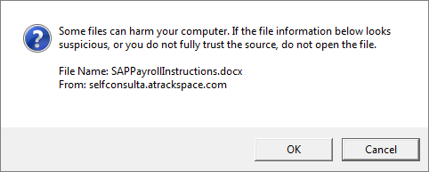
Modify the settings for Internet Explorer to add Connect NCDOT or Inside NCDOT to Trusted sites and to automate your login.
- Open Internet Explorer.
- Click the Tools icon (the cog) in the top right of the browser, and click Internet options.
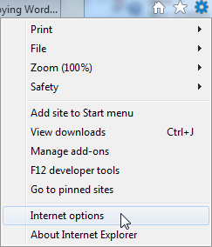
- Click the Security tab, click Trusted sites, and click the Sites button.
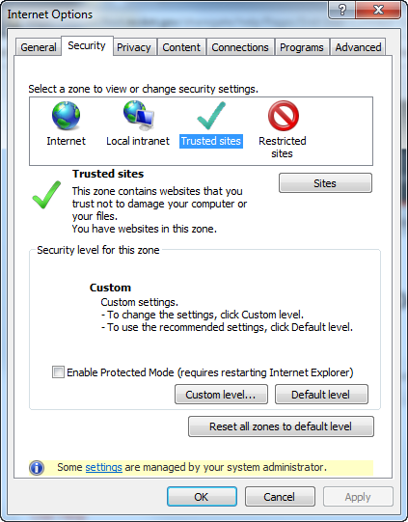
- Enter the URL of the SharePoint site to trust and click Add. Click Close.
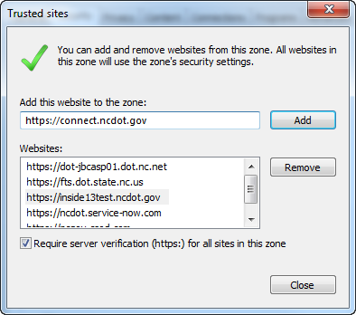
- Click Custom level.
- Scroll to the bottom and click Automatic logon with the current user name and password.
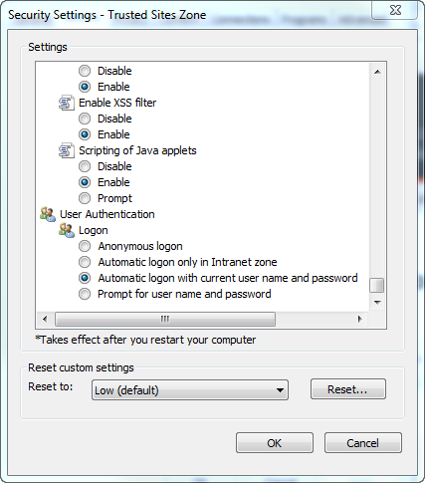
- Click OK and click OK again to exit Settings.

