SharePoint Help Site – Connect NCDOT
A link to User Help and Support is available on all pages of Connect NCDOT.
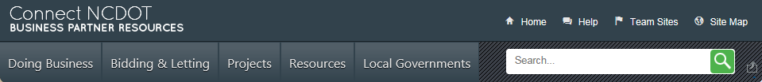
User Help and Support answers questions about Connect NCDOT and links to the SharePoint help site.
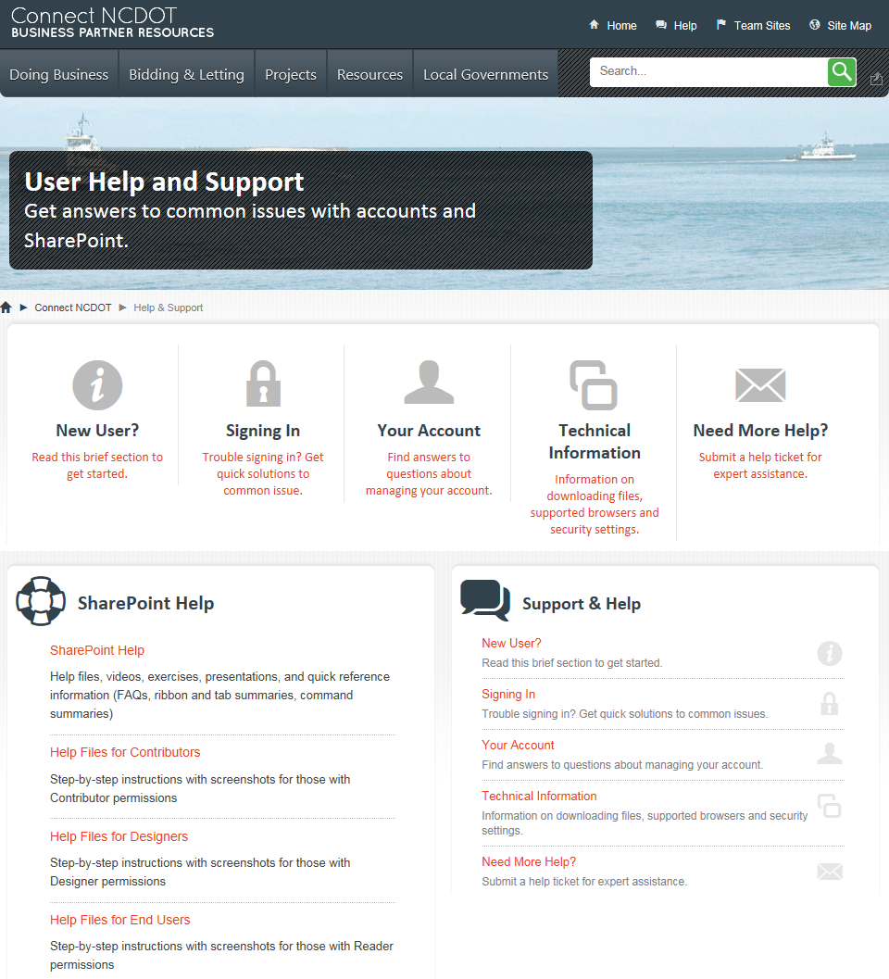
Click SharePoint Help or one of the Help Files links to go to the SharePoint help site. The direct URL for the site is https://connect.ncdot.gov/help/SharePoint-Training/.
The home page is organized by roles – End User, Contributor and Designer – and contains links for help, training, and quick reference materials. Click your role for information specific to your permissions.
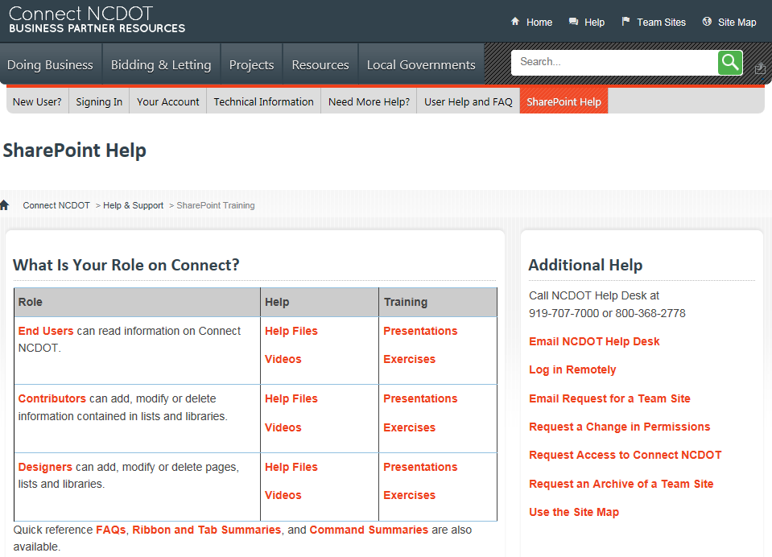

The role-specific page gives a brief description of responsibilities as well as links to comprehensive help information. This is an example of the SharePoint help for Contributors.
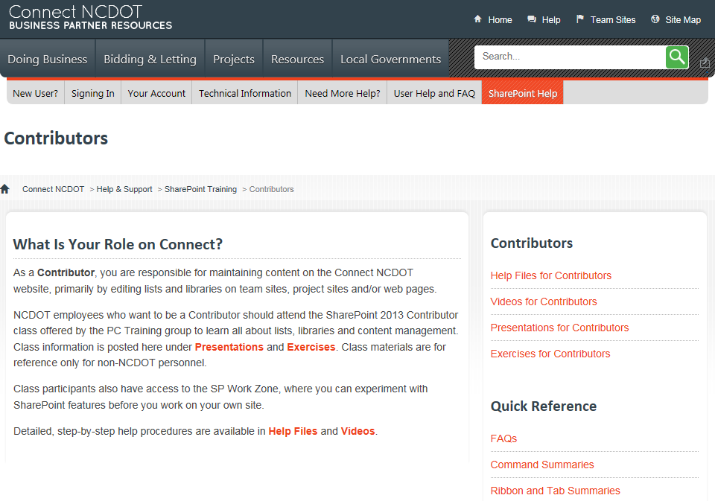
- Help Files – Step-by-step directions with screenshots for common procedures
- Videos – “How-to” explanations for common procedures
- Presentations– Slide deck from the PC Training class focusing on explanations, context and demos
- Exercises – Class exercises from the PC Training class focusing on “hands-on” examples of how to use SharePoint
- FAQs – Frequently-asked questions
- Command Summaries – Abbreviated descriptions of SharePoint commands
- Ribbon and Tab Summaries – Overviews of options on various tabs

