SharePoint Help Site – Inside NCDOT
A link to the SharePoint help site is available on all pages of Inside NCDOT.
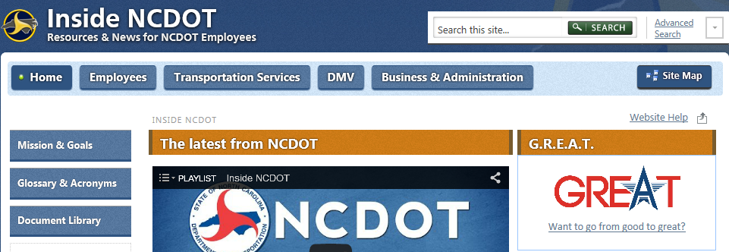
The SharePoint help site is located on Connect NCDOT at https://connect.ncdot.gov/help/SharePoint-Training/Pages/default.aspx.
The home page is organized by roles – End User, Contributor and Designer – and contains links for help, training and quick reference materials. Click your role for information specific to your permissions.
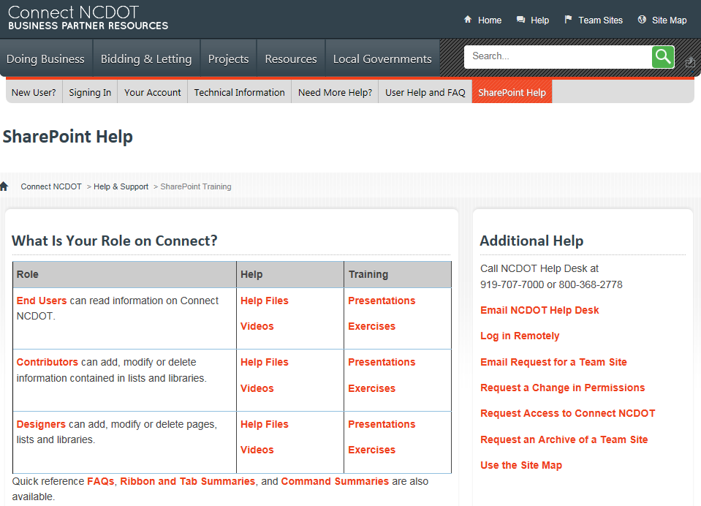
The role-specific page gives a brief description of responsibilities as well as links to comprehensive help information. This is an example of the SharePoint help for Contributors.
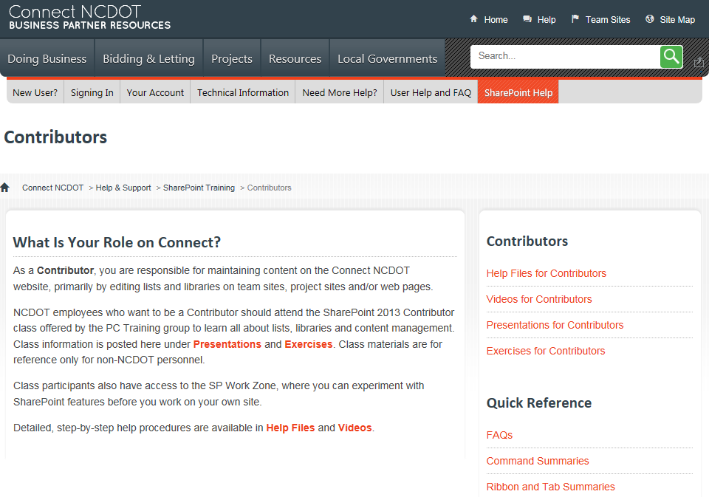
- Help Files – Step-by-step directions with screenshots for common procedures
- Videos – “How-to” explanations for common procedures
- Presentations– Slide deck from the PC Training class focusing on explanations, context and demos
- Exercises – Class exercises from the PC Training class focusing on “hands-on” examples of how to use SharePoint
- FAQs – Frequently-asked questions
- Command Summaries – Abbreviated descriptions of SharePoint commands
- Ribbon and Tab Summaries – Overviews of options on various tabs

