Image Viewer Web Part
The Image Viewer web part lets you place a static image on a page. You first add the image to the SharePoint Asset library, then add the Image Viewer web part to the page so you can display the image.

Contents
Add an Image to the Asset Library
Add the Image Viewer Web Part to the Page

Add an Image to the Asset Library
- Navigate to the Asset library.
- Upload the image.
  - Drag an image from your computer to the Asset library.
OR
  - Click new document.
In the Add a Document dialog, browse to the image to upload. Click Open. Click OK to add the image to the Asset library.
- Update the image properties as needed and click Save.
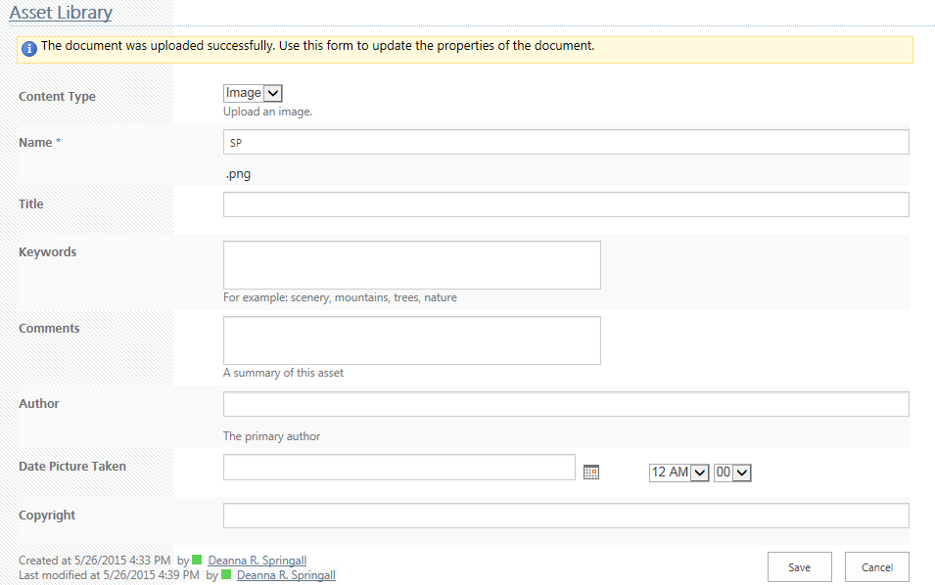
- Hover over the image, click the ellipsis, and copy the URL of the image from the callout.
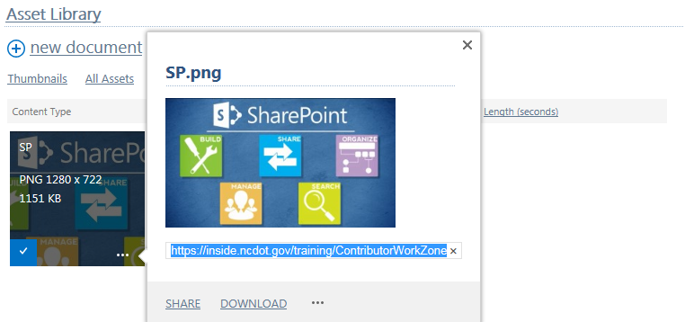

Add the Image Viewer Web Part to the Page
- Navigate to the page where you want to add the image.Click the Settings gear, and click Edit page. If prompted, check out the page.
- Click Add a Web Part in the web part zone where you want to add the image. In the Categories section, click the Media and Content category. In the Parts section, click the Image Viewer web part, and click Add.
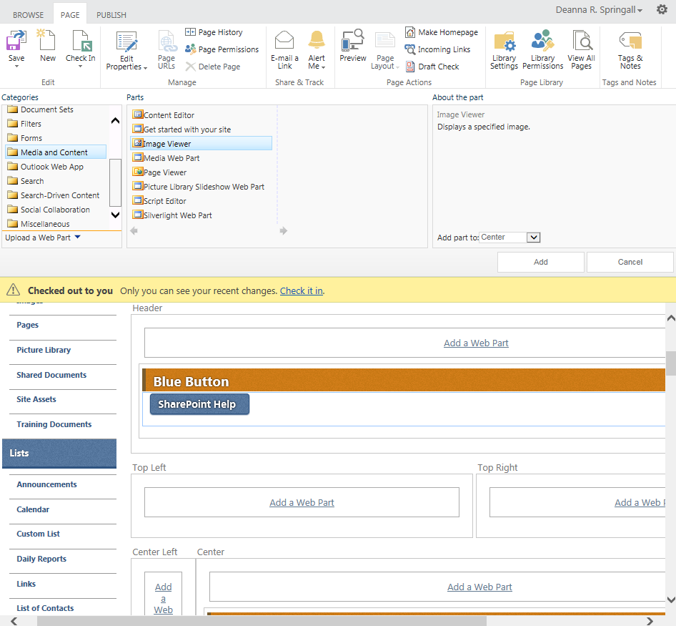
- In the Image Viewer web part, click open the tool pane.
- Paste the URL for the image in the Image Link text box. Click Test Link to ensure the link is correct. In Alternative Text, enter the text to be displayed when the user hovers over the image. Update alignment and color properties as needed.
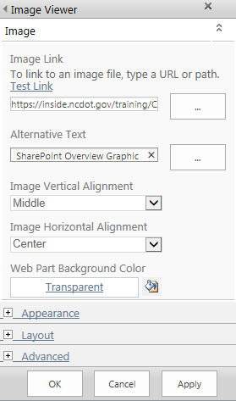
- Expand the Appearance section. Change the Title as needed or change the Chrome Type to Border Only or None if you want no title to appear. Update other appearance properties as needed.
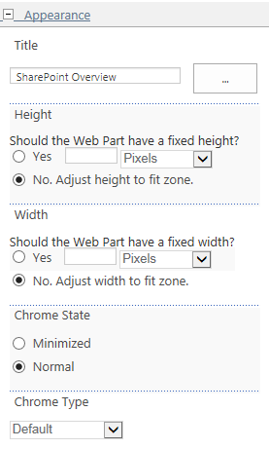
- Expand the Layout section if you wish to move the web part using the Zone Index.
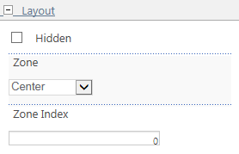
- Expand the Advanced section if you wish to have the web part title be a link. Click OK when complete.
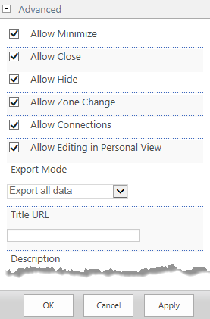
- Remember to save, check in, and publish the page. This is the page with an image added.
