Create a List by Importing a Spreadsheet
You can import information from an Excel spreadsheet to create a SharePoint list.
- Click the Settings gear, and click add an app.
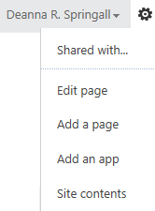
- Enter excel in the Find an app search box, or browse the list of apps to find the Import Spreadsheet app.
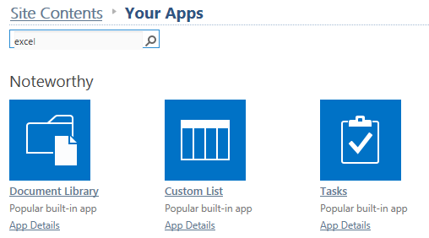
- Click Import Spreadsheet.
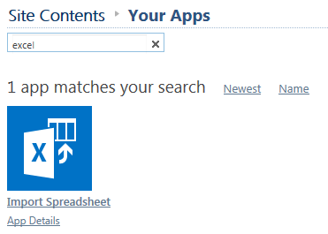
- Enter the name for the new list and, if desired, a description. Click Browse, select the spreadsheet and click Import. If prompted, log in.
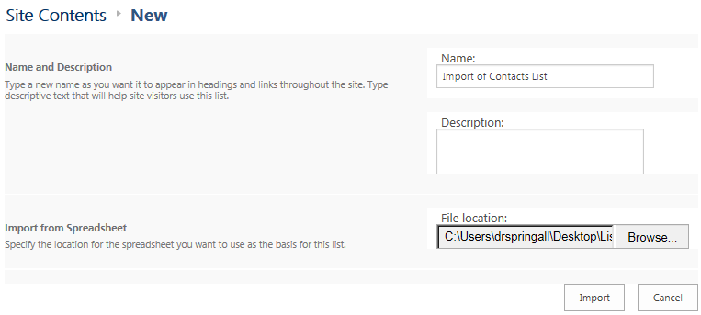
- The Excel spreadsheet opens. In the dialog, choose the Range Type and its associated Select Range. 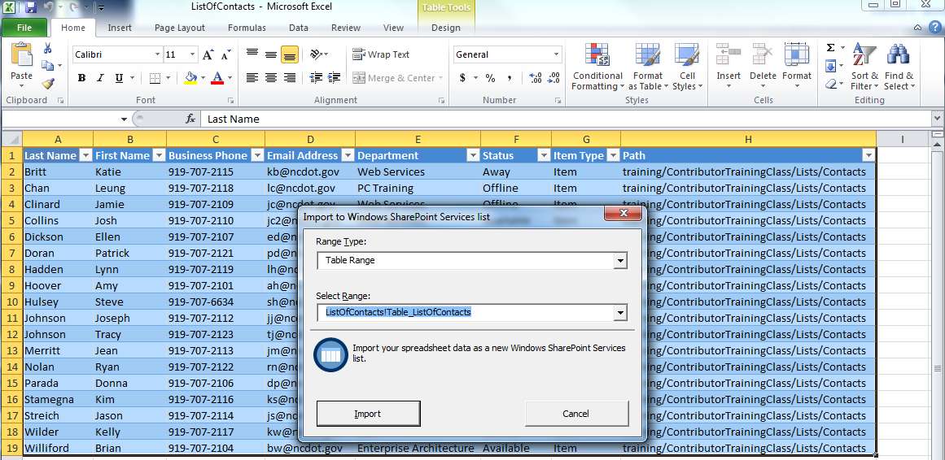
The import options are:
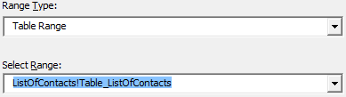
- Click Import. The list is created and contains the information from the spreadsheet.
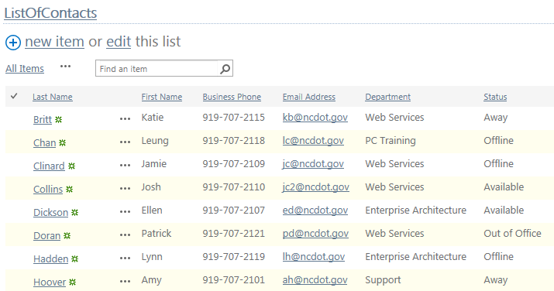
- Rename the list to a friendlier title.
