View Incoming Links to a Page
This is a list of other pages that link to the current page.
Many pages on Inside NCDOT and Connect NCDOT contain only web parts. If the incoming links are within web parts, they cannot be detected, so you may not see as many incoming links as you’d expect.
- Navigate to the page.
- On the ribbon, click the PAGE tab. In the Page Actions group, click Incoming Links.
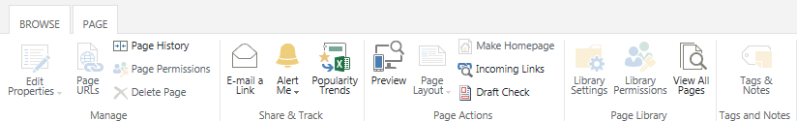
- A list of all pages that link to the current page is displayed. Click the file name to go to that page.
