Manage My Alerts
You can manage (view, add, edit or delete) your alerts through the My Alerts on This Site page, which is accessible from many different tabs. See the help file for Set an Alert for additional information on creating an alert.
Note: Only Designers can view the PAGE tab to set and manage alerts on pages.
Note: Alerts created in SharePoint 2010 have been migrated to SharePoint 2013. A few users have reported that alerts do not work after migration. The only known fix is to recreate the alerts.

Contents
View Your Alerts
Add an Alert
Edit an Alert
Delete an Alert

View Your Alerts
- Navigate to any list, library or page on the site.
- On the ribbon, click the ITEMS, LIST, FILES, LIBRARY or PAGE tab. In the Share & Track group on any of those tabs, click Alert Me. Click Manage My Alerts. This example uses the LIST ribbon.
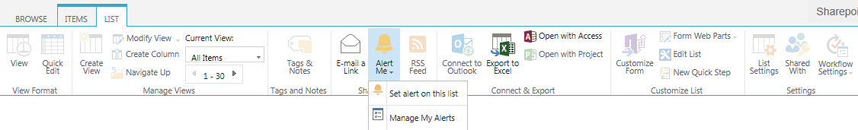
All of your alerts are listed on the My Alerts on This Site page.
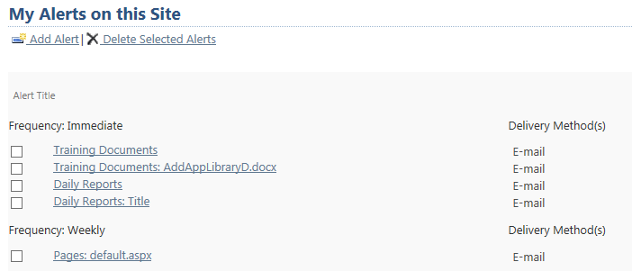

Add an Alert
To create an alert, you will probably find it easiest to use the method documented in the Set an Alert help file – simply clicking on the Set alert command in the ribbon. But, if you are already on the My Alerts on this Site page, you might wish to add an alert this way.
- Navigate to any list, library or page on the site.
- On the ribbon, click the ITEMS, LIST, FILES, LIBRARY or PAGE tab. In the Share & Track group on any of those tabs, click Alert Me. Click Manage My Alerts. This example uses the LIST ribbon.
- On the My Alerts on This Site page, click Add Alert.

- Select the content for the alert.
  - To set an alert on an item, file, folder or page: Click View this list under the name of the list or library that contains the content. Remember, pages reside in a library called Pages.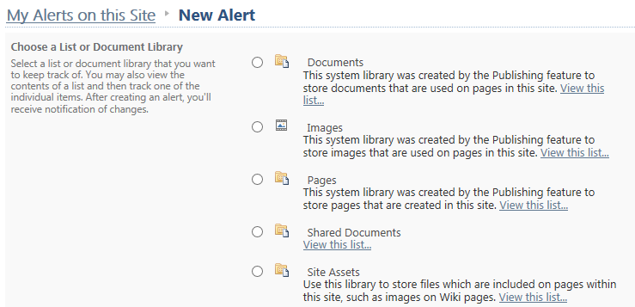When the list or library appears, add an alert just as you do when you set an alert.

  - To set an alert on a list or library: Click the radio button next to its name, and click Next at the bottom of the page.
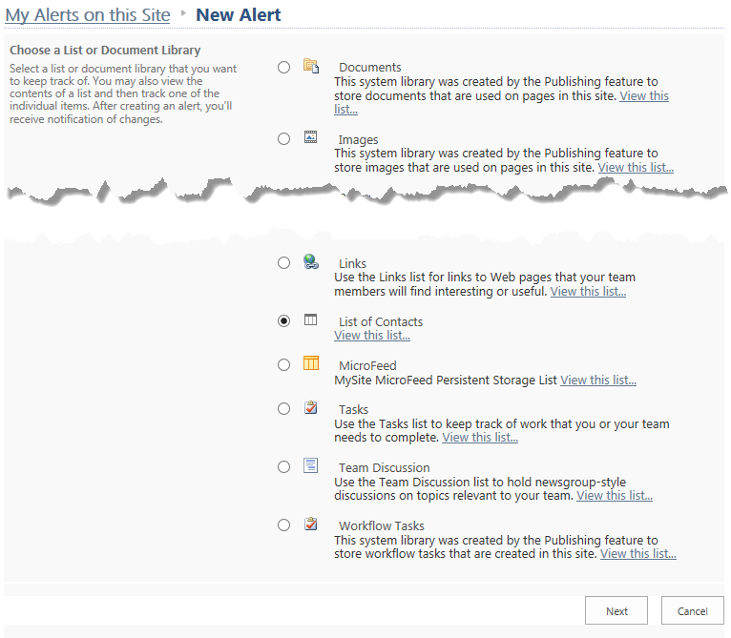In the New Alert page, add an alert just as you do when you set an alert.

Edit an Alert
- Navigate to any list, library or page on the site.
- On the ribbon, click the ITEMS, LIST, FILES, LIBRARY or PAGE tab. In the Share & Track group on any of those tabs, click Alert Me. Click Manage My Alerts. This example uses the PAGE ribbon.
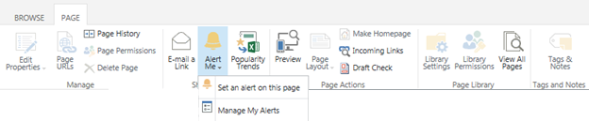

- On the My Alerts on This Site page, select the alert to change by clicking the name of the alert.
- Change the details of the alert as needed. When finished, click OK.
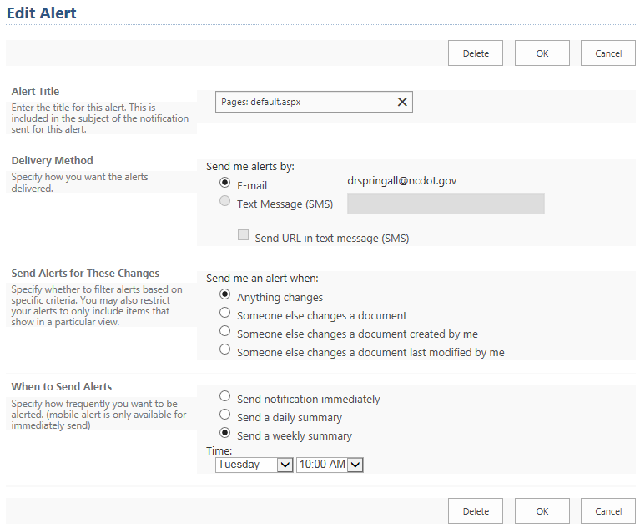

Delete an Alert
- Navigate to any list, library or page on the site.
- On the ribbon, click the ITEMS, LIST, FILES, LIBRARY or PAGE tab. In the Share & Track group on any of those tabs, click Alert Me. Click Manage My Alerts. This example uses the LIBRARY ribbon.
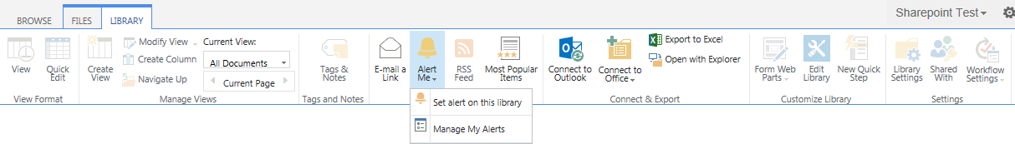

- On the My Alerts on This Site page, select one or more alerts to delete by clicking the checkbox next to their names. Click X Delete Selected Alerts. Click OK to confirm the deletion.
