Media Web Part
Use the Media web part, in conjunction with an Asset Library, to show video or play audio on a page. This help file focuses on video files, since they are in more common use at NCDOT.
First, choose how you want to store and access each video.
- Upload the video and store it in an Asset Library
- Link to the video and store the link in an Asset Library
- Embed the code for the video and store the embed code in an Asset Library
Once this information is available in the Asset Library, add the Media Web Part to a page so the video can be shown.
Note: Although images, illustrations, line art, and photos used in web pages should be stored in the Assets Library, be sure to use the Image Viewer web part, rather than the Media web part, to display them.
Contact the NCDOT Communications Office for assistance in uploading a video to the NCDOT YouTube account (https://www.youtube.com/user/NCDOTcommunications). Once it is uploaded, you can use the YouTube embed code with the Media web part or the Script Editor web part to display the video.

Contents
Store Video in the Assets Library
Add Media Web Part to the Page

Store Video in the Assets Library
- Click the Settings gear and click Site contents.
- Click the name of the Asset Library.
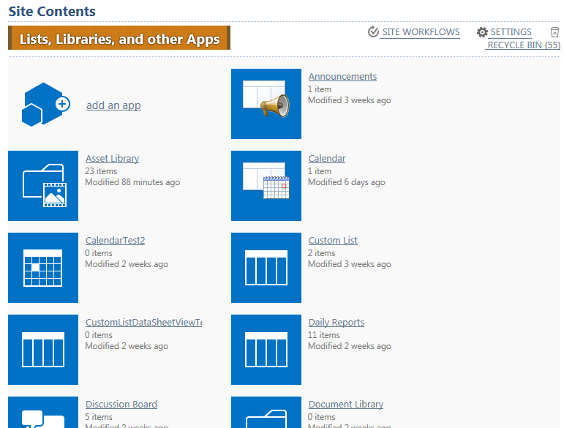
- On the ribbon, click the FILES tab. In the New group, click New Document, and click Video.
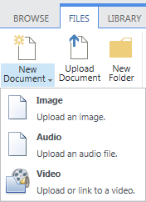
- In the dialog, choose one of the three options to store and access videos.

  - Upload a video from my computer - Browse to the video on your computer, click Open and click OK. This option uploads the video and stores it in the Asset Library, and click OK.
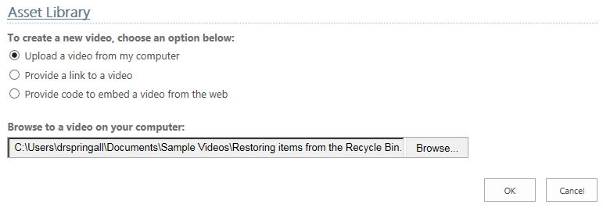
  - Provide a link to a video - Enter the link to the video. This option stores the link in the Asset Library, and click OK.
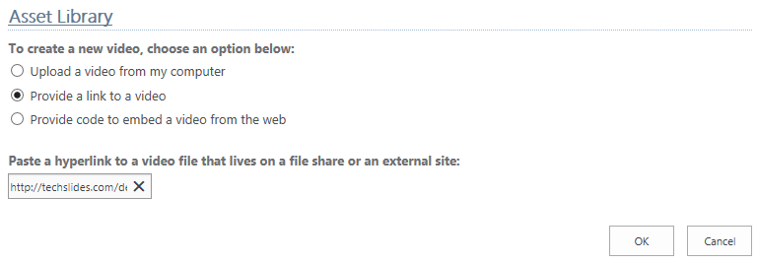
  - Provide code to embed a video from the web - Enter a name for the video and enter the embed code (available from YouTube if you are embedding a YouTube video). Click Preview to play and view the video on the Options page. Click OK.
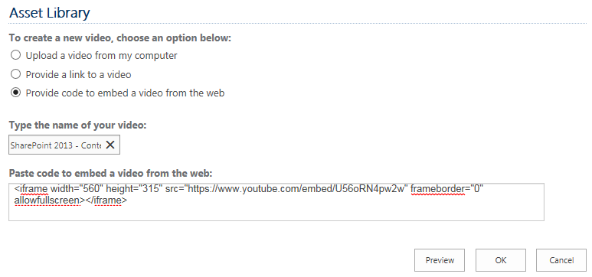
- In the video’s Properties page, you can change the video’s thumbnail and name, choose whether to show links to download or embed the video, and enter other additional or required information. When complete, click Save.
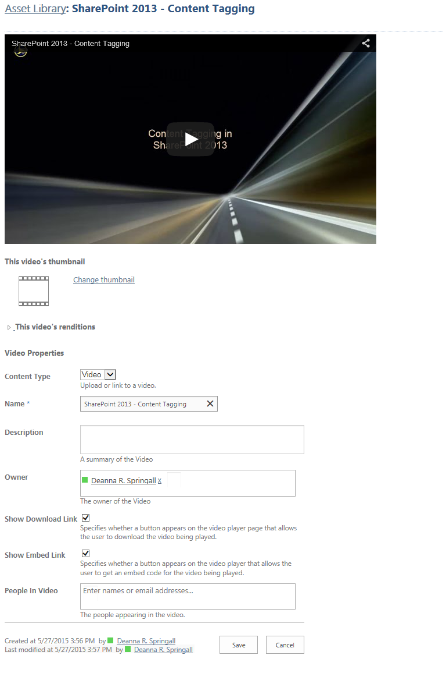

Three new videos appear in the Assets library, in addition to two images previously uploaded. By default, the Thumbnails view is displayed.
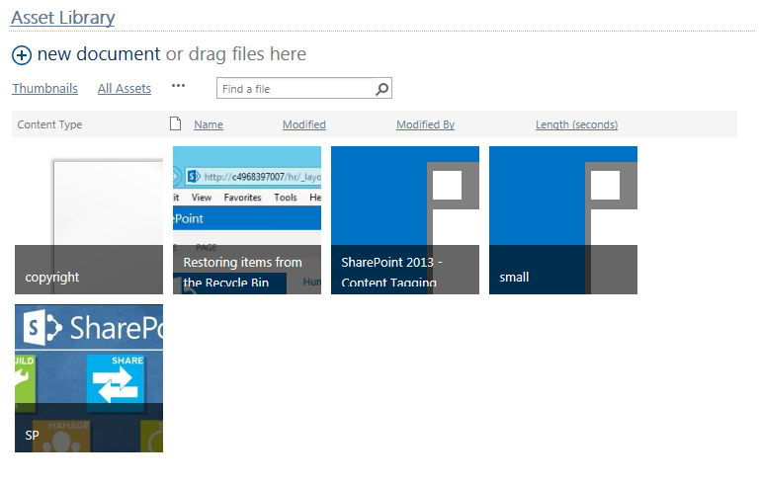
- Click the All Assets view to see more details about each video.
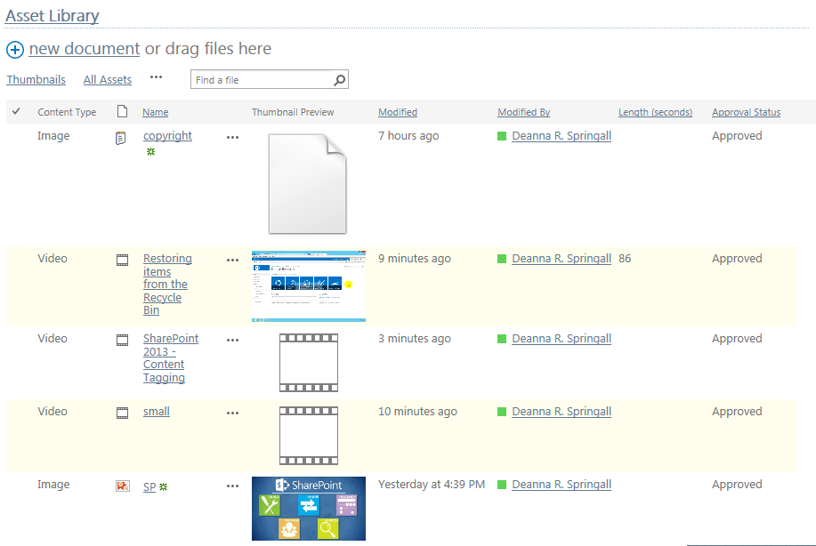

Add Media Web Part to the Page
- Navigate to the page where you want to add the video.
- Click the Settings gear, and click Edit page.
- Choose one of these two ways to add the Media web part.
  - Click Add a Web Part in a web part zone where you want the video. In the Categories section of the web part gallery, click Media and Content. In the Parts section, click Media Web Part, and click Add.
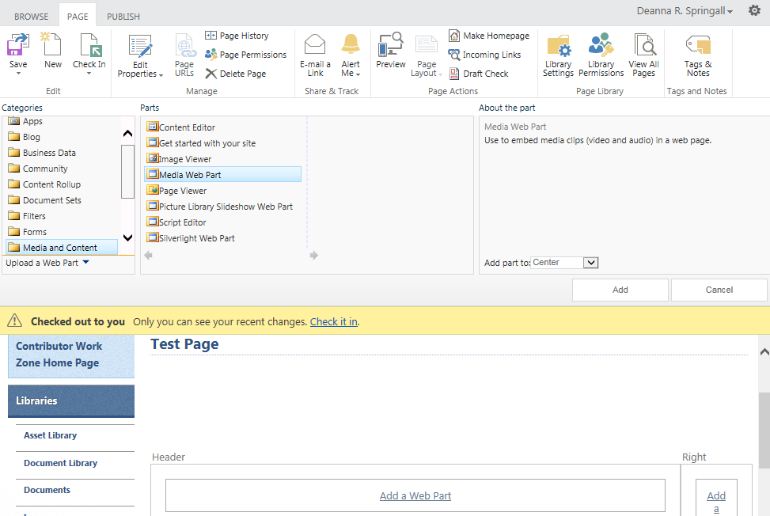

  - If the ribbon is not expanded, click the PAGE tab. Click between the outside edge of the web part zone and the outside edge of the Add a Web Part link in the web zone where you want the video.
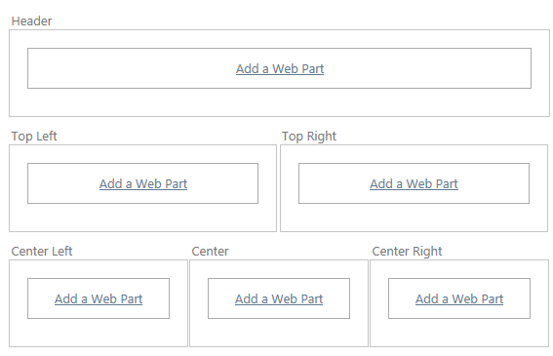
Click the INSERT tab and click Video and Audio.
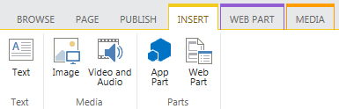

- Once the Media web part is on the page, click anywhere on the video placeholder. Tabs for WEB PART and MEDIA appear on the ribbon. (If these tabs do not appear, click the PAGE tab to open the ribbon and again click the video placeholder.) Click the MEDIA tab and click Change Media.
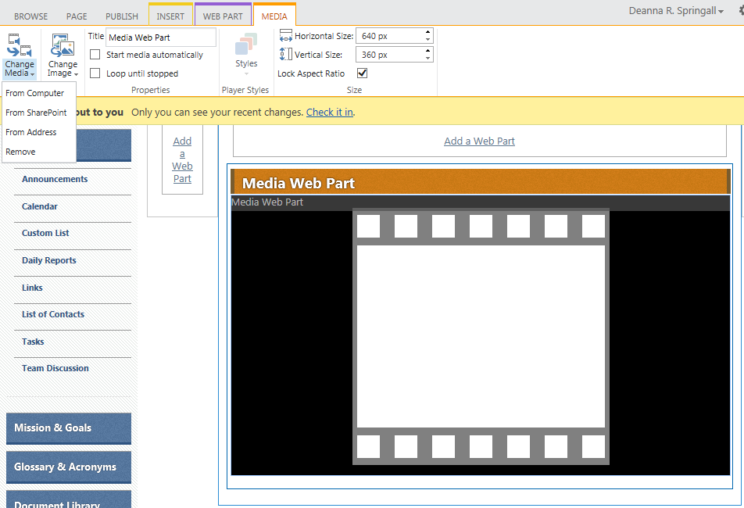
- Select the location of the video from your computer, SharePoint or another address.
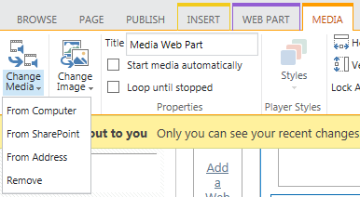
  - From computer – Browse to and upload a video from your computer. Be sure you select the Asset Library as its destination.
  - From SharePoint – Browse to the Asset Library and select a video.
  - From Address – Enter a link to a video.
  - Note: If the web part already contains a video, these three options replace the existing video with the new one you are identifying.
- Edit the properties if needed. You can use a different image as a preview for the video, change its title, determine how you want the file to play, and change the size of the player.
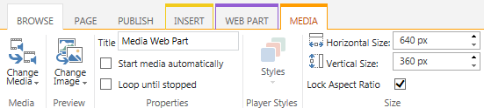
- Remember to save, check in, and publish the page.
A Note on Audio Files
If you have an audio file in .wav format, you may see a message that the Media Player Web Part cannot play files in this format. If you use Internet Explorer or other SharePoint-supported browsers, you can ignore the message because it only applies to Google’s Chrome browser.

