View Most Popular Items
SharePoint tracks and reports library usage; you can review what files have the most views, the most unique views, and are most recommended.
- Navigate to the list or library.
- On the ribbon, click the LIST or LIBRARY tab. In the Share & Track group, click Most Popular Items.
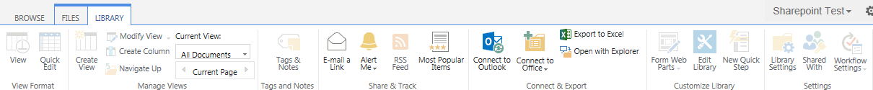This is an example of the default report, Most Views.
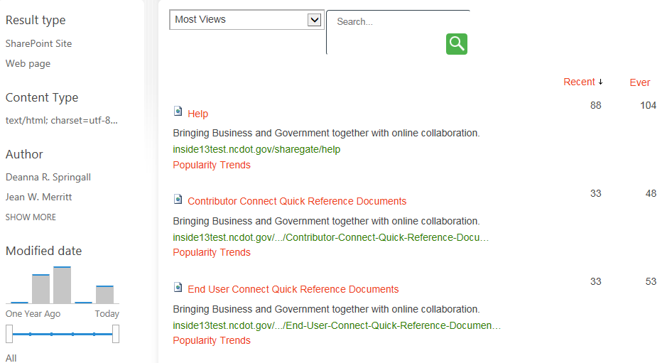
- Click the Most Views drop-down to select the Most Views by Unique Users report.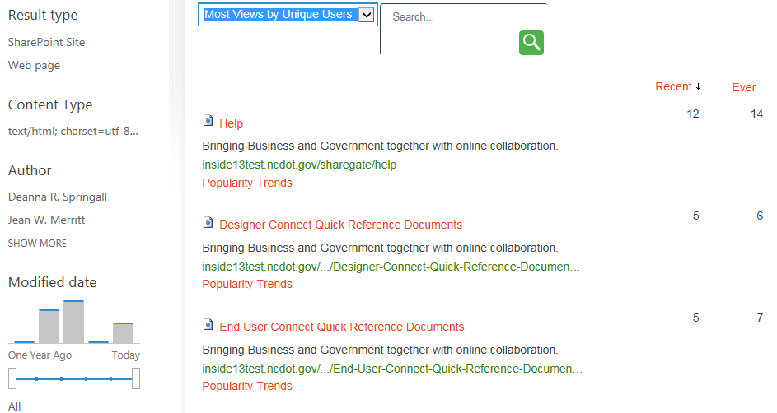
- Click the Most Views drop-down to select the Most Recommendation Clicks report if that feature is enabled.
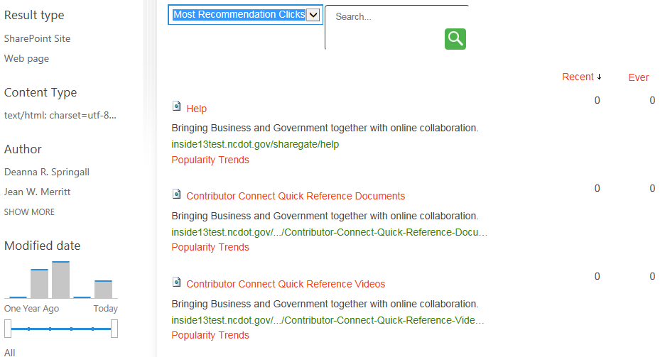
- In any of these reports, click Popularity Trends for a detailed report of that particular item or file.
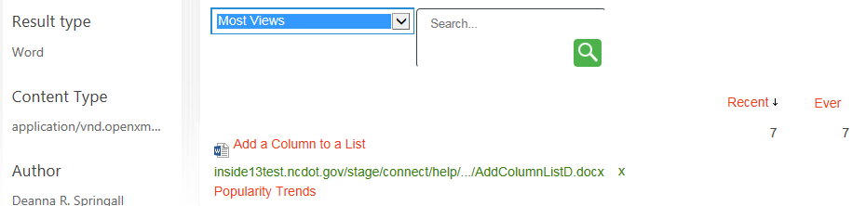
- You are prompted to open or save an Excel spreadsheet for easy analysis of popularity trend date.
The spreadsheet displays statistics such as daily and monthly views, hits and unique users.
