Move a Web Part
You can move web parts around on the page to arrange an appropriate layout. See the help files for commonly used web parts to learn how to use and customize specific web parts.
- Navigate to the page with web parts. If prompted, check out the page.
- Click the Settings gear, and click Edit page
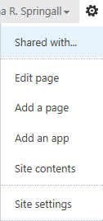
- Hover over the title of the web part, and pause until the pointer changes to a four-way arrow.
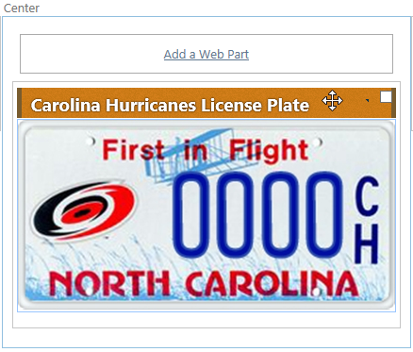
- Hold the mouse button down, and drag the web part to its new zone.
- In the ribbon, click the PAGE tab. In the Edit group, click Save to save the page.
- Remember to check the page in and publish it so users can see your changes.
You can also move the web part by selecting a different Zone in the Layout section of the tool pane. This is described in the help file on Add or Edit a Web Part.

