NCDOT Content Editor Web Parts – Connect NCDOT
NCDOT has developed two customized Content Editor web parts for use on Connect NCDOT. The Force File Download web part ensures that the download of Office documents works correctly, while the web-part-tabs.webpart creates a tabbed interface so you can efficiently display the content of several web parts.

Content
Force File Download (Unauthenticated Users)
Web Part Tabs

Force File Download (Unauthenticated Users)
On the unauthenticated (public) portion of Connect NCDOT, NCDOT generally recommends using the PDF format. If users need to download Word or other Office files, use a Content Query Web Part to display the files, then add the Force File Download web part to the bottom of the page.
The Force File Download web part resolves some difficulties that SharePoint has in working with Office files.
- Navigate to the page where you want to add the web part.
- Click the Settings gear, and click Edit page.
- Click Add a Web Part in the web part zone that contains the files to download. In the web part gallery, click _NCDOT Custom in the Categories section. In the Parts section, click Force File Download (Unauthenticated Users), and click Add.
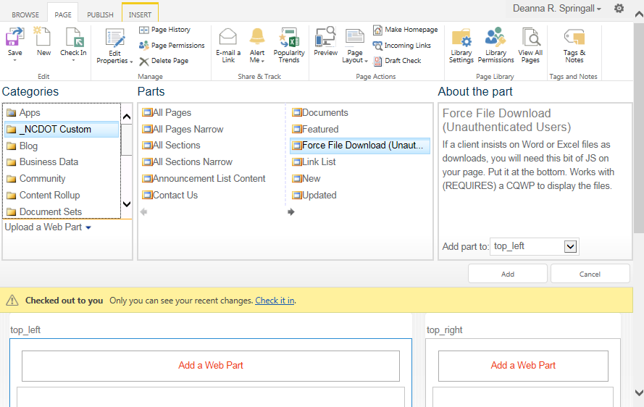
The web part is placed at the top of the column, but needs to be moved below the last web part that contains files to be downloaded.
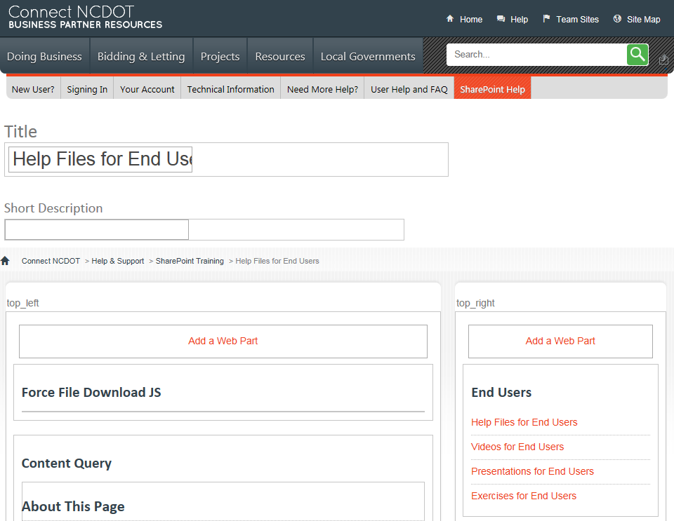
- Use the left mouse button to grab the web part title.
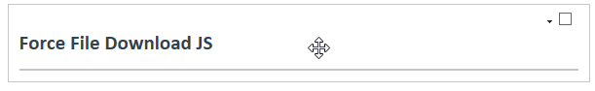
- Drag and drop the web part to the bottom of the column.
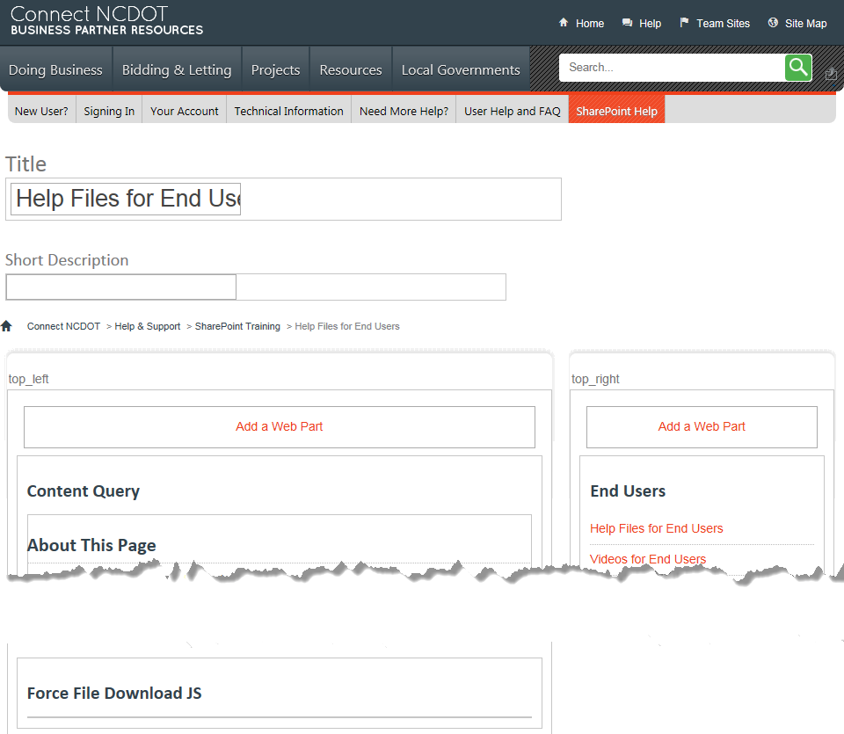
- Remember to save, check in and publish the page to make your changes visible to others.

Web Part Tabs
The web-part-tabs.webpart creates a tabbed interface so you can efficiently display the content of several web parts. The title of the web part becomes the name displayed on each tab. You cannot use more than one set of tabs on a single page.
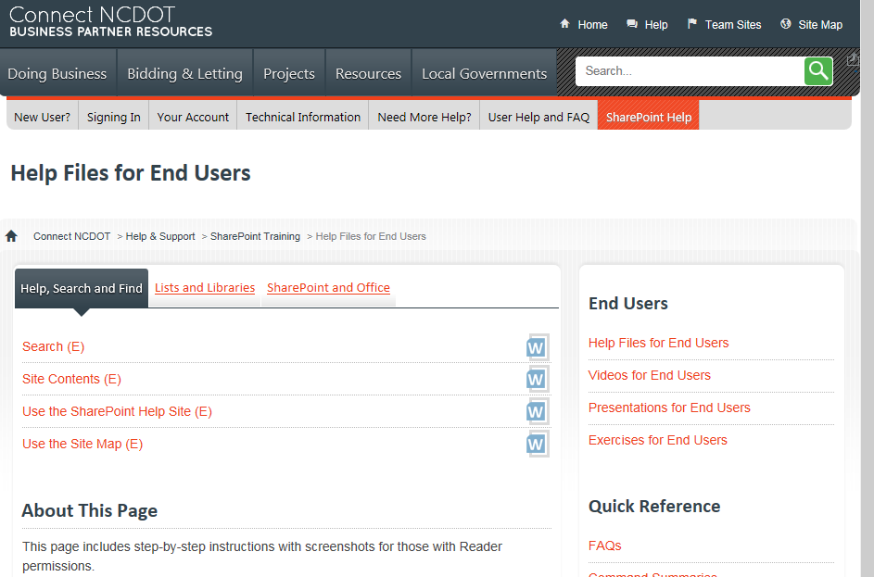
- Navigate to the page where you want to add the web part.
- Click the Settings gear, and click Edit page.

- Click Add a Web Part in the web part zone that contains the files to download. In the web part gallery, click _NCDOT Custom in the Categories section. In the Parts section, click web-part-tab.webpart, and click Add.
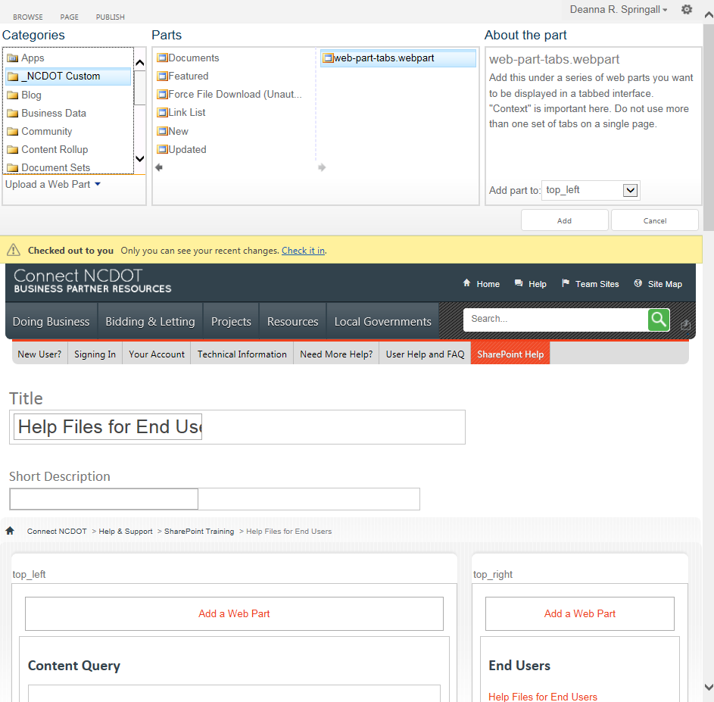

The web part is placed at the top of the column, but needs to be moved below the last web part that should become a tab.
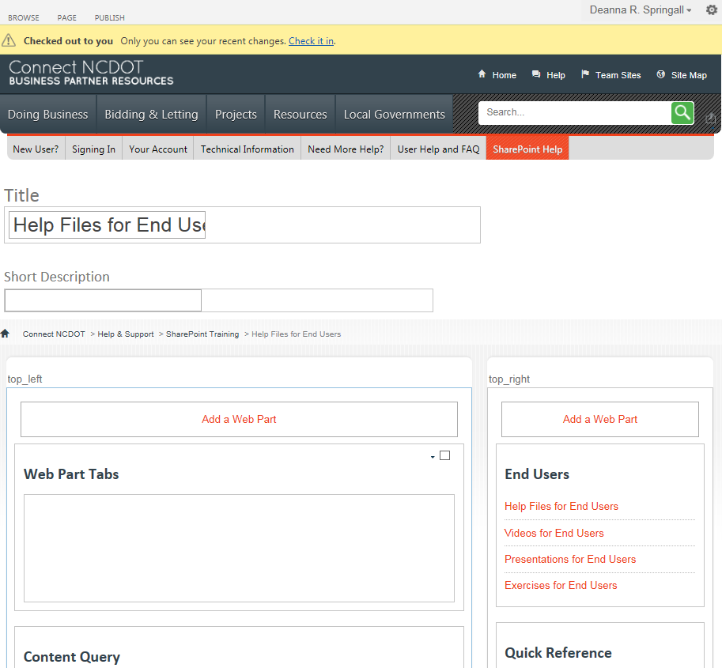
- Use the left mouse button to grab the web part title.
- Drag and drop the web part to the appropriate position.
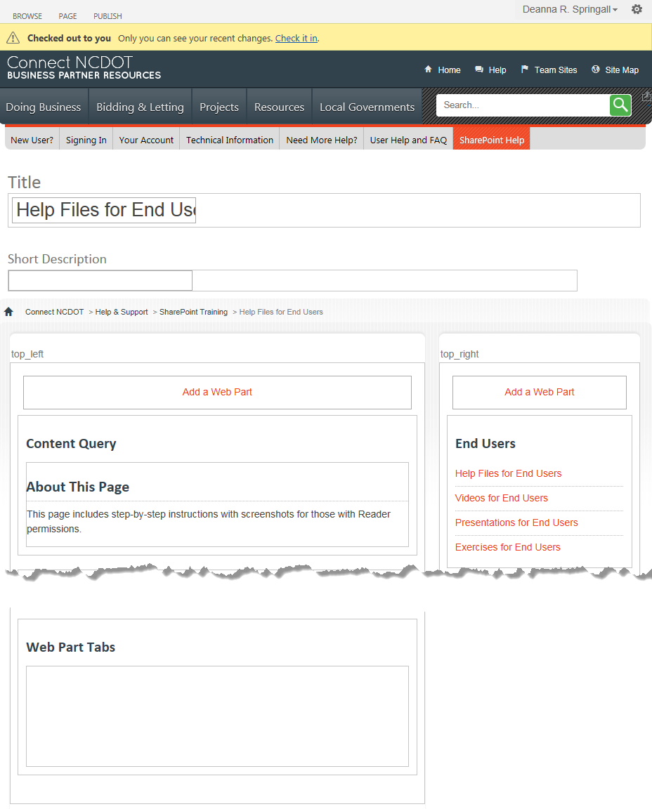
- If necessary, rearrange the other web parts so they are in the top-to-bottom order that you want the tabs to appear left to right.
- Remember to save, check in and publish the page to make your changes visible to others.

