NCDOT Content Query Web Parts – Connect NCDOT
NCDOT has developed a number of highly customized Content Query web parts (CQWPs) for specific uses on Connect NCDOT. Most of these web parts are configured to return results from the site collection level, but you can change the query so it examines only a site and its subsites, or even an individual list or library. There are also further options to customize results.

Contents
Announcement List Content
All Pages
All Pages Narrow
All Sections
All Sections Narrow
Contact Us
Documents
Featured
Link List
New
Updated
Error Message

Announcement List Content
Because Announcement List Content is one of the most commonly used NCDOT customized web parts, it is explained in complete detail here. The other NCDOT customized web parts work similarly.
The Announcement List Content web part is a customized CQWP that lets you place rich text (formatting and links) on a page without using the Content Editor web part.
The advantage of this approach is that, once a Designer places and configures this web part on a page, a Contributor can add items to the list and they appear as text on the page. If a Designer uses a Content Editor web part on the page instead, the Designer must edit the web part to have the content appear on the page.
This example uses a list called Interagency Leadership Content. It contains four items, of which two are tagged as Overview in the Section column.
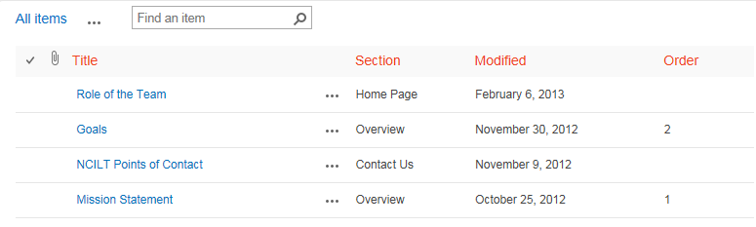
- Navigate to the page where you want to add the web part.
- Click the Settings gear, and click Edit page.
- Click Add a Web Part in the top_left web part zone on the page.
- In the web part gallery, click _NCDOT Custom in the Categories section. In the Parts section, click Announcement List Content, and click Add. 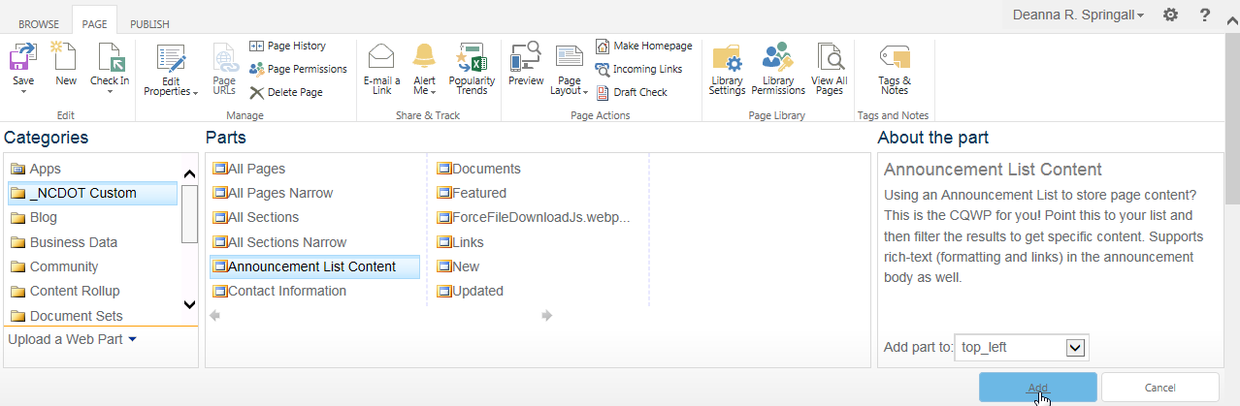By default, the web part displays all items from all announcement lists in the site collection.
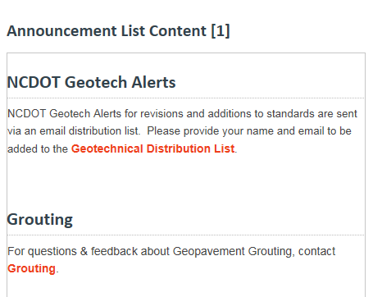
- Hover over the CQWP, click the down arrow, and click Edit Web Part.
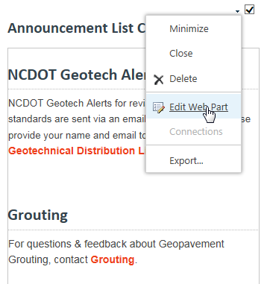
- Expand the Query section and, under Source, click Show items from the following list. Browse to Interagency Leadership Content.
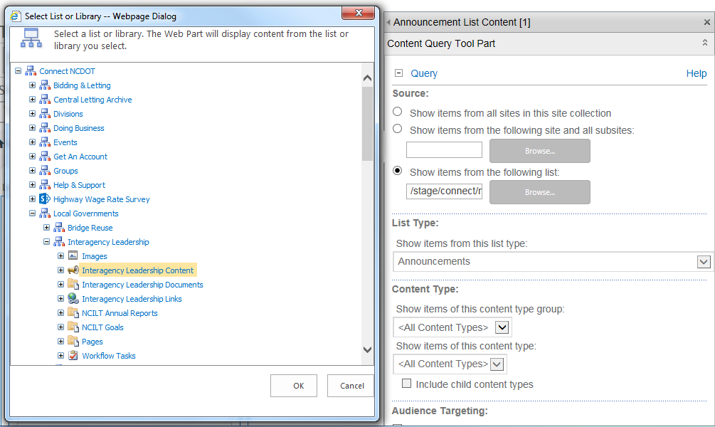
- Click OK.

- In the Additional Filters section, set Show items when Section is equal to Overview.
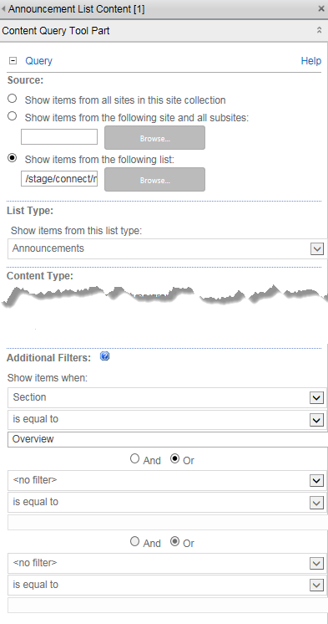
Two of the four items in the list are tagged with the value Overview in the Section column, so those are the items that appear in the query results.
- Expand the Presentation section, click Order from the Sort items by drop-down and check Show items in ascending order.
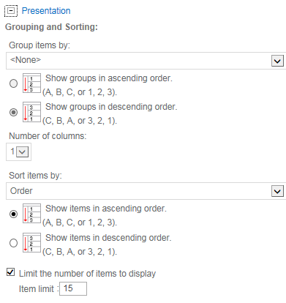
- Click OK to save the changes to the web part.
- Remember to save, check in and publish the page so users can see your changes.
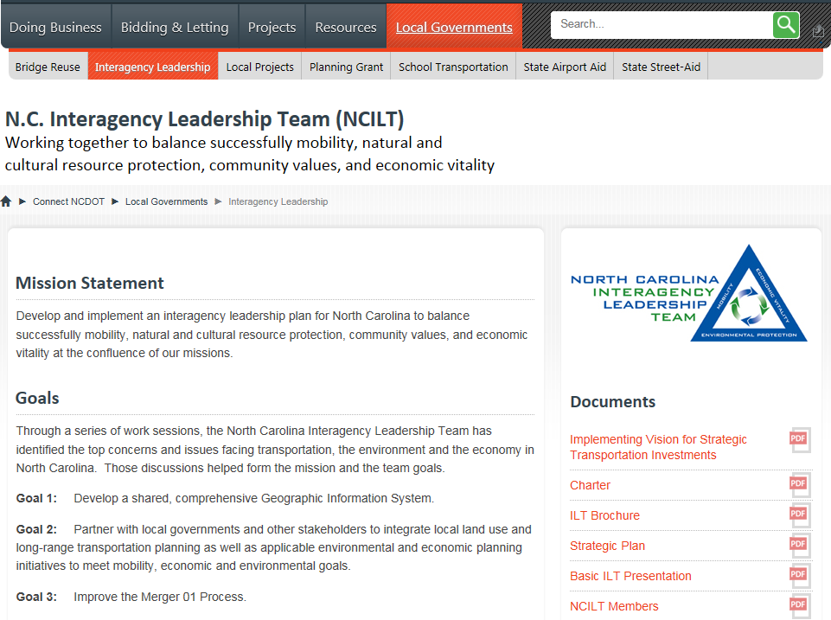
Now, whenever the Mission or Goals text needs to change, a Contributor can edit the announcements list. A Contributor can also add items and tag them as Overview, and can define or redefine their Order.
You can also use this approach to set up and reuse the same text on multiple pages.

All Pages
This is a CQWP that has been customized to list all pages in the site collection. The display includes page title, the page’s short description, and Read More text with an arrow icon. Both the title and the Read More text link to the page. Use this web part in the wide left column.
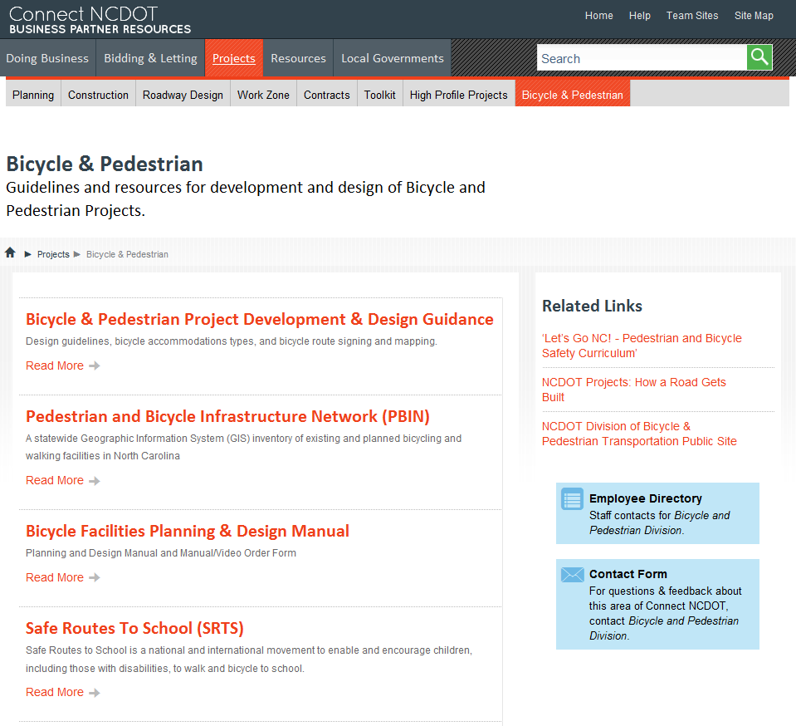

All Pages Narrow
This is a CQWP that has been customized to list all pages in a site collection. The display includes page title and the page’s short description. The title is linked to the page. Use this web part in the narrow right column.
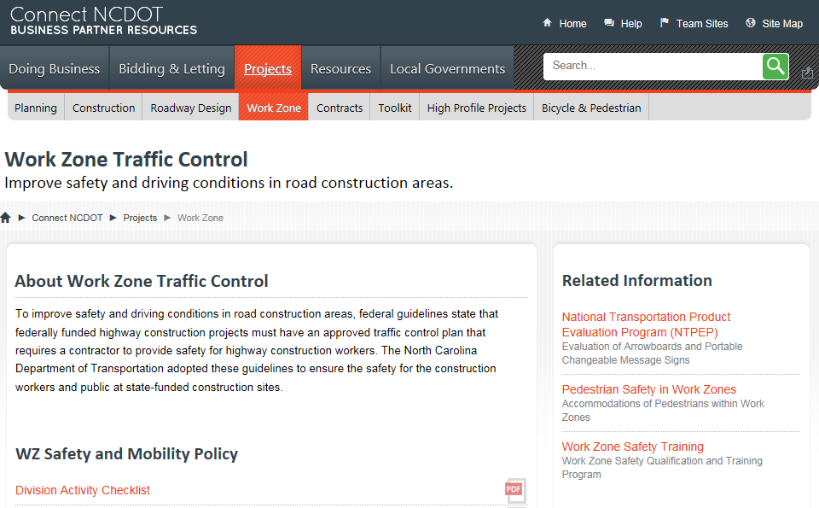

All Sections
This is a CQWP that has been customized to display all pages named "default.aspx" in a site collection. The display includes page title and the page’s short description. The title is linked to the page. Use this web part in the wide left column.
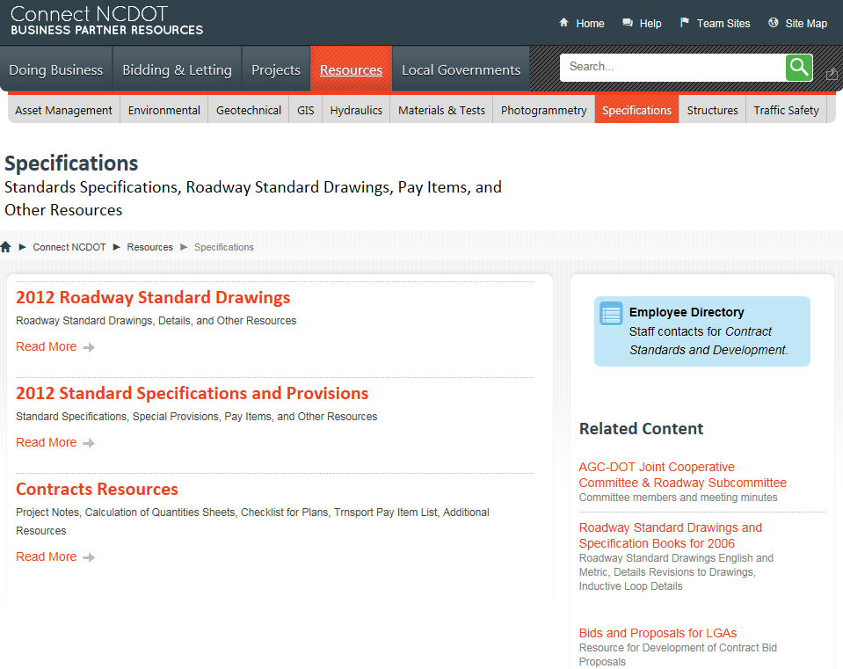

All Sections Narrow
This is a CQWP that has been customized to displays all pages named "default.aspx" in a site collection. The display includes page title and the page’s short description. The title is linked to the page. Use this web part in the narrow right column.

Contact Us
Note: This web part interacts with NCDOT.gov applications. Call or email the Help Desk to request assistance from Web Services
This is a CQWP that has been customized to display staff contacts and a contact form. Use this web part in the narrow right column
The Employee Directory image opens a new window and links to the related staff in the NCDOT Employee Directory.
The Contact Form image opens a new window and links to the NCDOT Post A Comment application on ncdot.gov.

Documents
This is a CQWP that has been customized to display files in a grid, rather than a list. The display includes a large file icon, file title, last modified date, and file size. The icon is linked to the file and has a dramatic hover state. Use this web part only in wide columns.
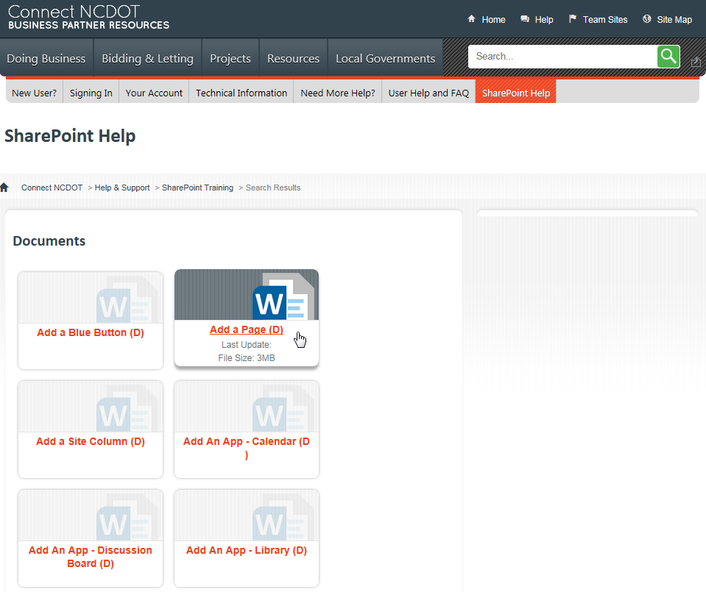

Featured
This is a CQWP that has been customized to list all files in a site collection that have been tagged with the word Featured in the column File Category. The display includes file title, date, and file icon. The title is linked to the file. Use this web part in the narrow right column.
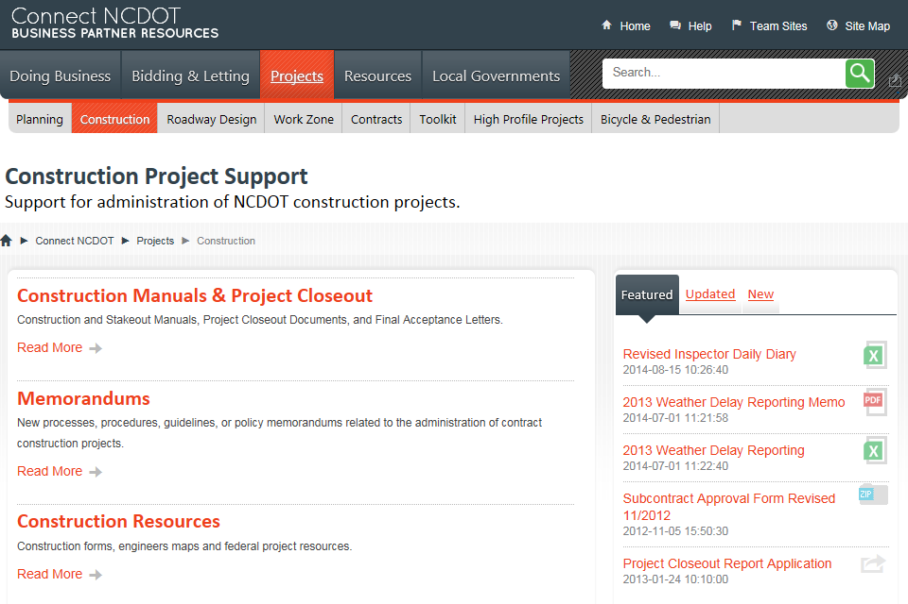

Link List
This is a CQWP that has been customized to combine all links in any link list in the Letting area of Connect. Note that the query starts at /letting/NameOfSubSite, so be sure to change the URL as needed.
The display includes a hyperlinked title and optional description (comment). The link opens in a new window. Use this web part in the narrow right column.
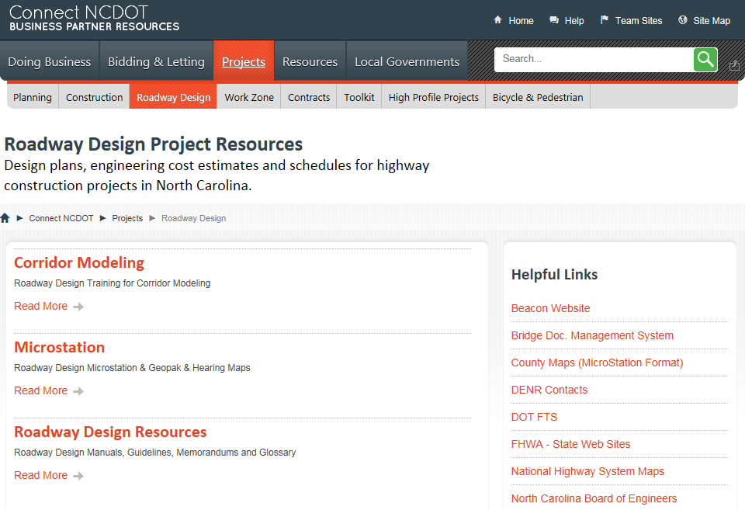

New
This is a CQWP that has been customized to list the five newest files from all libraries in the site collection. The display includes file title, date, and document icon. The title is linked to the file. Use this web part in the narrow right column.
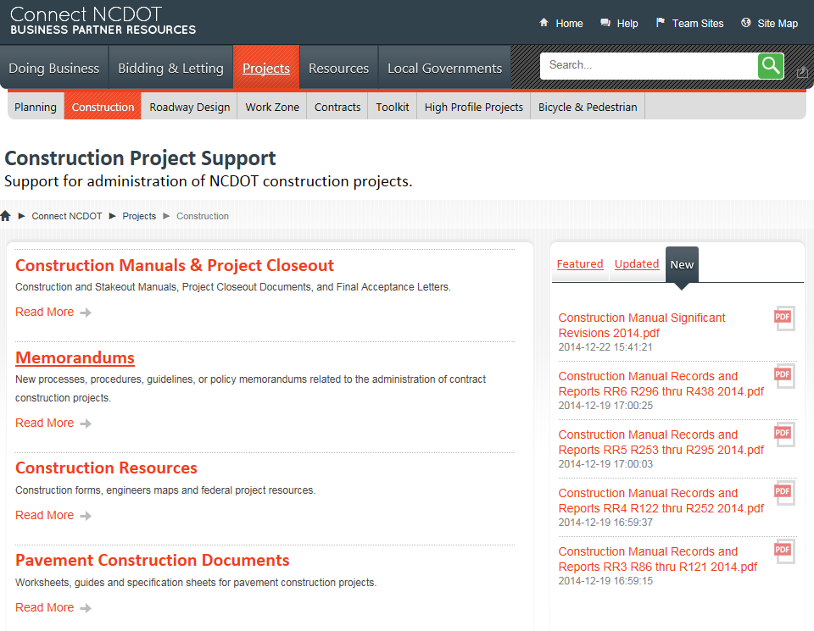

Updated
This is a CQWP that has been customized to list the five most recently updated files from all libraries in the site collection. The display includes file title, date, and document icon. The title is linked to the file. Use this web part in the narrow right column.
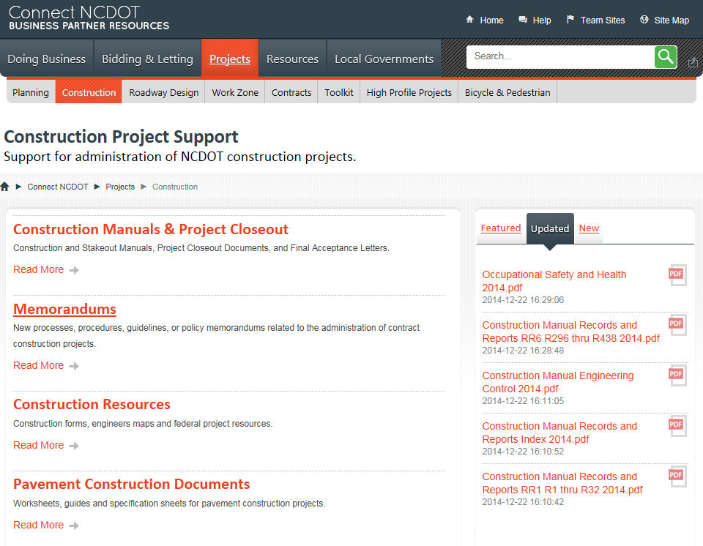

Error Message
If the content query returns a very large number of results, you may exceed the limits for a SharePoint display. If so, you will see this message.
Your query returned a greater number of results than the web application's query throttling limit. Please adjust the configuration of this Web Part or increase the throttling limit.
Edit the web part to reduce the number of results. You can, for example, query one site and its subsites, rather than the entire site collection. Or, you can apply filters to reduce the number of results.

