Edit the Name or Description of a List or Library
Once a list or library is created, you can change its name or description. A name change does not change the address (URL) of the library.
It’s a good idea to avoid spaces when you name a list or library because spaces appear as %20 in the URL, which lengthens the URL and interferes with readability. For example, when you create a library, name it SharedDocuments and then change its name to Shared Documents afterwards.
- Navigate to the list or library.
- On the ribbon, click the LIST or LIBRARY tab. In the Settings group, click List Settings or Library Settings. This example uses a library.
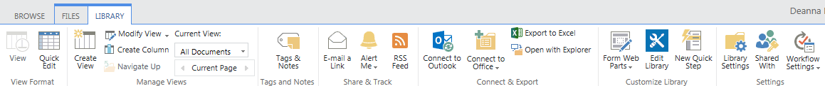
- On the Settings page under General Settings, click List name, description and navigation.
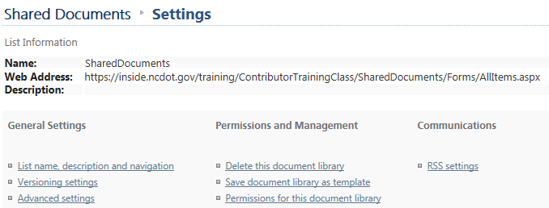
- Change the name, add or modify the description and click Save. The change is immediate.
