Create a New Document
You can add a file to a SharePoint library by creating the file on your computer and uploading, copying, or moving it into SharePoint. But, you can also create a new document directly within SharePoint, as shown in this help file.
Note: Properties are also called metadata. Some properties, such as security level or content type, may be required. It is important that you assign properties correctly.
- Navigate to the library.
- On the ribbon, click the FILES tab. In the New group, click the arrow next to New Document. Click Document from the drop-down.
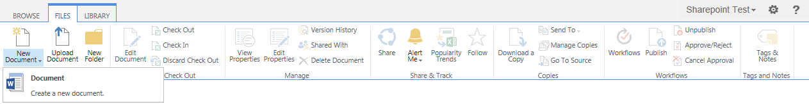Note: There may be different or additional options under New Document. For example, the Word document might be a template that is prepopulated with an outline and boilerplate text or the new document might be an Excel spreadsheet designed to be used as a form.
- If prompted, click OK to trust the file. If prompted, log in.
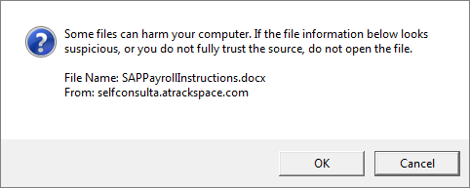

In this example, the template for a new document is an empty Word document. When Word opens, the document information panel (DIP) contains the properties associated with the library. (The DIP is also called Document Properties – Server.)
- Enter appropriate properties for the file in the DIP and add the content for the document.
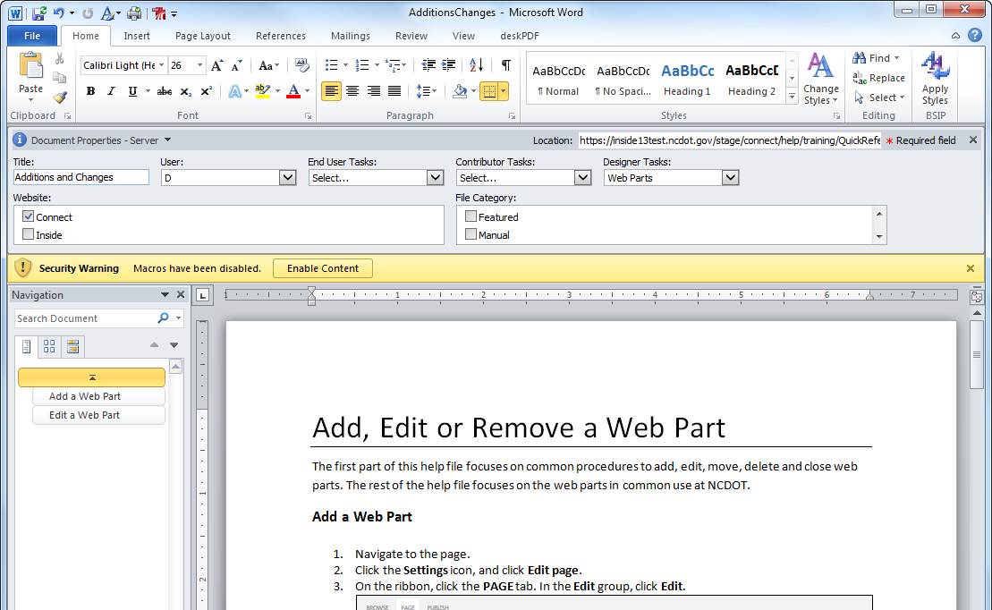
- When your work is complete, save the file, enter a name for the document, and save again. By default, the file is saved in the same SharePoint library where it was created, but you can navigate to a different location to save the file there instead.
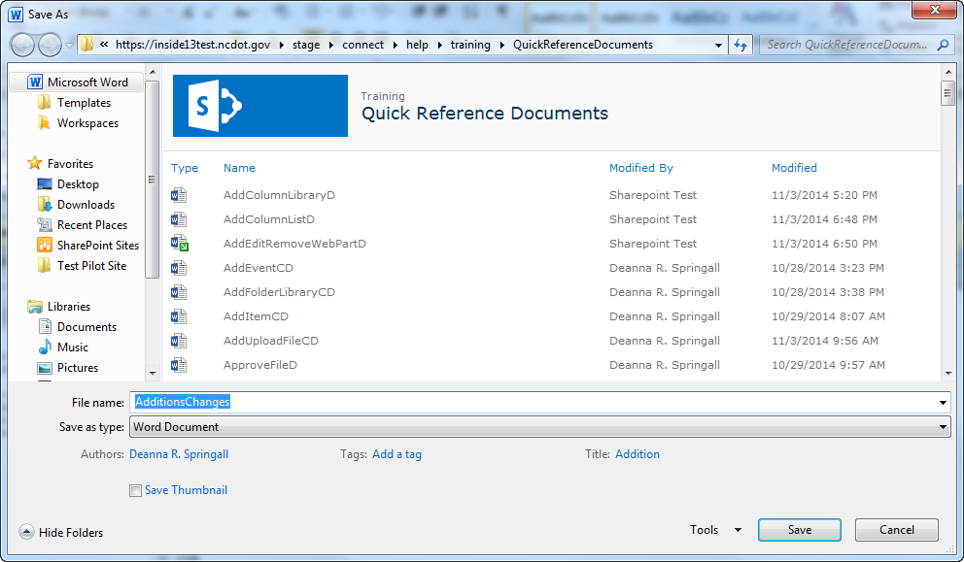The new file is now in the library.
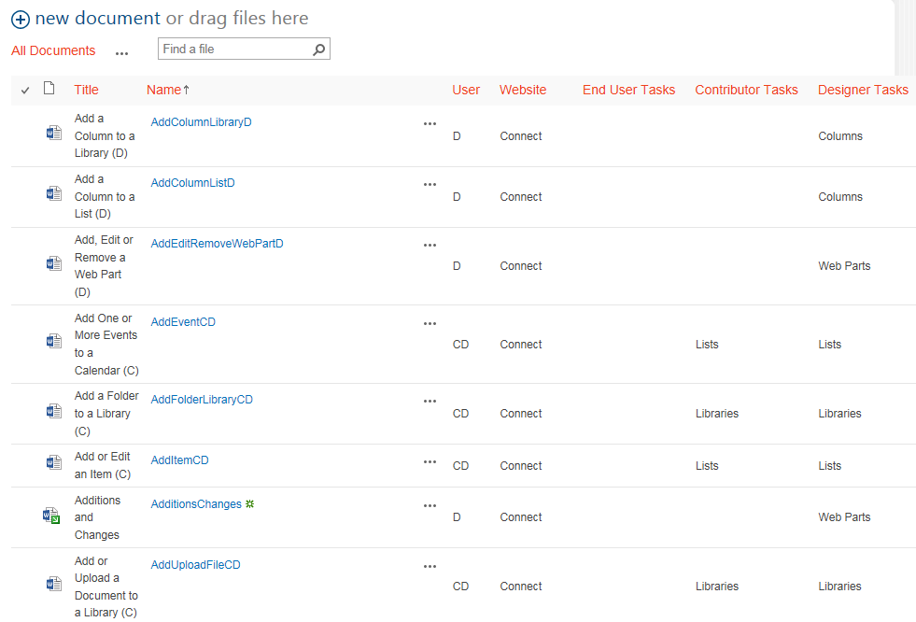The item has a green star to indicate it is new. Remember to check in the file.

