Create and Manage a New Document Set
A document set lets you work on and manage related documents as a group. For example, a document set for a construction project might include a schedule (Word), a set of requirements (Word), a drawing (Visio), and draft specifications (Excel). Templates for each of those documents can include default information and standard fields. This approach gives you a standardized starting point and an outline for your work when you start a new project.
Document sets can be versioned and can have a customized Welcome page.
Because all commands to work with a document set appear within the document set interface, this help file contains information on creating and managing a document set, as well as adding and creating documents within the document set.
Note: A Designer must create a document set template before a Contributor can use document sets.

Contents
Create a Document Set and Add an Initial Document
Add Multiple Documents
Create a New Document for a Document Set
Manage a Document
Manage a Document Set
Document Set Web Parts

Create a Document Set and Add an Initial Document
This section describes how to create a document set and add a single document, while the next section explains how to add multiple documents.
- Navigate to the library.
- On the ribbon, click the FILES tab. In the New group, click the down arrow by New Document, and click the type of document set.
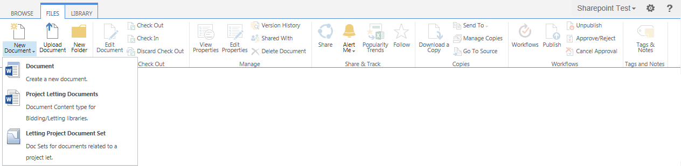
- Enter a name for the document set, complete the other properties, and click Save.
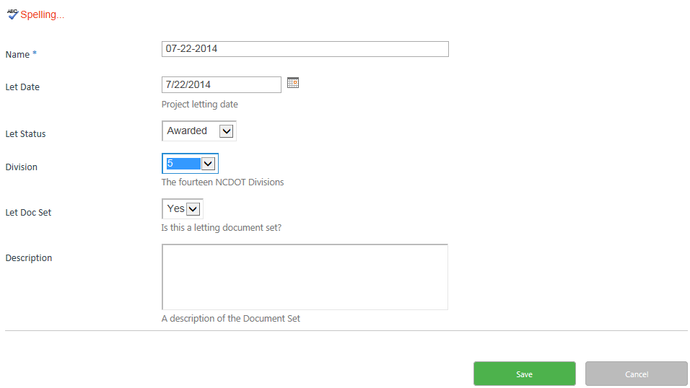
- Click + new document to add a document to the document set.
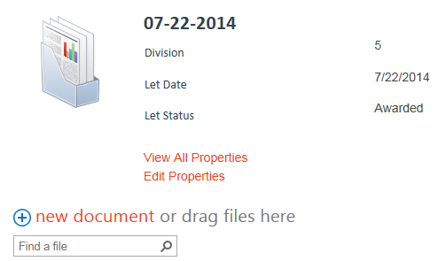

- Click Browse, select a document, click Open, and click OK. The Document Set is actually a folder with unique properties and display options, so the Destination Folder is the document set name.
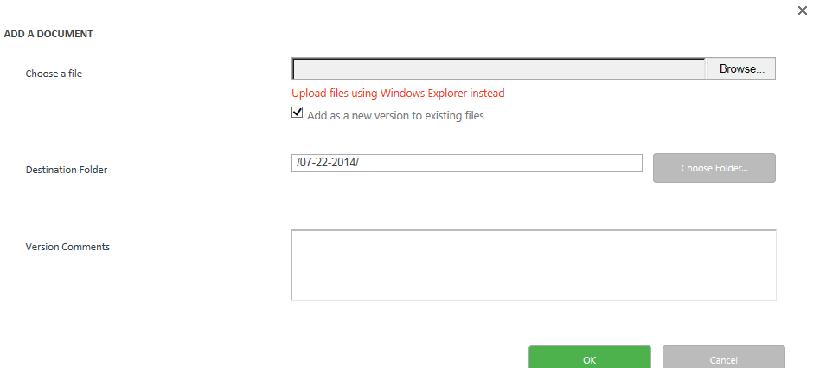
- Enter or confirm the document’s properties and click Save. If needed, check the document in.
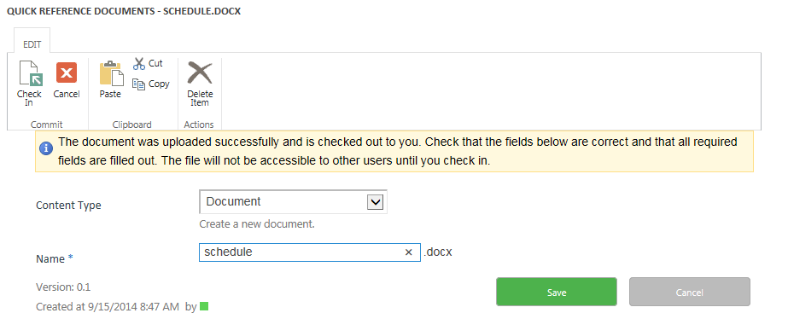The document is added to the document set.
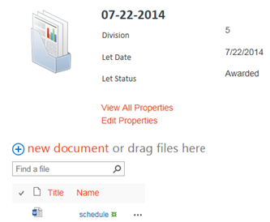

Add Multiple Documents
You can add multiple documents to a document set by using Windows Explorer.
- Navigate to the library that contains the document set and click the document set to open it.
- On the ribbon, click the FILES tab. In the New group, click Upload Document.
- Click Upload files using Windows Explorer instead. A Windows Explorer view of the document set appears. Drag and drop files from your computer.
You can also add multiple documents to a document set by dragging them to the drag files here area.
- Navigate to the library that contains the document set and click the document set to open it.
- Drag and drop files from your computer to the drag files here area.
If you upload multiple documents, you cannot enter individual document properties until the documents have been added. Use the same methods to edit document properties that you would with documents that are not in a document set.
- Select the document by clicking the checkbox next to the name of the document. On the ribbon, click the FILES tab. In the Manage group, click Edit Properties.
- Click the ellipsis next to the name of the document, and click the ellipsis in the callout. In the context menu, click Edit Properties.
- On the ribbon, click the LIBRARY tab. In the View Format group, click Quick Edit so you can quickly enter properties for multiple documents.
- Note that the document set also offers options to View All Properties and Edit Properties.

Create a New Document for a Document Set
You can create a new document within SharePoint and add it to the document set.
- Navigate to the library that contains the document set and click the document set to open it.
- On the ribbon, click the FILES tab. In the New group, click the arrow next to New Document, and click the type of document you need. This example creates a Project Letting Document that is based upon a Word template.
- If prompted, click OK to trust the document. If prompted, log in.

- When Word opens, the document information panel (DIP) contains the properties associated with the library. (The DIP is also called Document Properties – Server.) Enter appropriate values for the document in the DIP and add the content for the document.
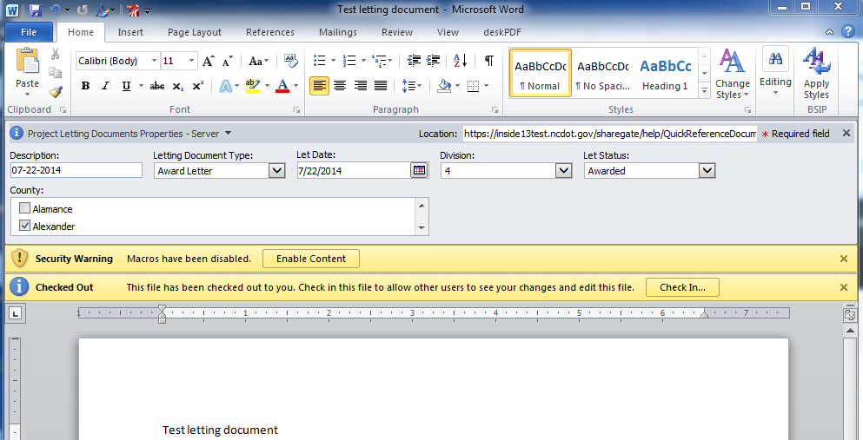
- When your work is complete, save the document, enter a name for it, and save again. By default, the document is saved in the same SharePoint library where it was created, but you can navigate to a different location to save the document there instead.
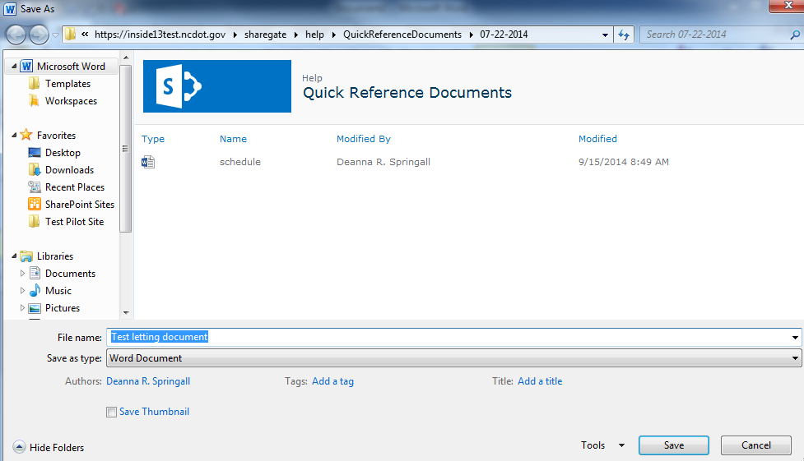
- Check in the document if needed; the document is added to the document set.
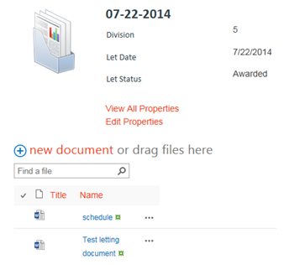

Manage a Document
Documents within a document set can be managed using the same methods as other documents in SharePoint. This example shows how to view document properties.
- Navigate to the library that contains the document set and click the document set to open it.

- Click the ellipsis next to the name of the document, and click the ellipsis in the callout. In the context menu, click View Properties.
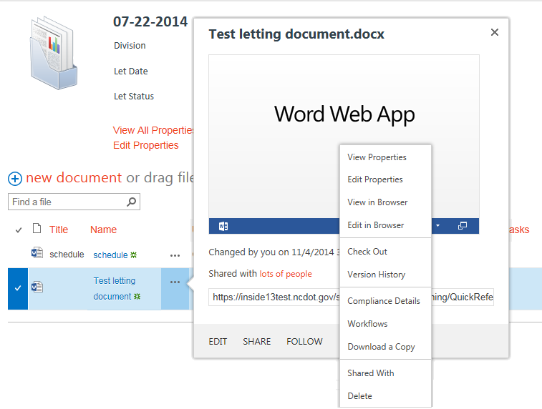The document properties are displayed.
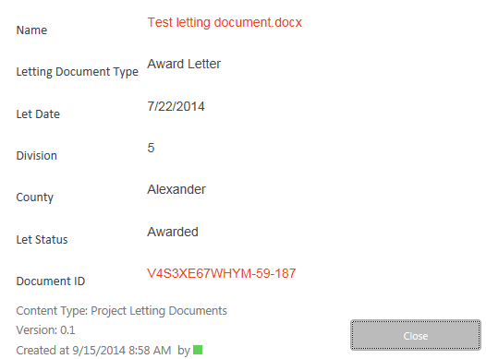
You can also select the document by clicking the checkbox next to the name of the document. On the ribbon, click the FILES tab. In the Manage group, click Edit Properties.

The document set also offers options to View All Properties and Edit Properties.

Manage a Document Set
Once a document set has been created, the ribbon contains a MANAGE tab that offers additional options. This example shows how to edit the properties of the document set.
- Navigate to the library that contains the document set and click the document set to open it.
- On the ribbon, click the MANAGE tab. In the Actions group, click Edit Properties.
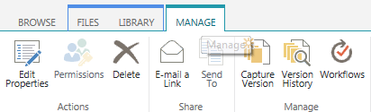
- Update the properties of the document set as needed, and click Save.
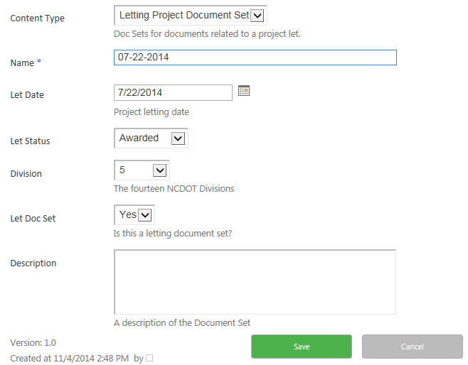

Document Set Web Parts
If you are a Designer, this section describes additional details about web parts for document sets. When a document set is created, a web parts page is automatically created to display the properties and contents of the document set.
- Navigate to the library containing the document set and click the document set to open it.
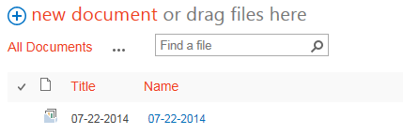

The document set page contains a document set image, the Document Set Properties web part (containing the properties of the document set), and the Document Set Contents web part (containing the documents in the document set).
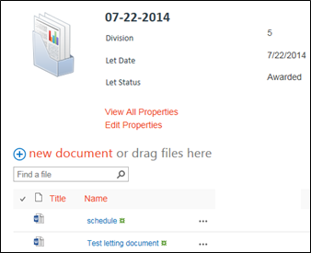
- Click the Settings gear, and click Edit page.
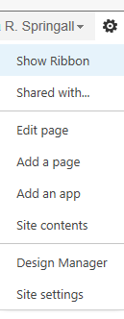
Notice the web parts on the page.
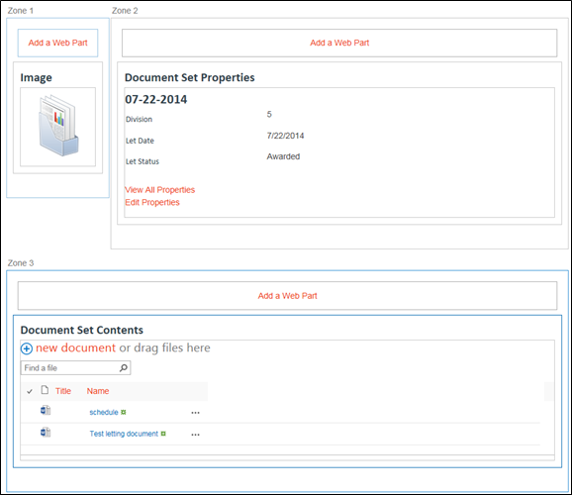See the help file for Add, Edit or Remove a Web Part for more information on web parts.

