Create a New Event in a Calendar
Calendars are a popular and often-used feature of SharePoint. If you are familiar with Outlook calendars, you will find much the same here.
If you have connected SharePoint to Outlook and are a Contributor or Designer, you can add event(s) to the SharePoint calendar in Outlook. See the help file for Connect (Overlay) a SharePoint Calendar to Outlook.

Contents
Add an Event or a Recurring Event
Add a Single Event
Add Multiple Events

Add an Event or a Recurring Event
- Navigate to the calendar.
- Hover over or click a day in the calendar, and click +Add.
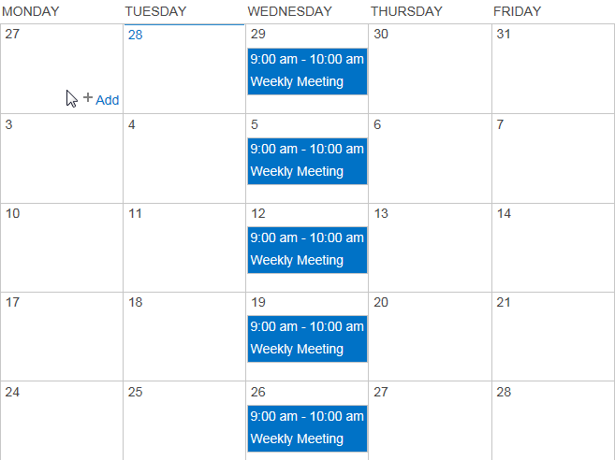
- Enter the title and the start and end times. Complete other properties as needed, and click Save.
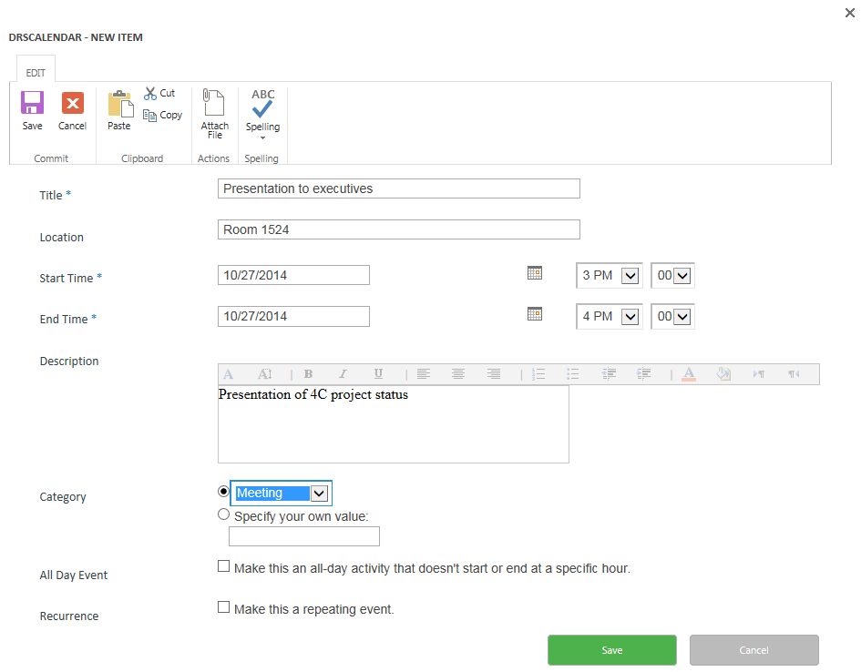
- For a recurring event, click Make this a repeating event.
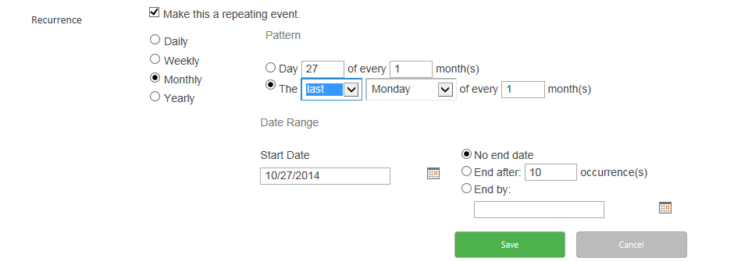
- Define the recurrence pattern as you would in Outlook, and click Save. The options will vary depending upon whether you are defining a daily, weekly, monthly or yearly recurring event.
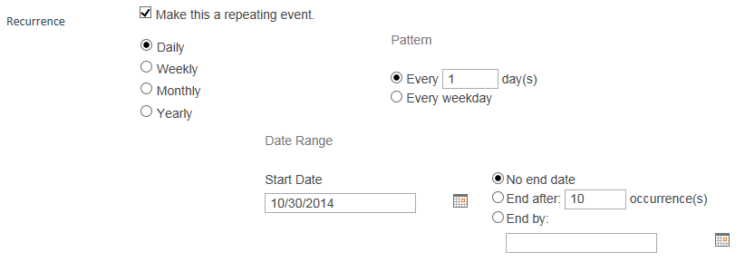

Add a Single Event
- Navigate to the calendar.
- On the ribbon, click the CALENDAR tab. In the Manage Views group, click the Current View drop-down. Under Public, click All Events to display the calendar in a list view.
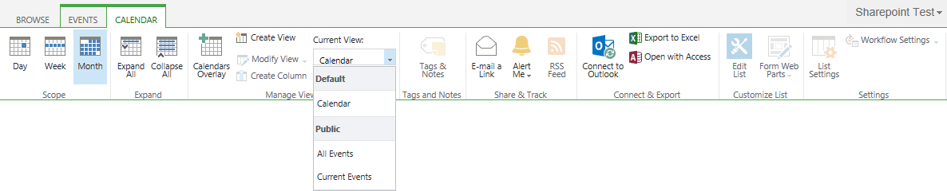
- Click + new event to add a single event.
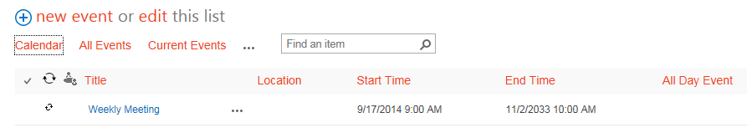

- Enter the title and the start and end times. Complete other properties as needed, and click Save.
- On the ribbon, click the CALENDAR tab to return to the calendar view. In the Manage Views group, click the Current View drop-down. Under Default, click Calendar.

Add Multiple Events
Note: You cannot set recurring events using this method. Open the individual items after they are created to define their recurrence. If the calendar contains columns that are not displayed in the view, you cannot edit them unless you change the view.
- Navigate to the calendar.
- On the ribbon, click the CALENDAR tab. In the Manage Views group, click the Current View drop-down. Under Public, click All Events to display the calendar in a list view for easier editing.
- Click edit this list to open a spreadsheet view that lets you enter multiple events.
- Enter the title and the start and end times for the first event. Complete other properties as needed. Repeat this step for as many events as you need to enter. If you do not enter a start and end time, it defaults to the current time.
- When your work is complete, click Stop editing this list.
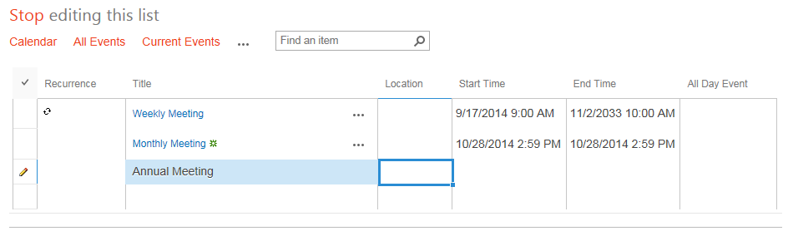
- On the ribbon, click the CALENDAR tab to return to the calendar view. In the Manage Views group, click the Current View drop-down. Under Default, click Calendar.

