Enable the New Folder Command in a Library
The New Folder command lets a Contributor add folders to a library. This option is usually available in all of Inside NCODT and in all of Connect NCDOT except for the unauthenticated (public) area. If the command has been disabled, you can enable it.
Note: Use of folders in lists, while possible, is discouraged and generally disabled.
- Navigate to the library.
- On the ribbon, click the LIBRARY tab. In the Settings group, click Library Settings.
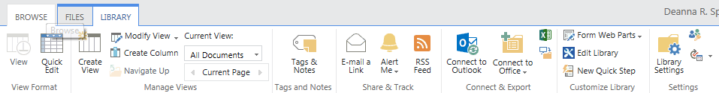
- On the Settings page in the General Settings column, click Advanced Settings.
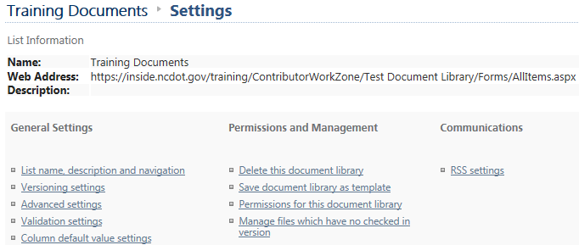
- Scroll to the Folders area, click Yes to turn on the New Folder command.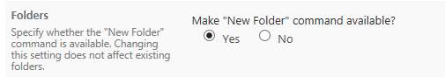
- Click OK to save the change.

