Create a New Folder in a Library
On a shared drive, folders are a commonly used feature to organize files. In SharePoint, they are an easy and familiar way to work with a large number of files in a library.
Adding a folder to a library is very similar to adding a file to the library, although you cannot drag folders to upload them. Once a folder is created, you can use the standard methods to add files to or create new files in the new folder.
Note: If content approval is enabled, the folder remains in Pending status until it is approved.
Note: If the New Folder option is grayed out in the ribbon, ensure that you have Contributor or Designer permissions; Designers can enable folder creation if it is not available.

Contents
Create a Folder
Move a File into a Folder

Create a Folder
- Navigate to the level of the library where you want to add the folder.
- On the ribbon, click the FILES tab. In the New group, click New Folder.
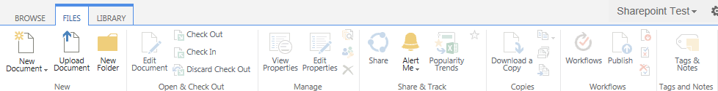
- In the CREATE A NEW FOLDER dialog, enter the name for the new folder and click Save.
- The new folder appears in the library. Click the new folder name to open it.

Move a File into a Folder
- To move a file within the library, drag the file to the folder, and release it when you see Move.
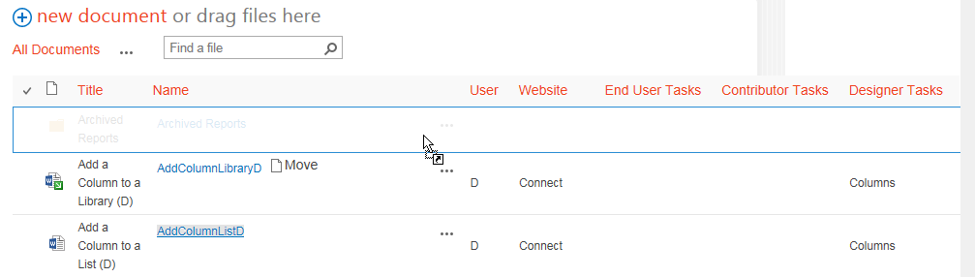
- Open the folder and confirm the document has been moved.
