Create a New Item
Each item has standard properties, such as name and title, and may have custom properties, such as district or department. When you add a new item, some properties may be required. You also have options to check spelling and to attach files; see the help file for Attach a File to an Item.
Methods in this help file describe how to add individual items one at a time. The Quick Edit feature is a much more efficient way to add multiple items at the same time; see the help file for Quick Edit.

Contents
Add an Item – Method 1
Add an Item – Method 2

Add an Item – Method 1
- Navigate to the list.
- Click + new item at the top of the list.
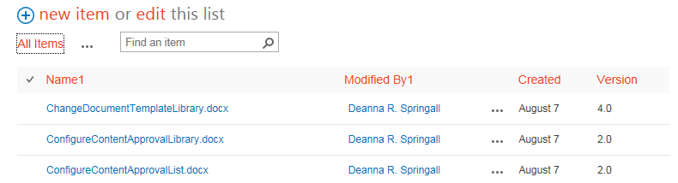
- Complete the details for the new item. In some cases, you may need to click Show More. When you complete your work, click Save at the bottom of the page or in the ribbon.
The item has a green star to indicate it is new.
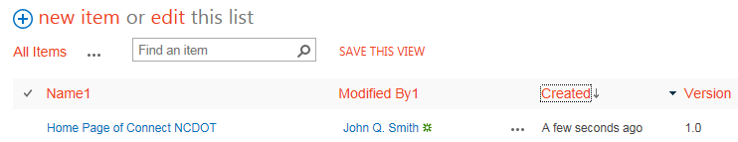

Add an Item – Method 2
- Navigate to the list.
- On the ribbon, click the ITEMS tab. In the New group, click New Item.
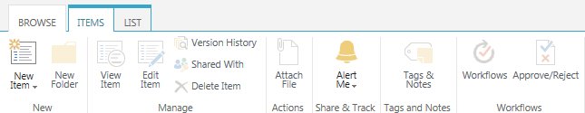
- Continue with Step 3 in the previous section.

