Edit Document Properties in Office
The Document Information Panel is a panel at the top of an Office document that displays properties used in the SharePoint library. You can choose to edit these properties in an Office application without opening SharePoint.
These processes are identical for Excel, PowerPoint and Word. In this help file, the examples use Word.

Contents
Edit Properties in the Document Information Panel
Edit Properties in the Properties Pane

Edit Properties in the Document Information Panel
- Open the document in Word.
- On the ribbon, click the File tab. In the left pane, click Info. In the right pane, click Properties.
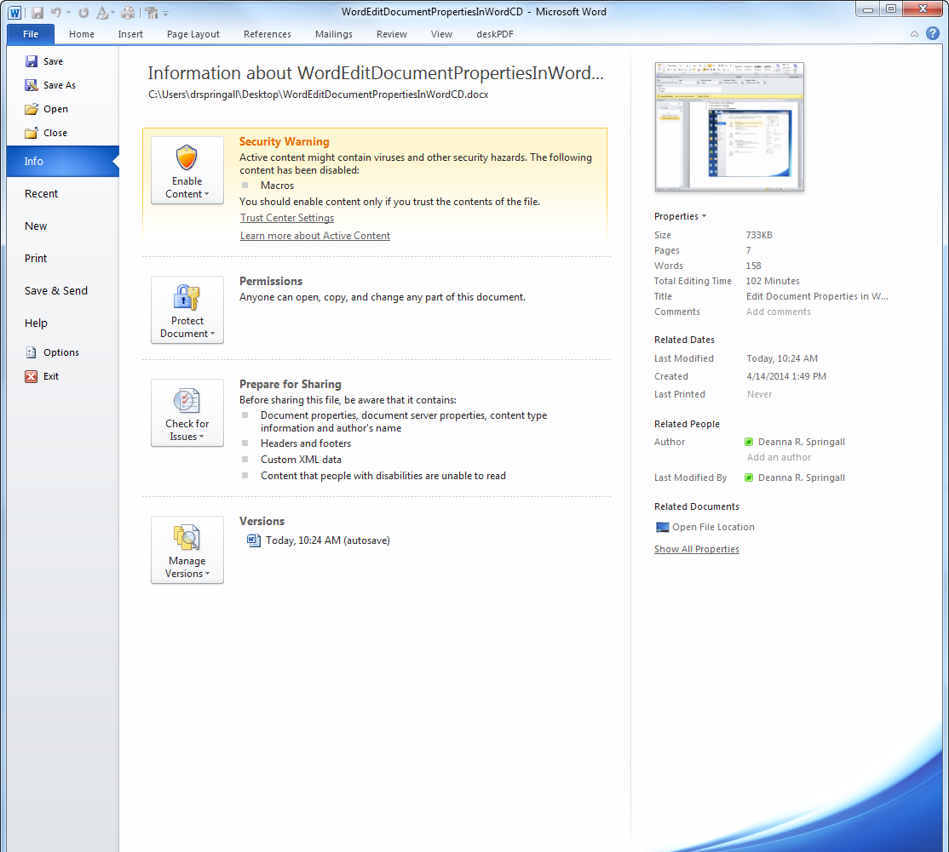
- Click Show Document Panel.
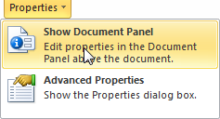
- Define the required properties (noted with an asterisk) and complete as many optional properties as you can.
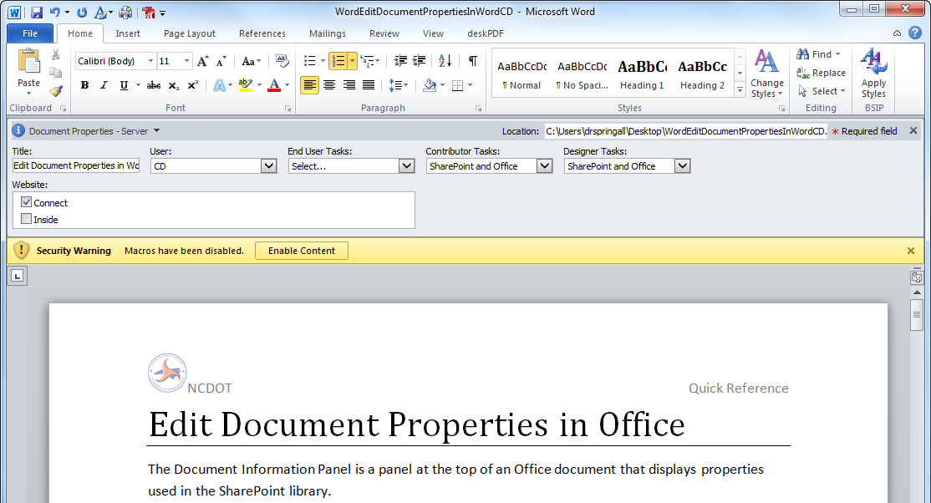
- Save the document.

Edit Properties in the Properties Pane
- Open the document in Word.
- On the ribbon, click the File tab. In the left pane, click Info. In the right pane, click Show All Properties to see more properties.
- To add or change properties, click the property you want to update and enter the information.
- Click the File tab to return to your document.
- Save the document.

