Open and Check Out a File in Office
You can use Office to work with a file in a SharePoint library without opening SharePoint.
These processes are identical for Excel, PowerPoint and Word. In this help file, the examples use Word.
Note: If you have not done so, connect the SharePoint library to your Office applications. See the help file for Connect to Office.

Contents
Open a Document
Check Out a Document That Is Already Open

Open a Document
- On the ribbon of the Office application, click the File tab. Click Open.
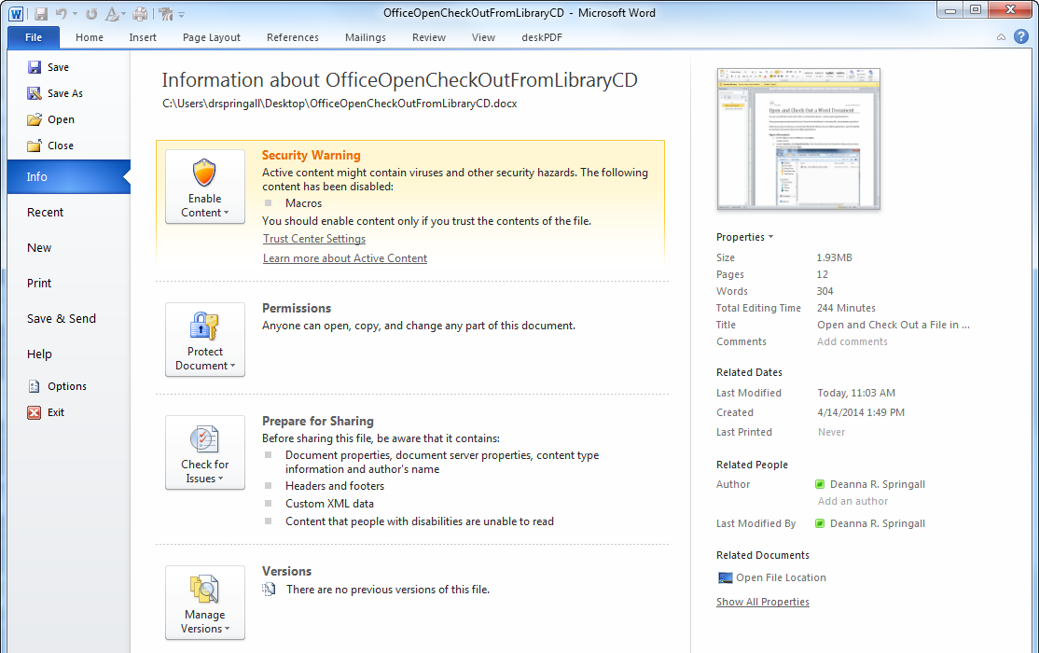
- Under Favorites, click SharePoint Sites. Click the shortcut to the SharePoint library that contains the document and click Open.
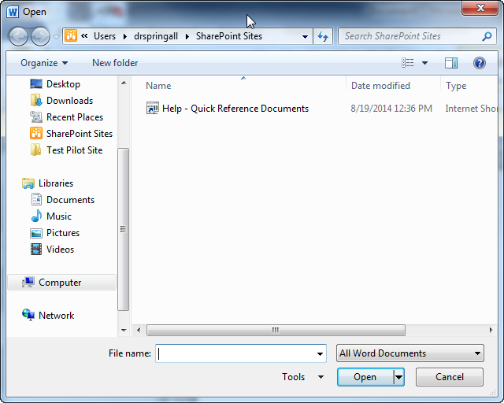Alternatively, you can enter a URL for the library in the File Name text box – but exclude Forms/AllItems.aspx. For example, use https://inside.ncdot.gov/help/QuickReferenceDocuments, but not https://inside.ncdot.gov/help/QuickReferenceDocuments/Forms/AllItems.aspx.
- Click the name of the document and click Open.
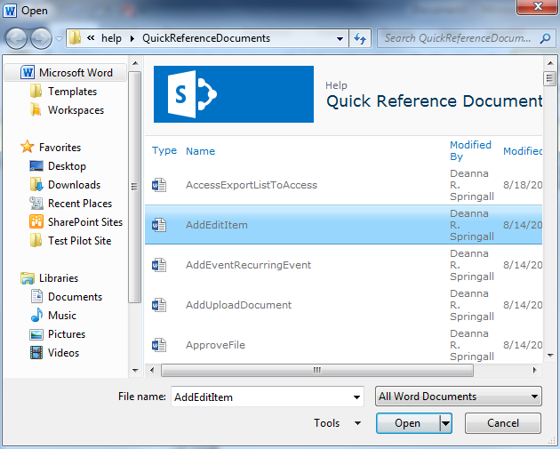If you want to open a document in another library, you can use this dialog or the address bar to navigate from one library to another.

If you do not need to make changes to the document, open it as read-only. Click the arrow on the Open button, and click Open Read-Only.
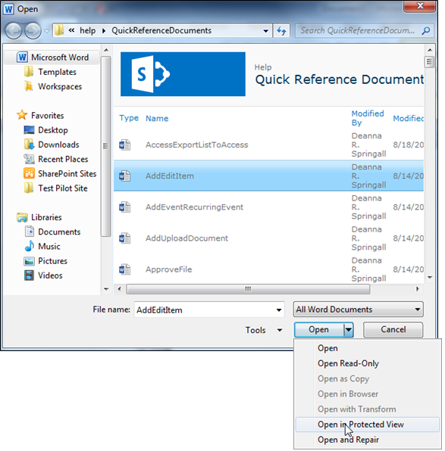
- Check out/check in is enabled on most libraries, so click the Check Out button to edit the document.
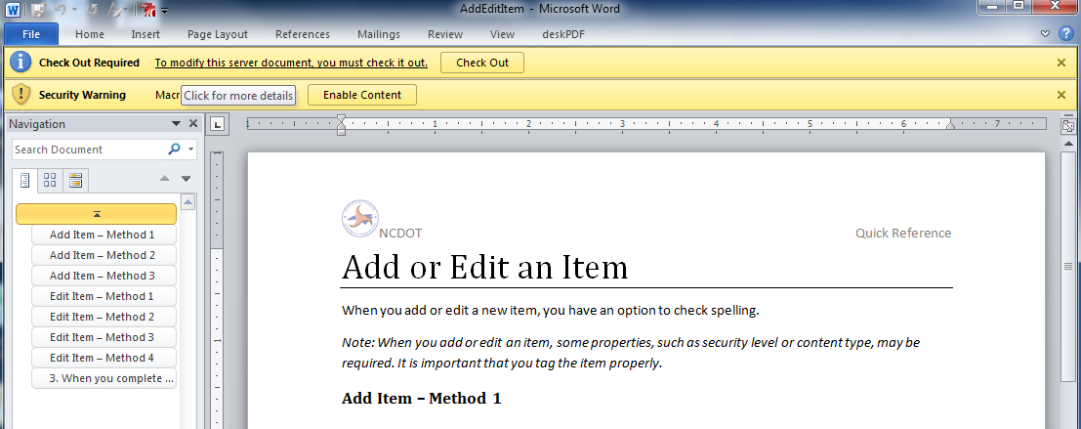
- When you finish your work, save and check in the document so others can see your changes.

Check Out a Document That Is Already Open
Even if check out/check in is not required, you may want to check out a document to ensure that no one else can make changes while you are working on it.
- Click the File tab, click Info, and click Manage Versions.
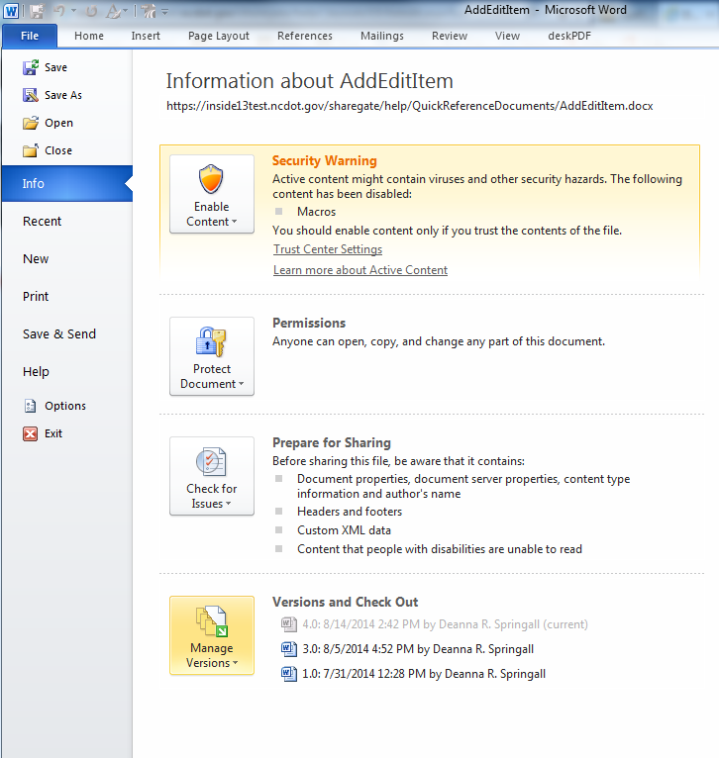
- Click Check Out.
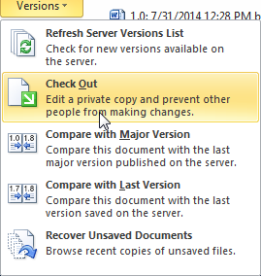
- When you finish your work, remember to save and check in the document so others can see your changes.

