Open a File
You can open a file from SharePoint in its associated application; generally, the applications are Office products such as Word, Excel, PowerPoint, etc.

Contents
Open File in SharePoint
Open File from Office Application

Open File in SharePoint
- Navigate to the library.
- Click the name of the file to open it.
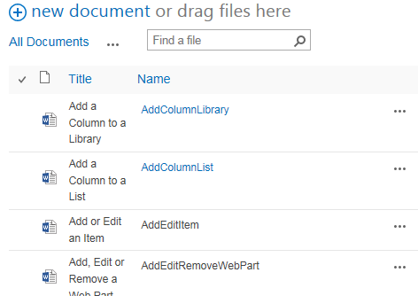
- You may be prompted to trust the file, log in, open the file, and/or enable content.
Office files (Word documents, Excel spreadsheets, PowerPoint presentations) open in read-only mode in the Office application. PDFs usually open in a browser window.
- Once the file is open, you can save it to your computer if needed.
  - In the Office application, click File and click Save As.
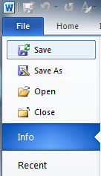
  - Save a PDF by hovering over the bottom of one of its pages and clicking the Save icon.
- Navigate to a location on your computer, and click Save.
Note: You must be a Contributor or Designer to check out and modify the document. End Users see an error message if they attempt this.

Open File from Office Application
Note: You must first connect the SharePoint library that contains the file you need to your Office applications. See the help file for Connect to Office.
- Open the office application.
- Click the File tab, click Open, click SharePoint Sites, and click the shortcut for the SharePoint library.
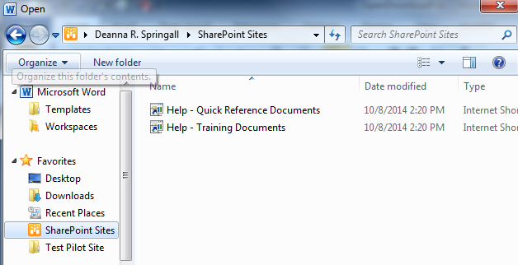or
Click the File tab, and click Recent to see if the SharePoint library containing the file is in the list.

- Double-click the name of the library to open it, and click the name of the file to open.

- You may be prompted to trust the file, log in, open the file, or enable content.
The file opens in read-only mode in the Office application (Word, Excel, PowerPoint).
- Once the file is open, you can save it to your computer. In the Office application, click File, click Save As, navigate to a location on your computer, and click Save.

