Open a Page in Maintenance View
Use the Web Part Maintenance Page to troubleshoot corrupted or problematic web parts. The maintenance page lets you close, reset or delete any or all web parts at the same time so you do not have to open each one individually.
If you are not sure which web part is causing problems, close the web parts one by one to identify the problem.
- Navigate to the page.
- On the ribbon, click the PAGE tab. In the Manage group, click Edit Properties. If prompted, check out the page.
- Scroll to the bottom of the Properties page, and click Open Web Part Page in maintenance view. 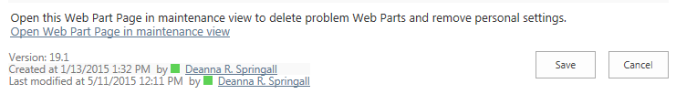
- The maintenance view appears. By default, you are editing the shared view (seen by all users); click Switch to personal view only if you have created a personal view of the page and you wish to edit that.
- Select one or more web parts by clicking the checkbox next to their title, or click Select All for all web parts.
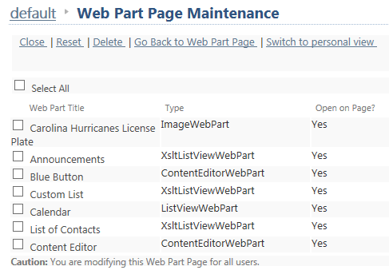
- Close, reset or delete the web part(s).

  - Close – Removes the web part from being displayed on the page, but keeps it (and any customizations you did) available so you can add it back to the page. This example shows that the List of Contacts has been closed.
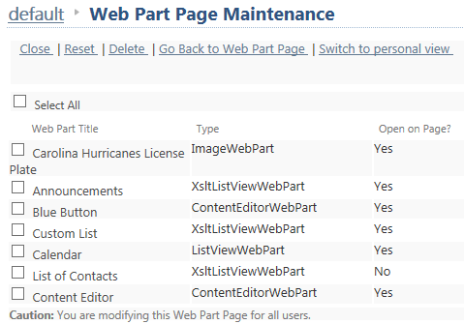
To add a closed web part back to the page, open the page for editing and add a web part. You will find closed web parts under the Closed Parts category in the web part gallery.
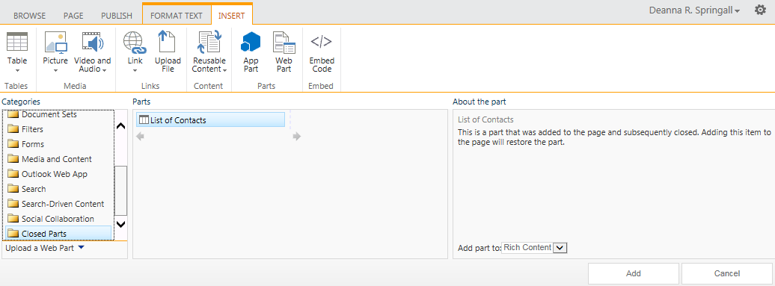
  - Reset – Overrides all personalized settings for all users and changes them back to the standard (shared) values.
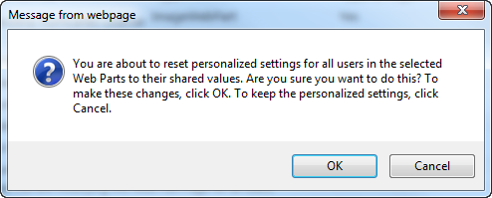
  - Delete - Removes the web part permanently from the current page; you will lose any customizations. The part is remains available in the web part gallery..
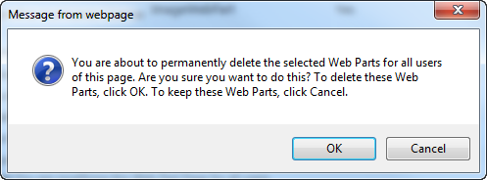
- Click Go Back to Web Part Page when you are finished.

