Open Library with Explorer
The Windows Explorer view is useful when you need to work with multiple files. For example, you may need to copy several files to your computer or send several files to someone outside the SharePoint environment.
End Users can copy a file from SharePoint to their computer, while Contributors and Designers can copy, move or delete files within SharePoint.
Use Ctrl+Shift and click to select multiple contiguous files or Ctrl and click to select multiple, non-contiguous files.
Note: When you copy a file to your computer, the source file remains in SharePoint. The two files are not synchronized.
Note: You can use Explorer to print multiple files from the same application. Select files with the same format (all .docx, all .xlsx, all .pptx, etc.), right-click, and click Print.
- Navigate to the library.
- On the ribbon, click the LIBRARY tab. In the Connect & Export group, click Open with Explorer.
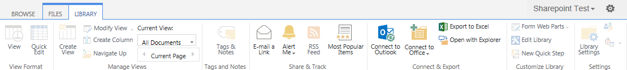
- If prompted, log in. The library is displayed in the traditional Windows Explorer view.
