View the History of a Page
If versioning is turned on, a version is created whenever a page is edited. The history lists the versions of the page, the date and time the version was created, and any comments that describe the changes.
Many pages on Inside NCDOT and Connect NCDOT contain only web parts. Because page history does not track changes within web parts, you may not see as many changes as you’d expect.
- Navigate to the page.
- On the ribbon, click the PAGE tab. In the Manage group, click Page History to see the preceding page versions.
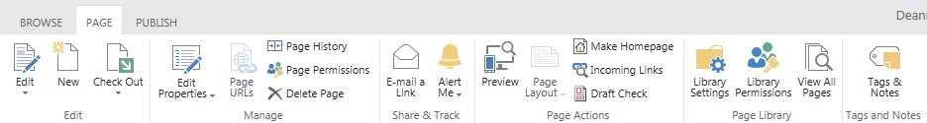
- Click Version History to see more details of the revisions over time
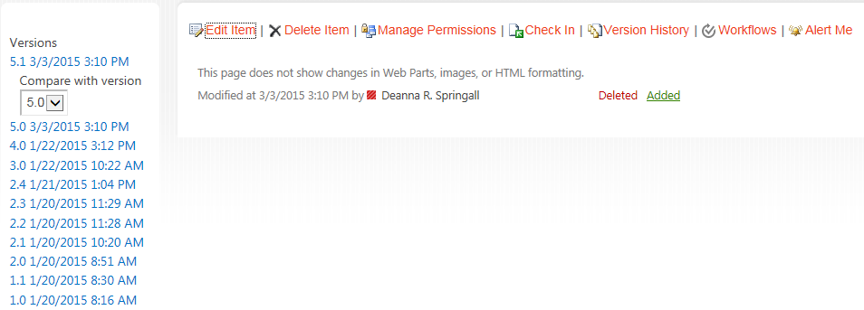

In this example, the Title was changed in Version 1.0. Other changes between Version 1.0 and the current version must have occurred in web parts, images, or HTML formatting because no information exists to document the revisions.
