View Popularity Trends for an Item
SharePoint tracks and reports item usage; you can review what items have the most views, the most unique views, and are most recommended.
- Navigate to the list and select the item.
- On the ribbon, click the ITEMS tab. In the Share & Track group, click Popularity Trends.
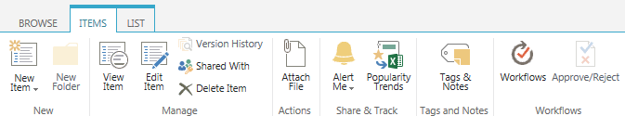
- You are prompted to open or save an Excel spreadsheet for easy analysis of popularity trend date.
The spreadsheet displays statistics such as daily and monthly views, hits and unique users.
