View Popularity Trends for a Page
SharePoint tracks and reports page usage; you can review what pages have the most views and the most unique users. This option may not be available on all pages.
- Navigate to the page.
- On the ribbon, click the PAGE tab. In the Share & Track group, click Popularity Trends.
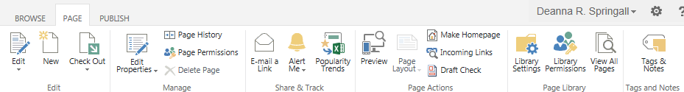
- Open or save the Excel spreadsheet to see the popularity trend data.
The spreadsheet displays statistics such as daily and monthly hits and unique users.
