Use Quick Edit to Change a Library
Quick lets you “bulk edit” so you can efficiently change the properties of many files at one time. You will find this far more efficient than editing one file at a time.
Note: Designers can rename columns and can add a column by clicking the plus in the upper right of the grid. It is not displayed here.

Contents
Open Quick Edit
Edit File Properties
Delete a File
Limitations

Open Quick Edit
- Navigate to the library.
- On the ribbon, click the LIBRARY tab. In the View Format group, click Quick Edit.
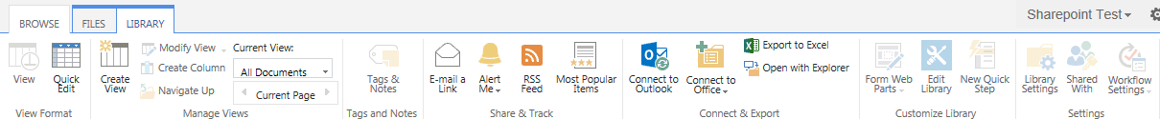The view changes to a spreadsheet format.
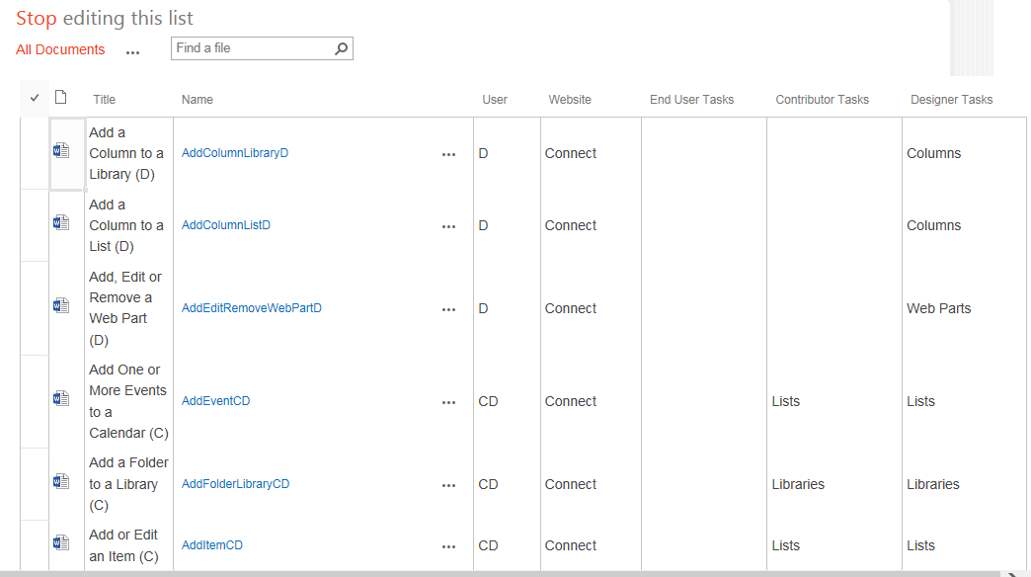

Edit File Properties
Note: If checkout is enabled, you must check out the items before you can use Quick Edit.
Edit the cells as you would in Excel. You can copy and paste from Excel. When you complete your work, click Stop editing this list.
Here are several methods to use Quick Edit. You can pick a value from a drop-down. Columns defined as dates have a date picker.
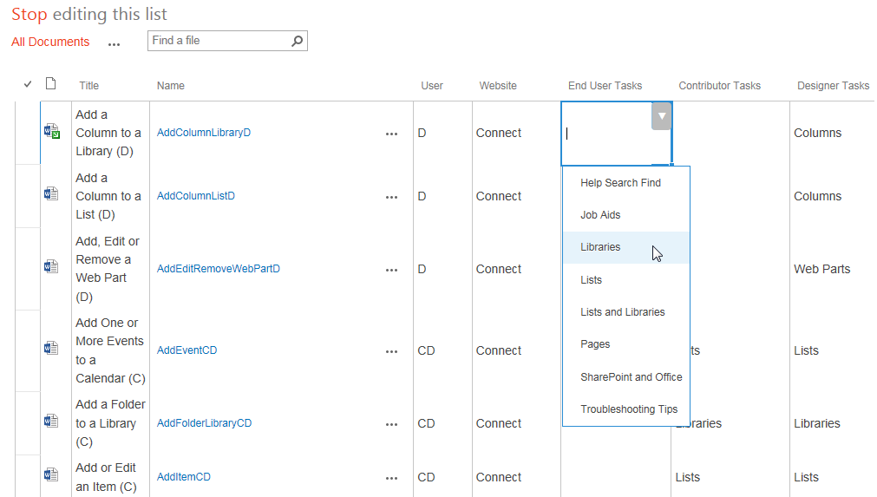
You can drag to copy. Highlight the correct value. The bottom right of the cell has small bar. Drag the Auto Fill handle down or over to copy the value to other cells.
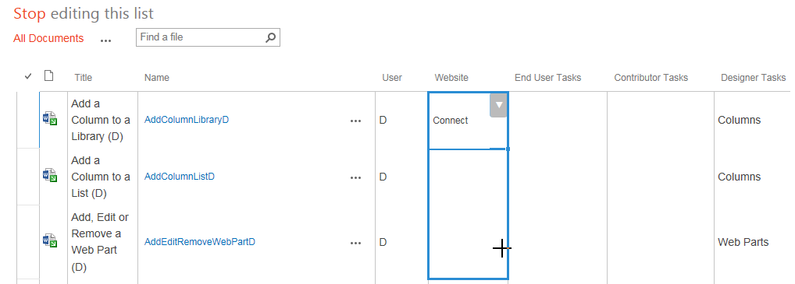
You can copy the value in a cell (Ctrl + C), highlight the destination cell(s) for the value, and press Ctrl + V to paste.
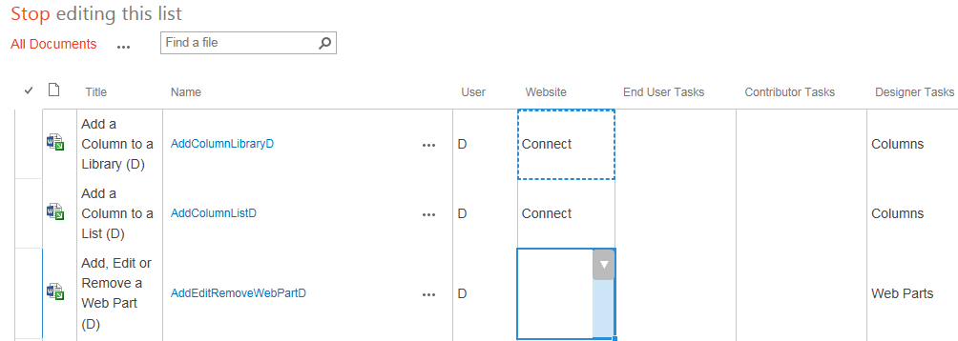

Delete a File
- Select one or more files by clicking the checkbox column next to the names of the files. Press Delete and click OK to confirm.
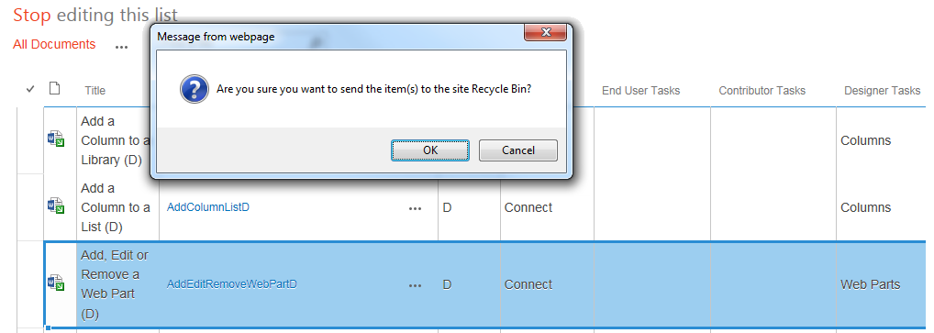
- You can delete an individual value by highlighting it and pressing Delete. When you complete your work, click Stop editing this list.

Limitations
These are issues and problems you might experience.
- If you receive the error message Unable to communicate with server, you are likely trying to edit too many records. Work with less than 100 records at a time.
- Be careful with bulk editing because Quick Edit does not have an undo capability. It is easy to accidentally overwrite a lot of data using Auto-fill.
- When you enter data in a cell, SharePoint often “loses” the first letter. Check your entries to ensure they are complete.
- You can only edit the current view. If the library contains columns that are not in the current view, you cannot edit them unless you change the view.
- You cannot edit content types, custom columns, or rich text columns.
- You cannot edit a library that is in a grouped view.
- You cannot edit a library that uses anything but the Default style. Quick Edit is not available if the list uses the Basic Table, Document Details, Newsletter, Newsletter no lines, Shaded, or Preview Pane style.
- You cannot add or upload files using Quick Edit – you can only change their properties.
Before using Quick Edit, create some type of backup by turning on versioning or by exporting the list to Excel. You can also work around these limitations by simply editing individual, rather than multiple, items.

