Use Quick Edit to Change a List
Quick Edit lets you can add multiple items to a list at the same time as well as edit the properties of multiple items at the same time. You will find this far more efficient than adding or editing one item at a time.
In this example list, division and region are automatically assigned based upon the county and midpoint is a calculated column, based upon the start date and an end date (that is not displayed); thus, those properties cannot be added or edited.
Note: Designers can rename columns and can add a column by clicking the plus in the upper right of the spreadsheet. It is not displayed here.

Contents
Open Quick Edit – Method 1
Open Quick Edit – Method 2
Add One or More Items
Edit One or More Items
Delete an Item
Limitations

Open Quick Edit – Method 1
- Navigate to the list.
- Click edit this list.
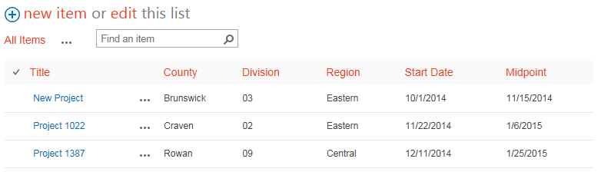The view changes to a spreadsheet format.
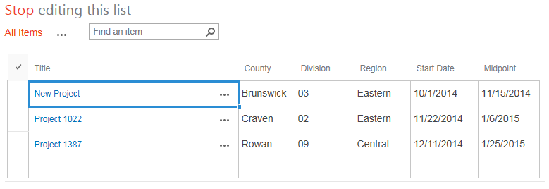

Open Quick Edit – Method 2
- Navigate to the list.
- On the ribbon, click the LIST tab. In the View Format group, click Quick Edit.
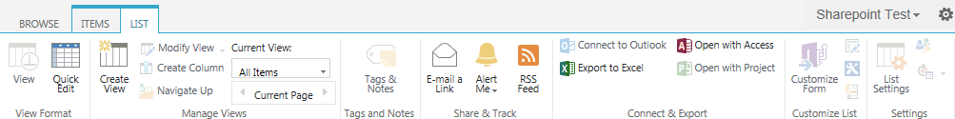The view changes to a spreadsheet format.

Add One or More Items
- Navigate to the list and open Quick Edit. The view changes to a spreadsheet format. At the bottom is an empty line where you can add new items.
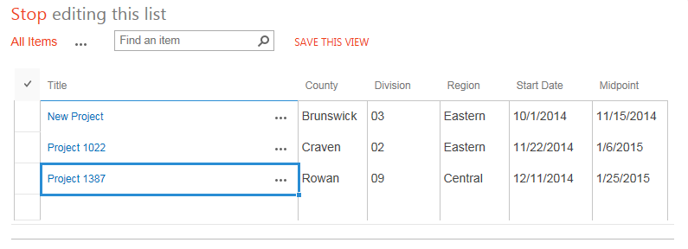
- Add the details for the new item, and add as many additional items as needed. You can copy and paste from Excel. When you complete your work, click Stop editing this list.
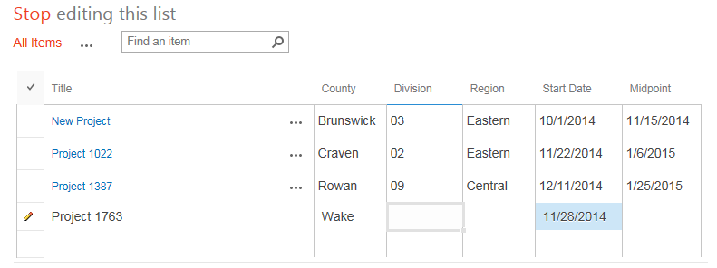
The item has a green star to indicate it is new.
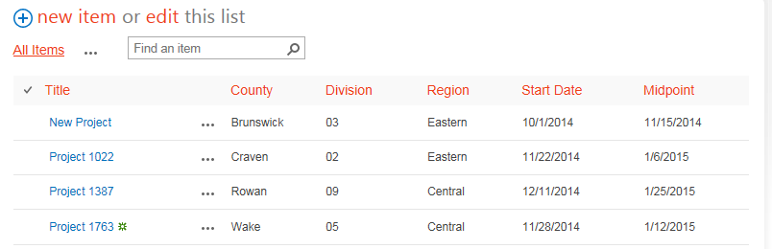

Edit One or More Items
Note: If checkout is enabled, you must check out the items before you can use Quick Edit.
Edit the cells as you would in Excel. You can copy and paste from Excel. When you complete your work, click Stop editing this list.
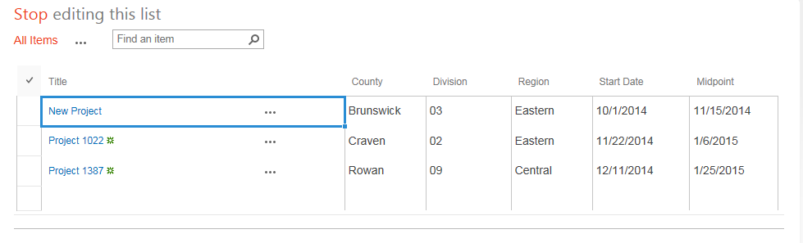

Here are several methods to use Quick Edit. You can pick a value from a drop-down. Columns defined as dates have a date picker.
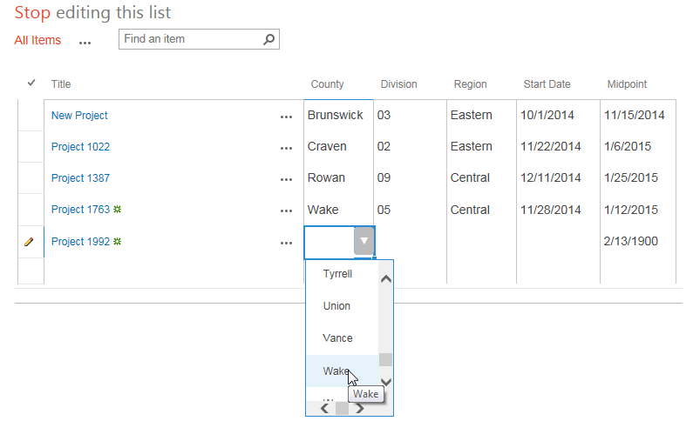
You can drag to copy. Highlight the correct value. The bottom right of the cell has small bar. Drag the Auto Fill handle down or over to copy the value to other cells.
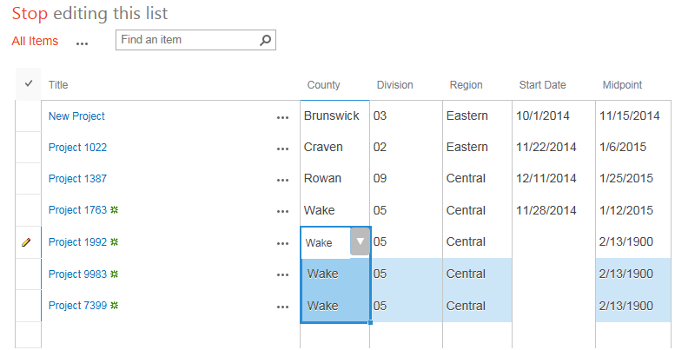

You can copy the value in a cell (Ctrl + C), highlight the destination cell(s) for the value, and press Ctrl + V to paste.
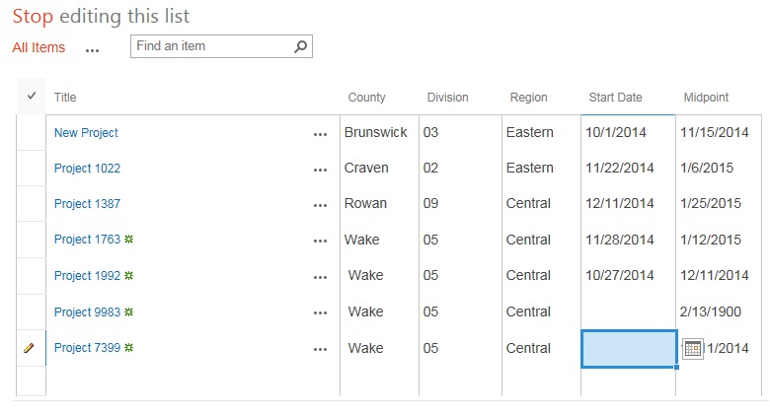

Delete an Item
- Select one or more items by clicking the checkbox column next to the titles of the items. Press the Delete key and click OK to confirm.
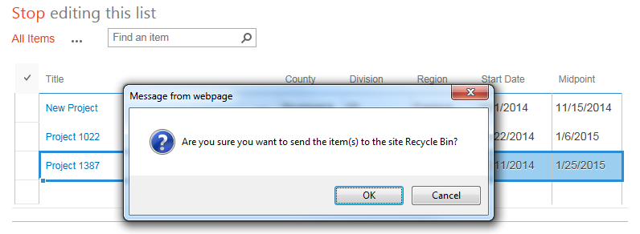
- You can delete an individual value by highlighting it and pressing Delete. When you complete your work, click Stop editing this list.

Limitations
These are issues and problems you might experience.
- If you receive the error message Unable to communicate with server, you are likely trying to edit too many records. Work with less than 100 records at a time.
- Be careful with bulk editing because Quick Edit does not have an undo capability. It is easy to accidentally overwrite a lot of data using Auto-fill.
- When you enter data in a cell, SharePoint often “loses” the first letter. Check your entries to ensure they are complete.
- You can only edit the current view. If the list contains columns that are not in the current view, you cannot edit them unless you change the view.
- You cannot edit content types, custom columns, or rich text columns.
- You cannot edit a list that is grouped.
- You cannot edit a list that uses anything but the Default style. Quick Edit is not available if the list uses the Basic Table, Boxed no labels, Boxed, Newsletter, Newsletter no lines, Shaded, or Preview Pane style.
Before using Quick Edit, create some type of backup by turning on versioning or by exporting the list to Excel. You can also work around these limitations by simply editing individual, rather than multiple, items.

