Connect to an RSS Feed
You can use an RSS (Really Simple Syndication or Rich Site Summary) feed to be notified of changes to a SharePoint list or library. While a SharePoint alert uses email for notifications, an RSS feed can be viewed in a browser, Outlook or another RSS reader. The feed usually contains a headline, a summary, and a link to the full content. If you subscribe to the feed, the RSS reader automatically checks for and downloads new content.
This help file uses Internet Explorer 10 as an example of an RSS reader.

Contents
Subscribe to a Feed
View a Feed

Subscribe to a Feed
- Navigate to the list or library.
- On the ribbon, click the LIST or LIBRARY tab. In the Share & Track group, click RSS Feed.
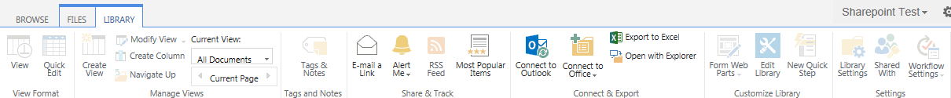
- Click subscribe to this RSS feed.
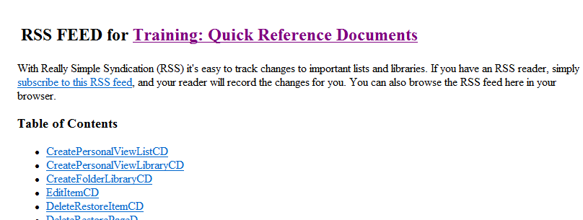
- Enter a name for the feed or accept the default name. Click Subscribe.
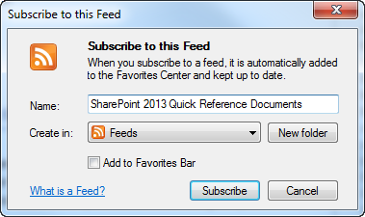
A confirmation message appears.
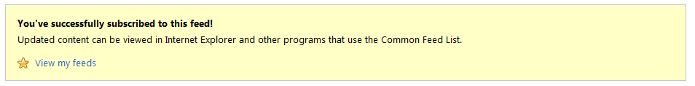

View a Feed
- In Internet Explorer, click the Favorites icon, click the Feeds tab, and click the name of the feed to display. This is an RSS feed from SharePoint Pro magazine.
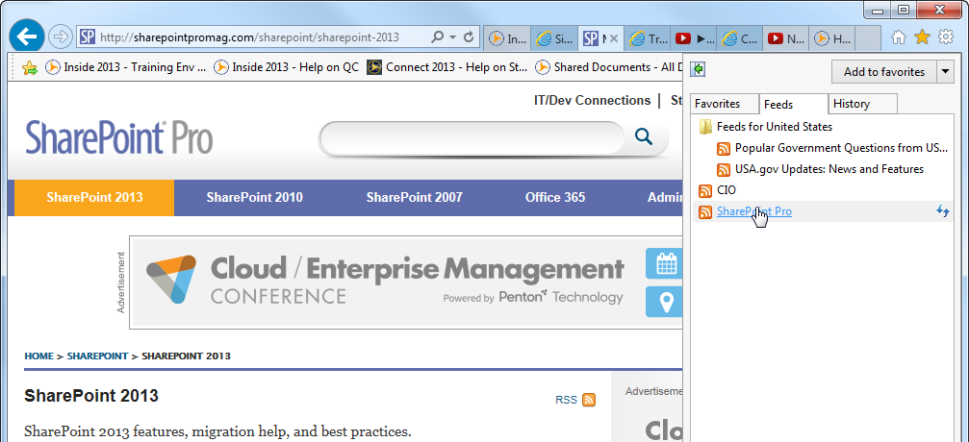Recent news from the feed is displayed.
