Configure Settings for Ratings
You can add rating controls to a list or library and let voters rate the content with Stars or Likes. A voter must have Contributor permissions or higher in order to rate or like content.
- Navigate to the list or library.
- On the ribbon, click the LIST or LIBRARY tab. In the Settings group, click List Settings or Library Settings.
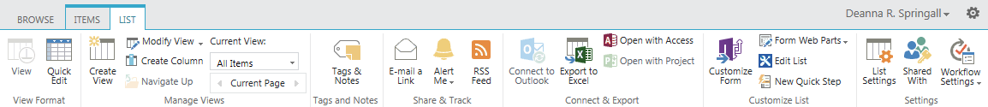
- On the Settings page under General Settings, click Rating Settings.
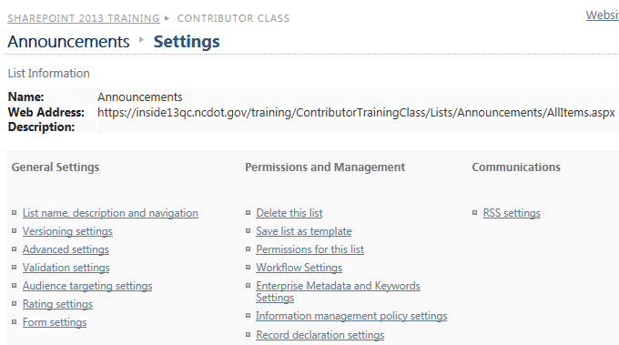
- Click Yes for Allow items in this list to be rated. Choose whether to enable Likes or Star Ratings, and click OK.
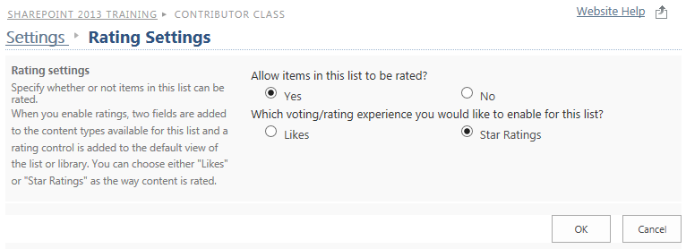
- Return to the list to see the rating system.
Likes: A column for Number of Likes is added. The voter clicks Like to vote for the item; once Liked, the voter can click Unlike to remove the vote. The number of voters is also shown.
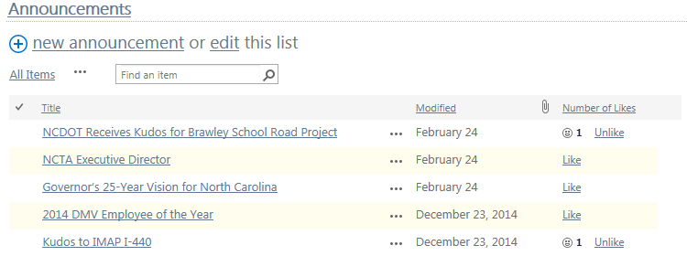Star Ratings: A Ratings column is added; the voter clicks 1 to 5 stars to indicate degree of approval. The number of voters is also shown.
