Request Access to Inside or Connect
Inside NCDOT: https://inside.ncdot.gov Connect NCDOT: https://inside.ncdot.gov
End users may need to request additional access if they wish to view project and/or team sites. Contributors and Designers need to request additional access so they can work with and manage their lists, libraries, and pages.
This flow chart details how to request the appropriate level of access:
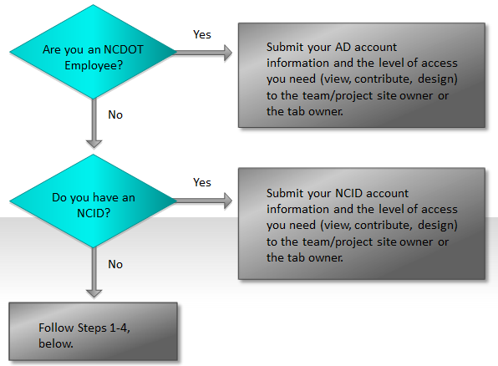
Active Directory (AD) is an identity management and access service for NCDOT employees.
North Carolina Identity Management (NCID) is an identity management and access service for state, local, business, and individual users who do not have AD accounts.

To request an NCID:
- Navigate to https://ncidp.nc.gov/pmf/Registration.html, and complete the form on the NCID website. Be sure to choose the Business Account option on the first page of the form.
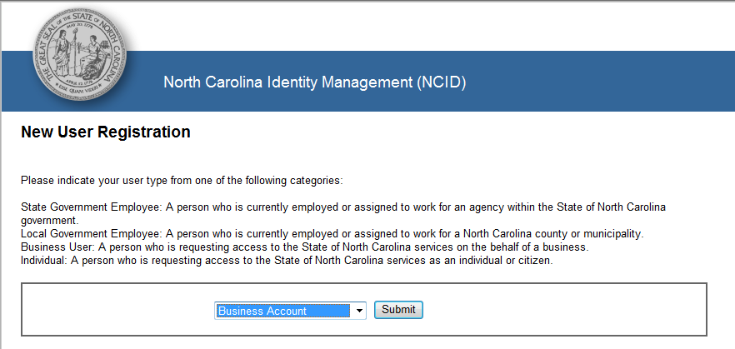
- Wait for the NCID activation email.
- Click the link in the email to activate your NCID.
- Submit your NCID account information and the level of access you need (view, contribute, design) to the team or project site owner or to the tab owner.

