Require Check Out
The check out feature is enabled through Library Settings.
When a user checks out a file, no one else can edit the file until it is checked back in. This prevents conflicting changes by multiple users. Users can also see what files are checked out and to whom, and can add comments describing their changes.
- Navigate to the library.
- On the ribbon, click the LIBRARY tab. In the Settings group, click Library Settings.
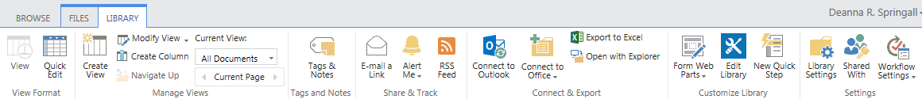
- On the Settings page under General Settings, click Versioning Settings.
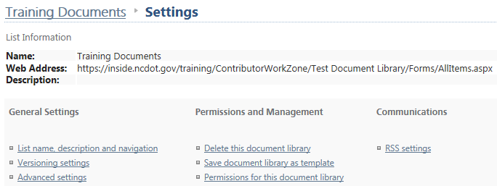
- In the Require Check Out section, click Yes for Require documents to be checked out before they can be edited? and click OK to save the change.
