Restore or Delete from Recycle Bin
Deleted content may be restored from the Recycle Bin if necessary.
- Deleted content is stored in the Recycle Bin for 30 days.
- You only see content you have deleted.
- You can only restore content you have deleted.
Web Services may be able to recover deleted content that is no longer in the Recycle Bin. Call or email the Help Desk to request assistance from Web Services.
- Click the Settings gear, and click Site contents.
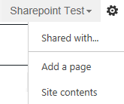
- On the Site Contents page, click RECYCLE BIN. The number in parentheses indicates the number of items in the recycle bin.
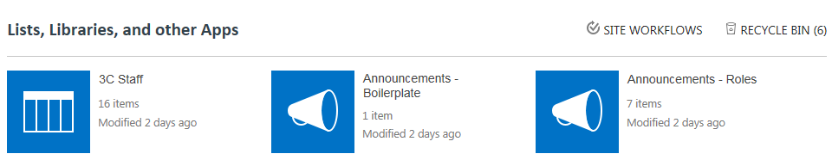
- In the Recycle Bin, select one or more items by clicking the checkbox next to the names.
  - To restore a selection, click Restore Selection and click OK to confirm. The content is restored to its original location.
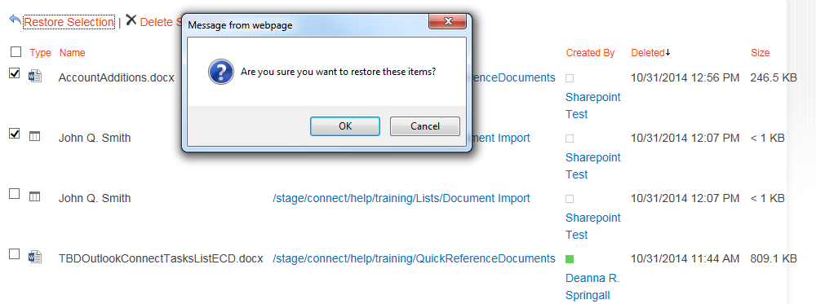
  - To delete a selection from the Recycle Bin, click X Delete Selection and click OK to confirm.
