Restore an Earlier Version of a File
If versioning is turned on, you can revert to an earlier version of a file.
You can also use the version history to copy content from an earlier to a later version. Open the earlier version and copy the content, then open the later version and paste the content.

Contents
Restore Earlier Version – Method 1
Restore Earlier Version – Method 2

Restore Earlier Version – Method 1
- Navigate to the library.
- Click the ellipsis next to the name of the file, and click the ellipsis in the callout. In the context menu, click Version History.
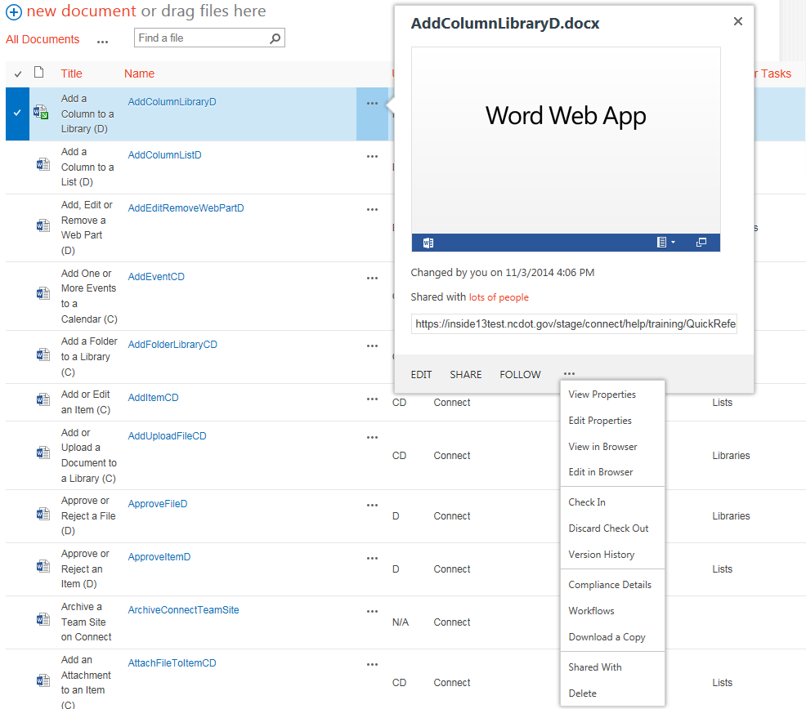
- Hover over the date of the version to restore. Click the down arrow that appears, and click Restore.
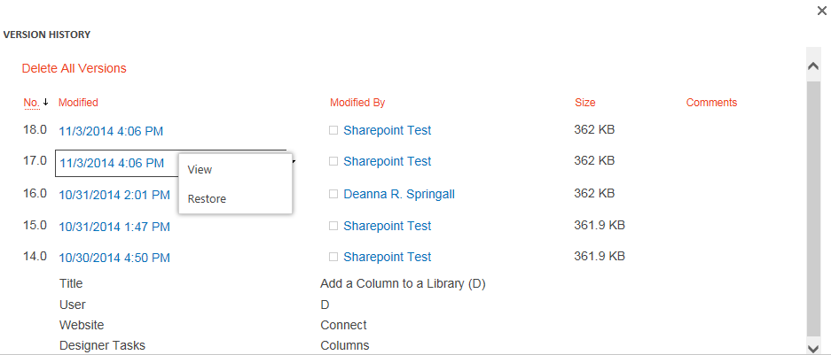
- You are prompted to restore the earlier version. Click OK to confirm.
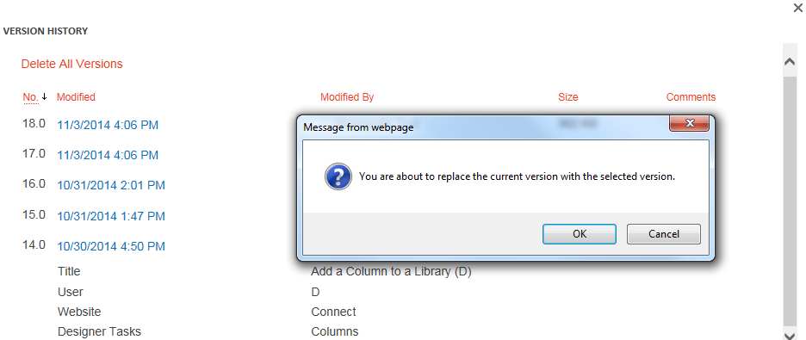 A new version is created with the content from the older version. Check in the new version of the file and check out the file again.
- Return to the Version History and note that there is a new version of the document. This new version is actually the earlier version that has been restored.
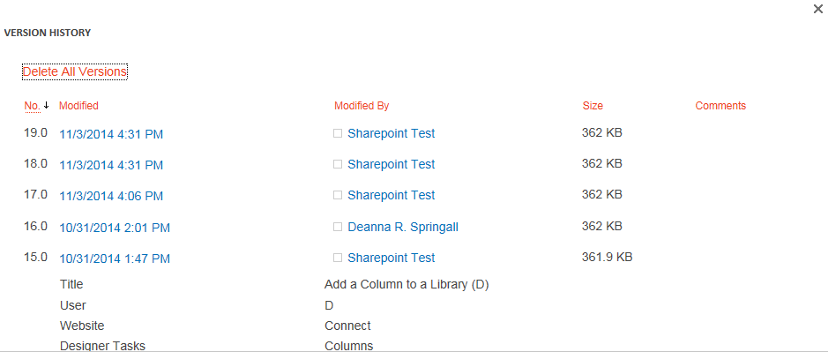

Restore Earlier Version – Method 2
- Navigate to the library.
- Select the document by clicking the checkbox next to the name of the document.
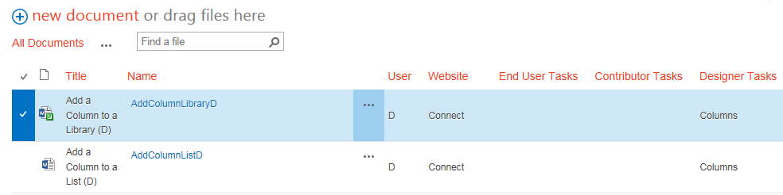
- On the ribbon, click the FILES tab. In the Manage group, click Version History.
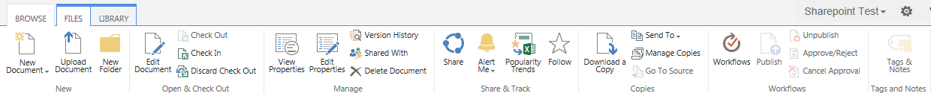
- Continue with step 3 in the previous section.

