Restore an Earlier Version of a Page
If versioning is turned on, you can restore an earlier version of a page.
- Navigate to the page.
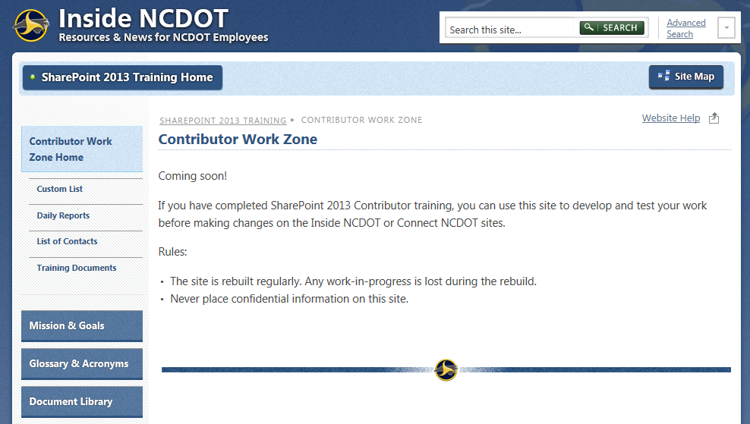
- Click the Settings gear and click Edit page.
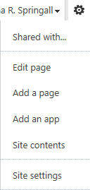
- Click OK to check out the page.
- On the ribbon, click the PAGE tab, and click Page History.
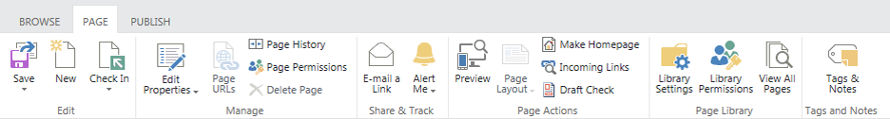The left navigation pane displays the current and all existing previous versions of the page.
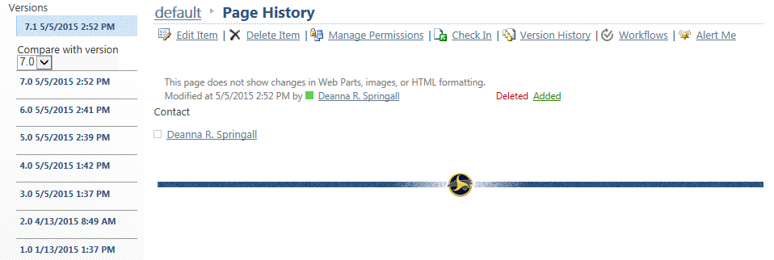
- In the Compare with version drop-down list, click the older version that you want to compare to the current version. In this example, you can see that some text was deleted from the table.
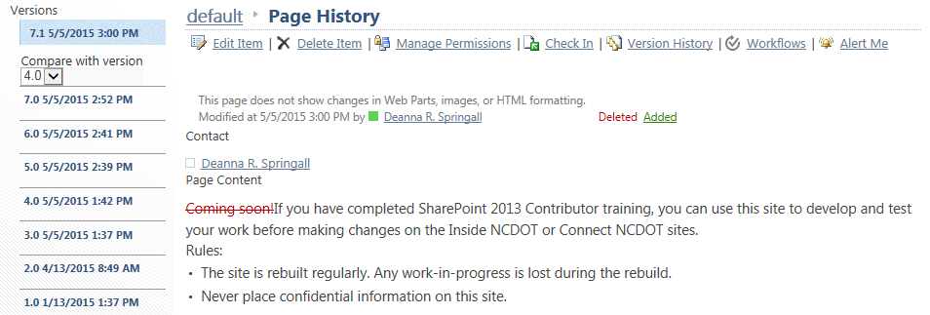
- To restore this older version, click the older version number in the left navigation pane, click Restore this version, and click OK to replace the current version with the older version.
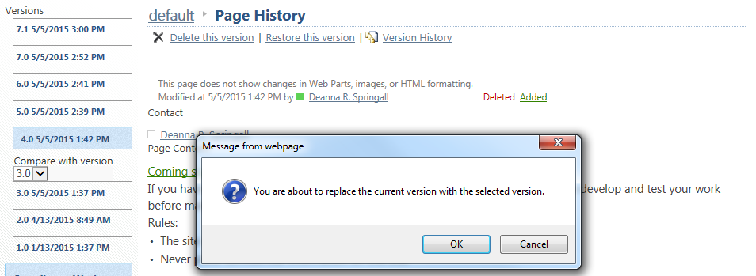A list of versions that have been saved appears.
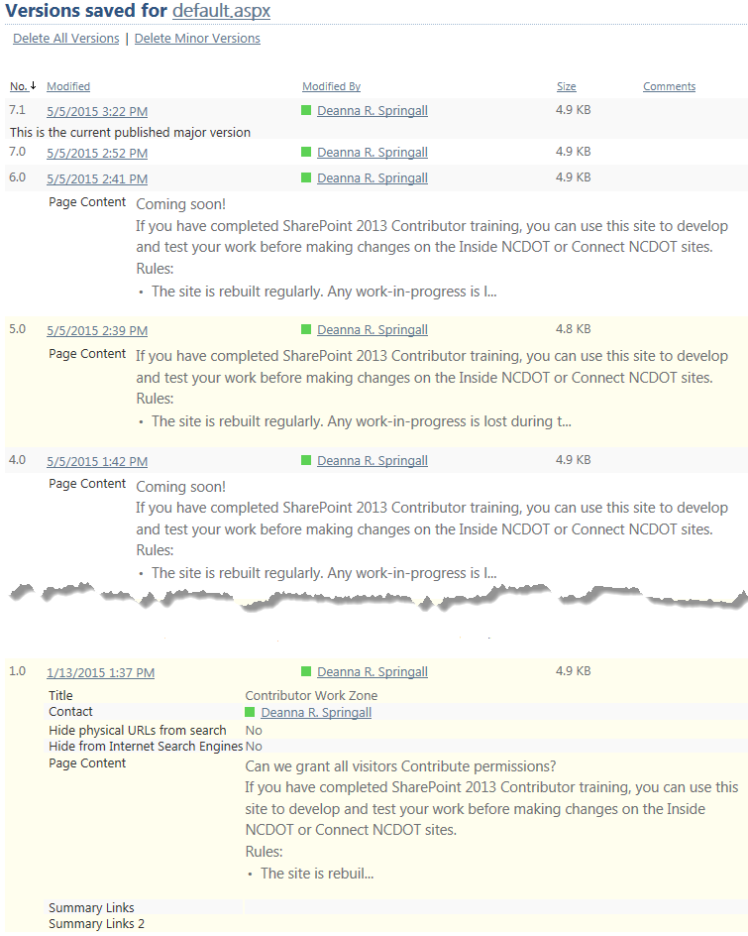
- Navigate to the page and check that the text deletion in version 4.0 appears.
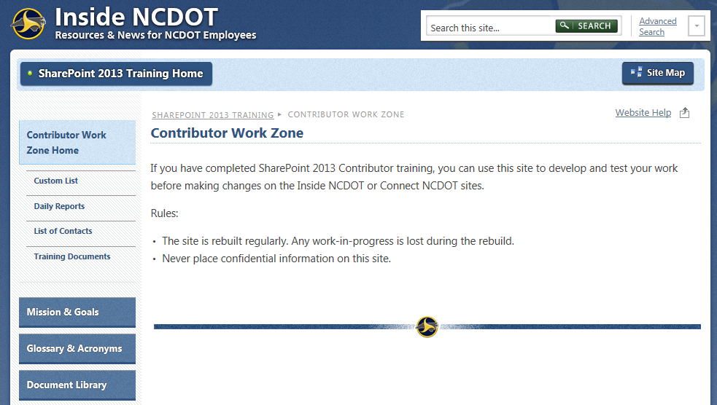
- Check in and publish the page.

