Script Editor Web Part
The Script Editor web part lets you insert HTML, CSS or scripts on a page. Common uses include adding the embed code for a YouTube video, adding custom HTML to a page, or incorporating CSS in a page to override default display characteristics.
You may not need to use the tool pane because it is already set up to hide the chrome and to not display content. However, you can make the standard web part changes if needed.
- Appearance – resize the web part, modify the Chrome State and Chrome Type
- Layout – move the web part within a zone or between zones
- Advanced – make the web part title a link
Note: The </> Embed Code option appears under the INSERT tab when you are editing a page. While you can use it to add code to a page, use the Script Editor web part if possible. </> Embed Code is not a web part, it only works in Page Content areas, and it cannot be modified – only deleted and replaced.
This example embeds an NCDOT YouTube video; it assumes that the NCDOT Communications Office has already uploaded the video to YouTube and that you have copied the embed code from YouTube. The example also hides the column headings in lists. This is the page before modifications.
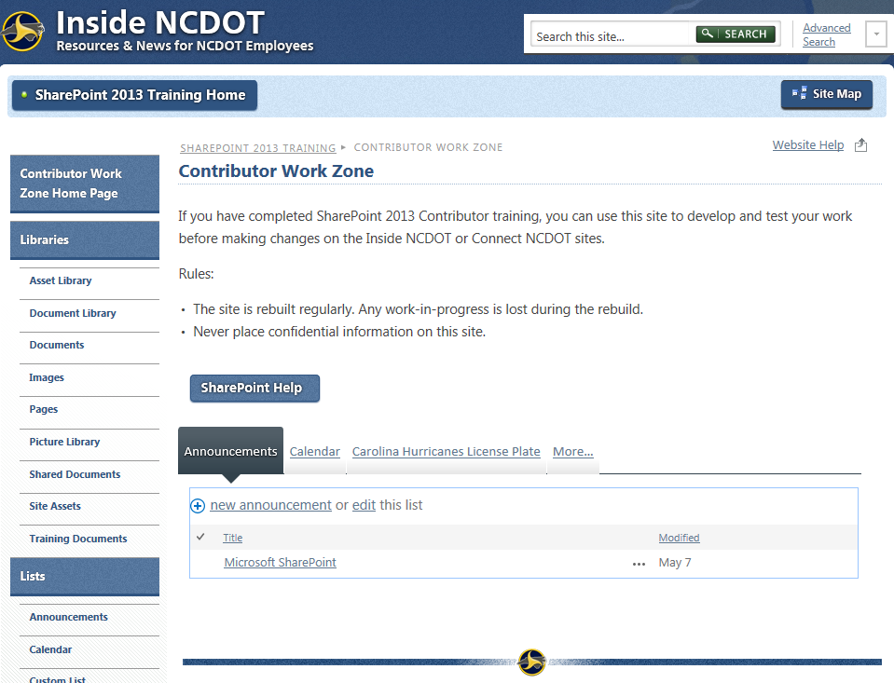
- Navigate to the page where you want to add a Script Editor web part.
- Click the Settings gear, and click Edit page.
- Click Add a Web Part in the web part zone where you want to add the web part. In the Categories section of the web part gallery, click the Media and Content category. In the Parts section, click the Script Editor web part, and click Add.
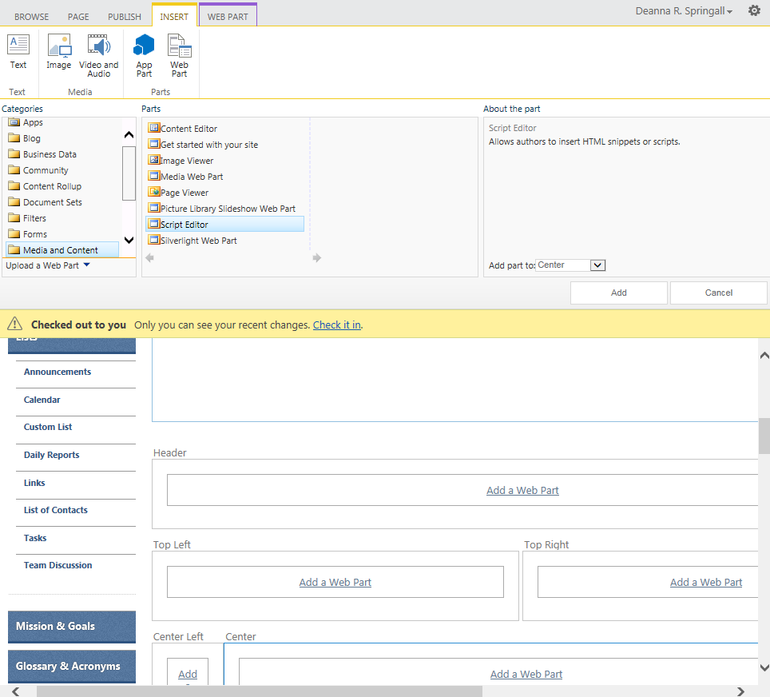
- In the Script Editor web part, click EDIT SNIPPET.

- In the Embed dialog, paste the HTML snippet or script. Once the code is added, the dialog shows a preview. Click Insert.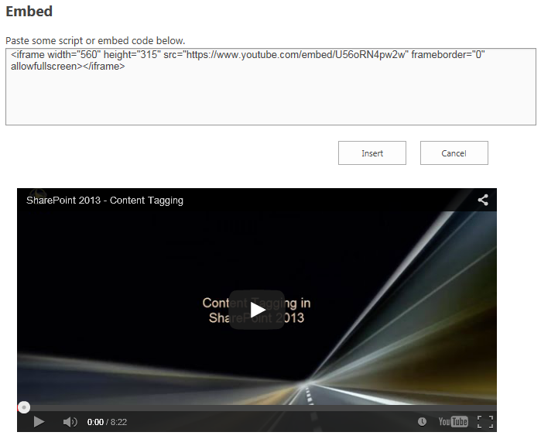
- Move the Script Editor web part below the last tab in the web part zone. Try to drag and drop Script Editor to the correct location. If that doesn’t work, change its Zone Index.
  - Hover over the title of the last web part in the zone, click the down arrow, and click Edit Web Part to open the tool pane.
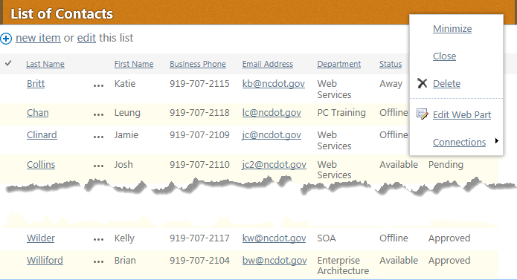
  - Expand the Layout section and note the Zone Index. Cancel out of the tool pane.
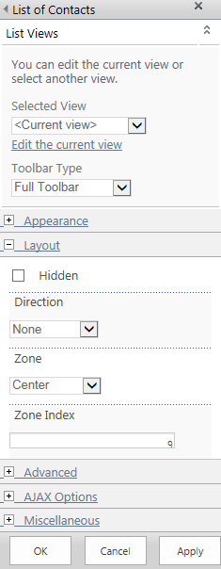
  - Edit the Script Editor web part and assign it a Zone Index that is larger than the Zone Index for the last web part. In this example, assign a value greater than 9. Click OK to save the settings.
- Remember to save, check in, and publish the page.
Repeat the process to add a second Script Editor. In the snippet, insert this CSS that hides column headings. Move the second Script Editor web part to the bottom of the web part zone.
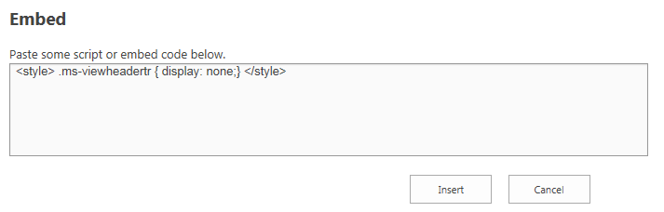
This is the page after modifications. The video was embedded; the checkbox, Title and Modified column headers are no longer visible.
