Search
The search box appears on the most pages of Inside NCDOT or Connect NCDOT.
Matches are returned in an order based on file names, titles, metadata/keywords and popularity. For example, content that is accessed frequently is higher in the search results than content that is less frequently used.

Contents
Basic Search
Search Refiners
Promoted Results
Search Queries with Logical Operators
Search Queries with Metadata
Set Alerts on Search Results

Basic Search
- Enter the text to search for in the search box, and click the magnifying glass icon or press the Enter key.
In this example, the query returned 14 results. Each result includes an icon to indicate the type of result (such as a document or list item). The title of the item or name of the file links to the item or file that matched the query, bolds the matching text, and gives the URL of the match.
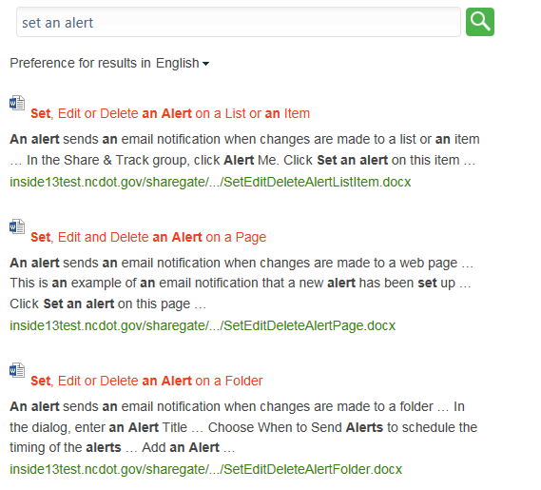
- Browse through the results to find the items you need.

- Hover over a result to display a callout, which gives a preview and offers additional options that vary with the type of result and your permissions.

Search Refiners
Once you have executed a search, the Refiners pane in the left column offers filters such as type of file and author. Click a filter to apply it.
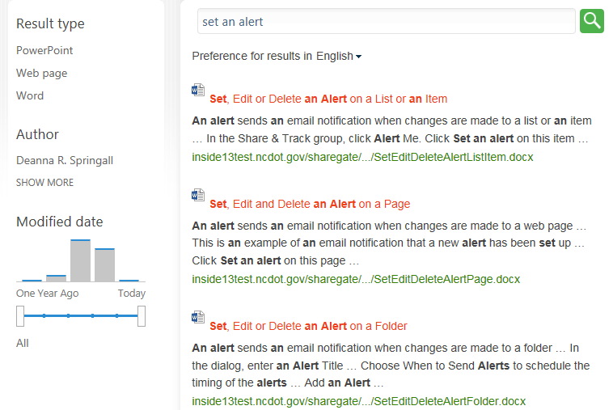
In this example, the filter for PowerPoint results reduced the number of results from the previous query from 14 to 2. To remove the filters, click All to return to all Result types.
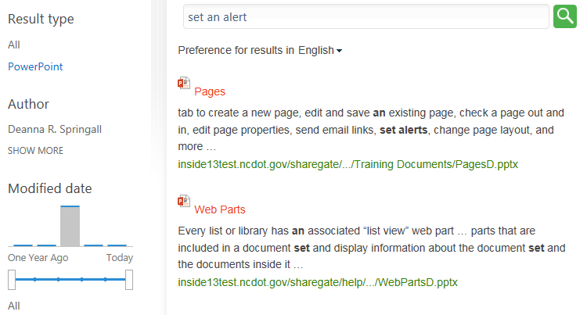

Promoted Results
Results at the top of the search results page with a special icon are “promoted” results and are deemed to be the most relevant results for your query.
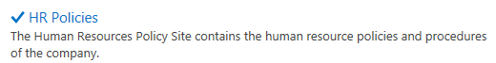

Set Alerts on Search Results
An alert sends an email notification when results from a search query change or are updated.
- Perform a search. At the bottom of the search results page, click Alert Me.
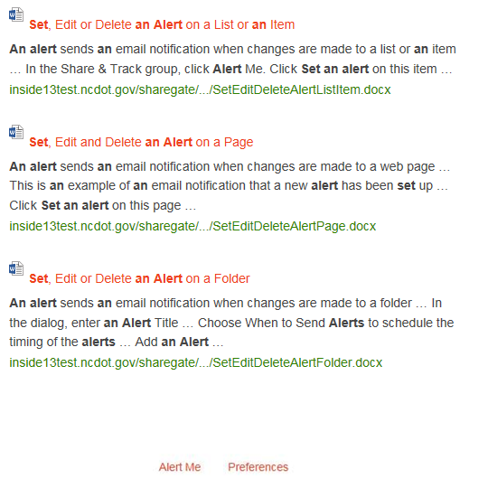
- Define the details of the alert.
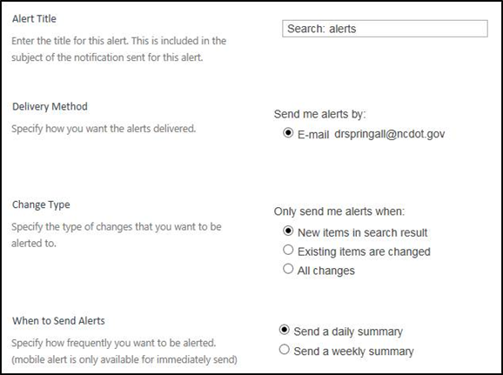
  - The dialog contains a default title.
  - The default Delivery Method is email.
  - Select the Change Type to choose the events that you want to know about.
  - Choose When to Send Alerts to schedule the timing of the alerts.
  - Click OK.
- Confirm that the alert has been configured. On the ribbon, click Alert Me and click Manage My Alerts to see that your alert has been added.
Note: On Connect, you can also do this by clicking Manage My Alerts in the page footer.

