Project Files Search – Inside NCDOT
Project Files Search is a property (metadata)-driven search of these records.
- As-built plans from all centrally let highway projects as far back as DOT records exist (the 1910s)
- Pre-Construction content for TIP projects (information in Project Store)
- Construction content for projects with Construction sites (accessible only by DOT Construction users)
The interactive interface makes the information easily searchable and immediately accessible.

Content
Search Interface
One-Click Search
Advanced Search
Refiners

Search Interface
In the top right of the Inside NCDOT site, hover over the down arrow next to Advanced Search and click Project files.
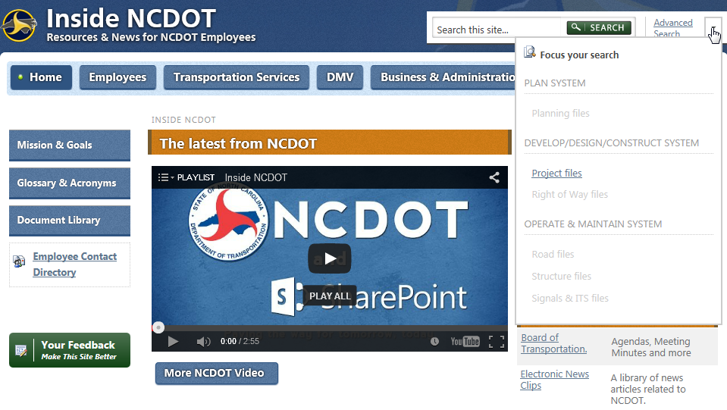

The Project Files Search page appears.
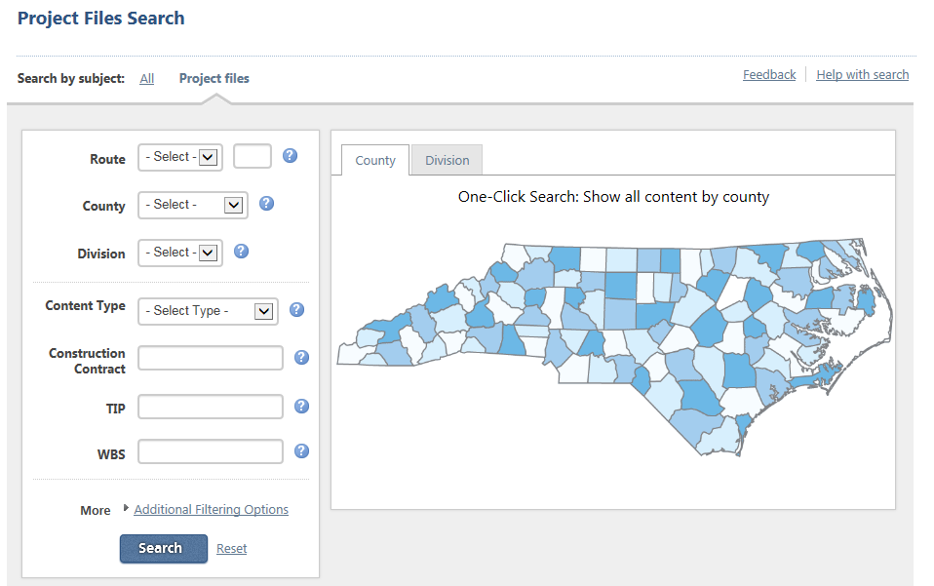

One-Click Search
Click the County or Division tab, then click the area of interest on the map. For example, click Wake County.
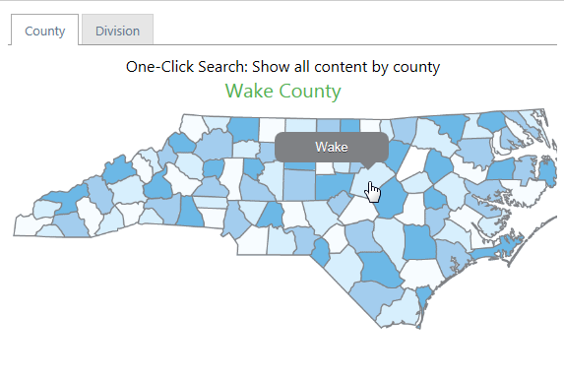
These are the results.
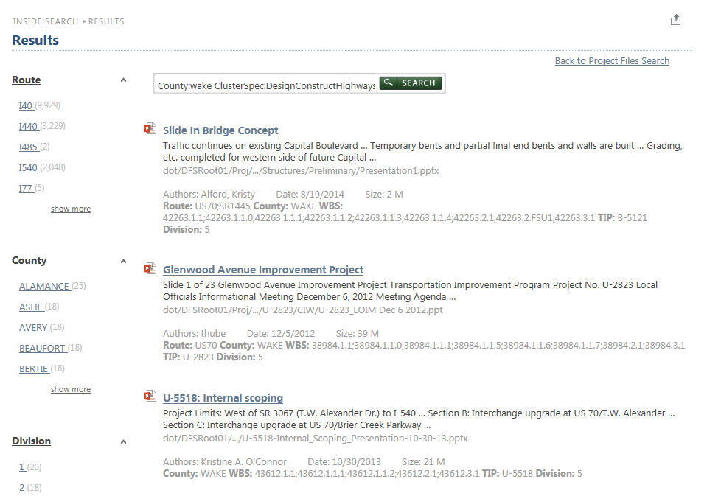

Advanced Search
In the left column, enter one or more search criteria and click Search. For example, search for Route=I 440 and County=Wake.
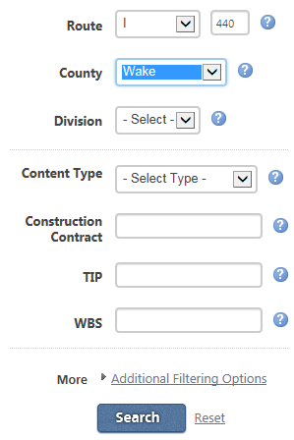
In this example, there are 2,884 results.
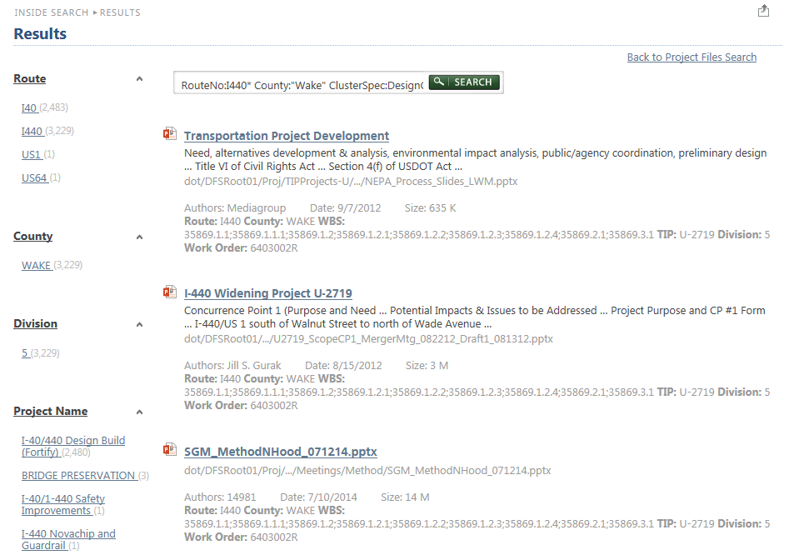

Refiners
If many documents are returned on the search results page, you may wish to use the search refiners on the left side to narrow your search. For example, if you click the Project Name of I-40/440 Design Build (Fortify) in the Advanced Search example, above, these are the 2,388 results.
