Set an Alert
An alert sends an email notification when changes are made to a page, list, item, library, file or folder. You can also set an alert on search results; see the help file for Search.
For items, files and folders, you can also set up an alert through the View Properties option. See the help files for View Properties.
Note: Alerts created in SharePoint 2010 have been migrated to SharePoint 2013. A few users have reported that alerts do not work after migration. The only known fix is to recreate the alerts.

Contents
Examples of Alerts
Settings on the New Alert Page
Set an Alert on a List or Library
Set an Alert on an Item or a File
Set an Alert on a Page
Set an Alert on a Folder
Set an Alert on a Discussion Item

Examples of Alerts
This is an example of an email notification that a new alert has been set up on a page.

This is an example of an alert on a page change.
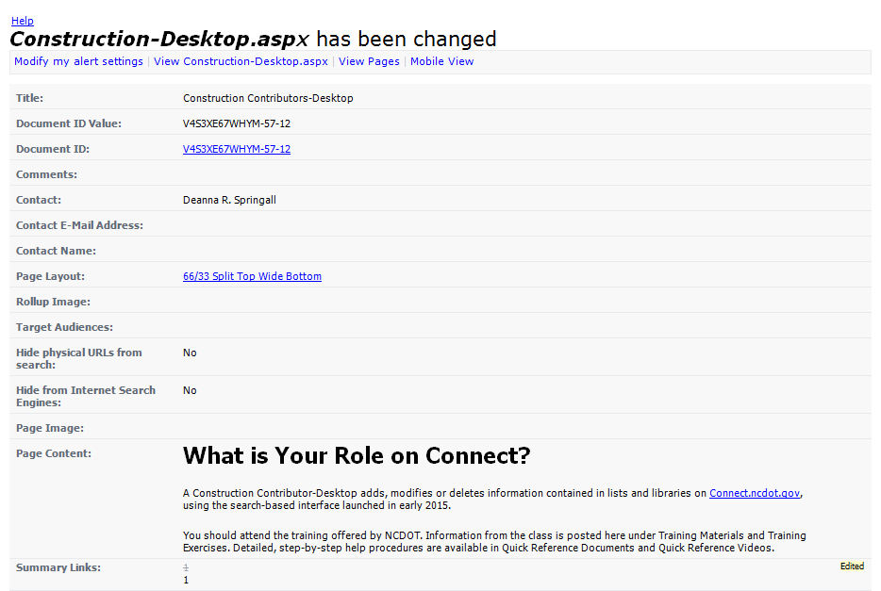

Settings on the New Alert Page
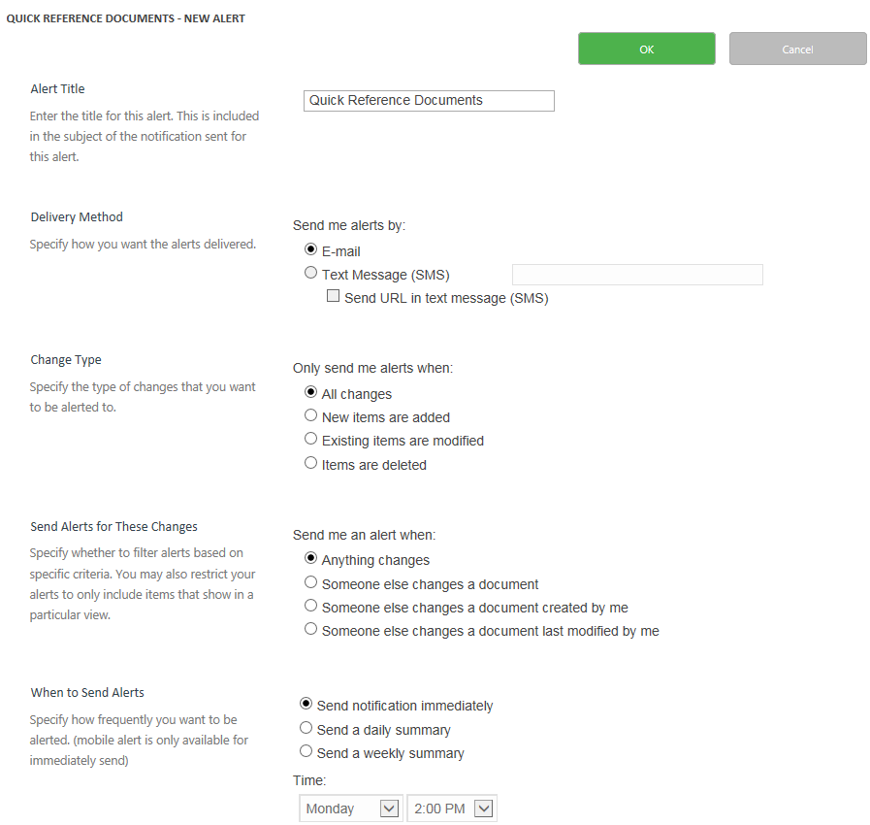
- In the dialog, enter an Alert Title.
- The default Delivery Method is email. Text alerts are not enabled at NCDOT.
- For folders, lists and libraries, select the Change Type to choose the events that you want to know about.
- Select Send Alerts for These Changes to further restrict the alerts you receive. You are likely more interested in changes made by someone else; if you select the first radio button, you are alerted about your own changes as well.
- Choose When to Send Alerts to schedule the timing of the alerts.

Set an Alert on a List or Library
- Navigate to the list or library.
- On the ribbon, click the LIST or LIBRARY tab. In the Share & Track group, click Alert Me. Click Set alert on this list or Set alert on this library.
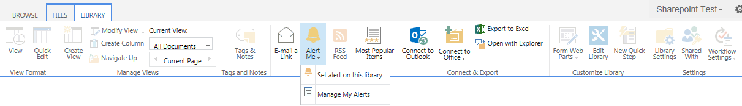
- Define the details of the alert on the New Alert page as described earlier and click OK.

Set an Alert on an Item or a File
- Navigate to the list or library.
- Select an item or file by clicking the checkbox next to its title or name.
- On the ribbon, click the ITEMS or FILES tab. In the Share & Track group, click Alert Me. Click Set alert on this item or Set alert on this document.
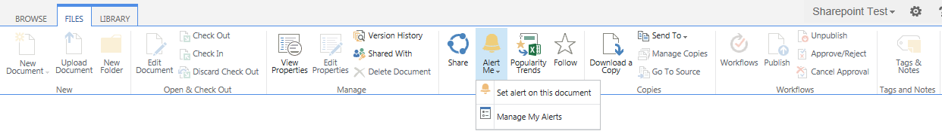
- Define the details of the alert on the New Alert page as described earlier and click OK.

Set an Alert on a Page
- Navigate to the web page.
- On the ribbon, click the PAGE tab. In the Share & Track group, click Alert Me. Click Set an alert on this page.
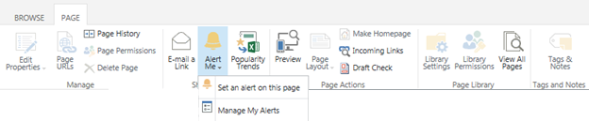
- Define the details of the alert on the New Alert page as described earlier and click OK.

Set an Alert on a Folder
- Navigate to the library.
- Click the ellipsis by the folder name. Click the ellipsis in the callout, and click View Properties.
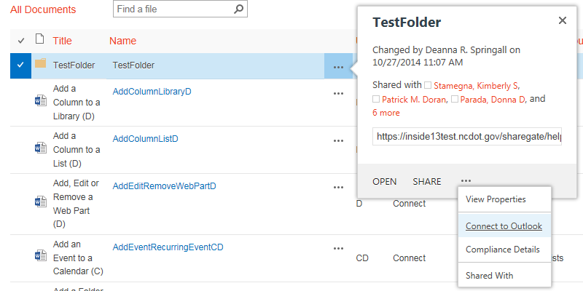
- Click Alert Me.
- Define the details of the alert on the New Alert page as described earlier and click OK.

Set an Alert on a Discussion Item
- Navigate to the discussion board.
- Click the discussion you want to monitor.
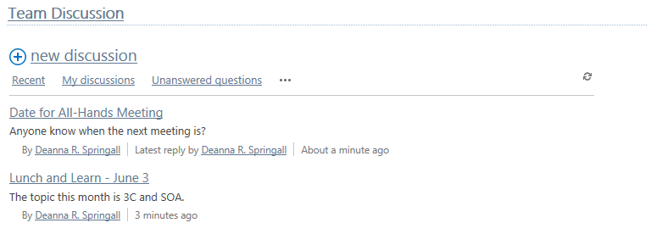
- Click the ellipsis by the discussion options and click Alert Me.
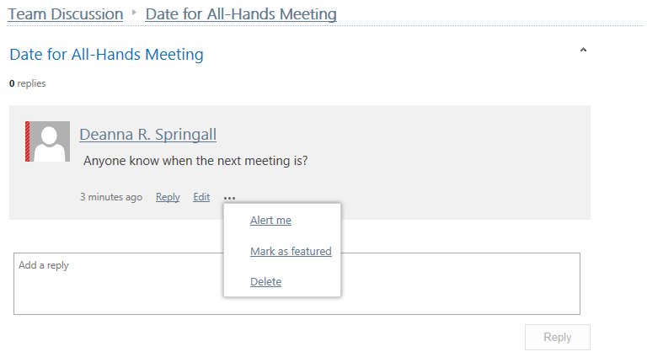
- Define the details of the alert on the New Alert page as described earlier and click OK.

