Simple Tabs and Simple Tabs – More Option Web Parts – Inside NCDOT
The Simple Tabs web part is a customized NCDOT web part for use on Inside NCDOT. It creates a tabbed interface so you can efficiently display the content of several web parts. The title of the web part becomes the name displayed on each tab.
If the tabs do not fit well on a single line, use the Simple Tabs – More Option web part to create tabs for the first three web parts and a More link for the remaining tabs.

Contents
Simple Tabs Web Part
Simple Tabs – More Option Web Part

Simple Tabs Web Part
If you have a number of web parts on a page, they may appear one after another down the page; this lengthens the page and forces a user to scroll down to see content. The Simple Tabs web part lets you create a tabbed interface so you can compactly display a number of web parts in the same area of the page. The user simply clicks the tab to display that web part.

This is an example of how Simple Tabs works with five web parts.
Before Simple Tabs – Scroll down the page | After Simple Tabs – Click the tab
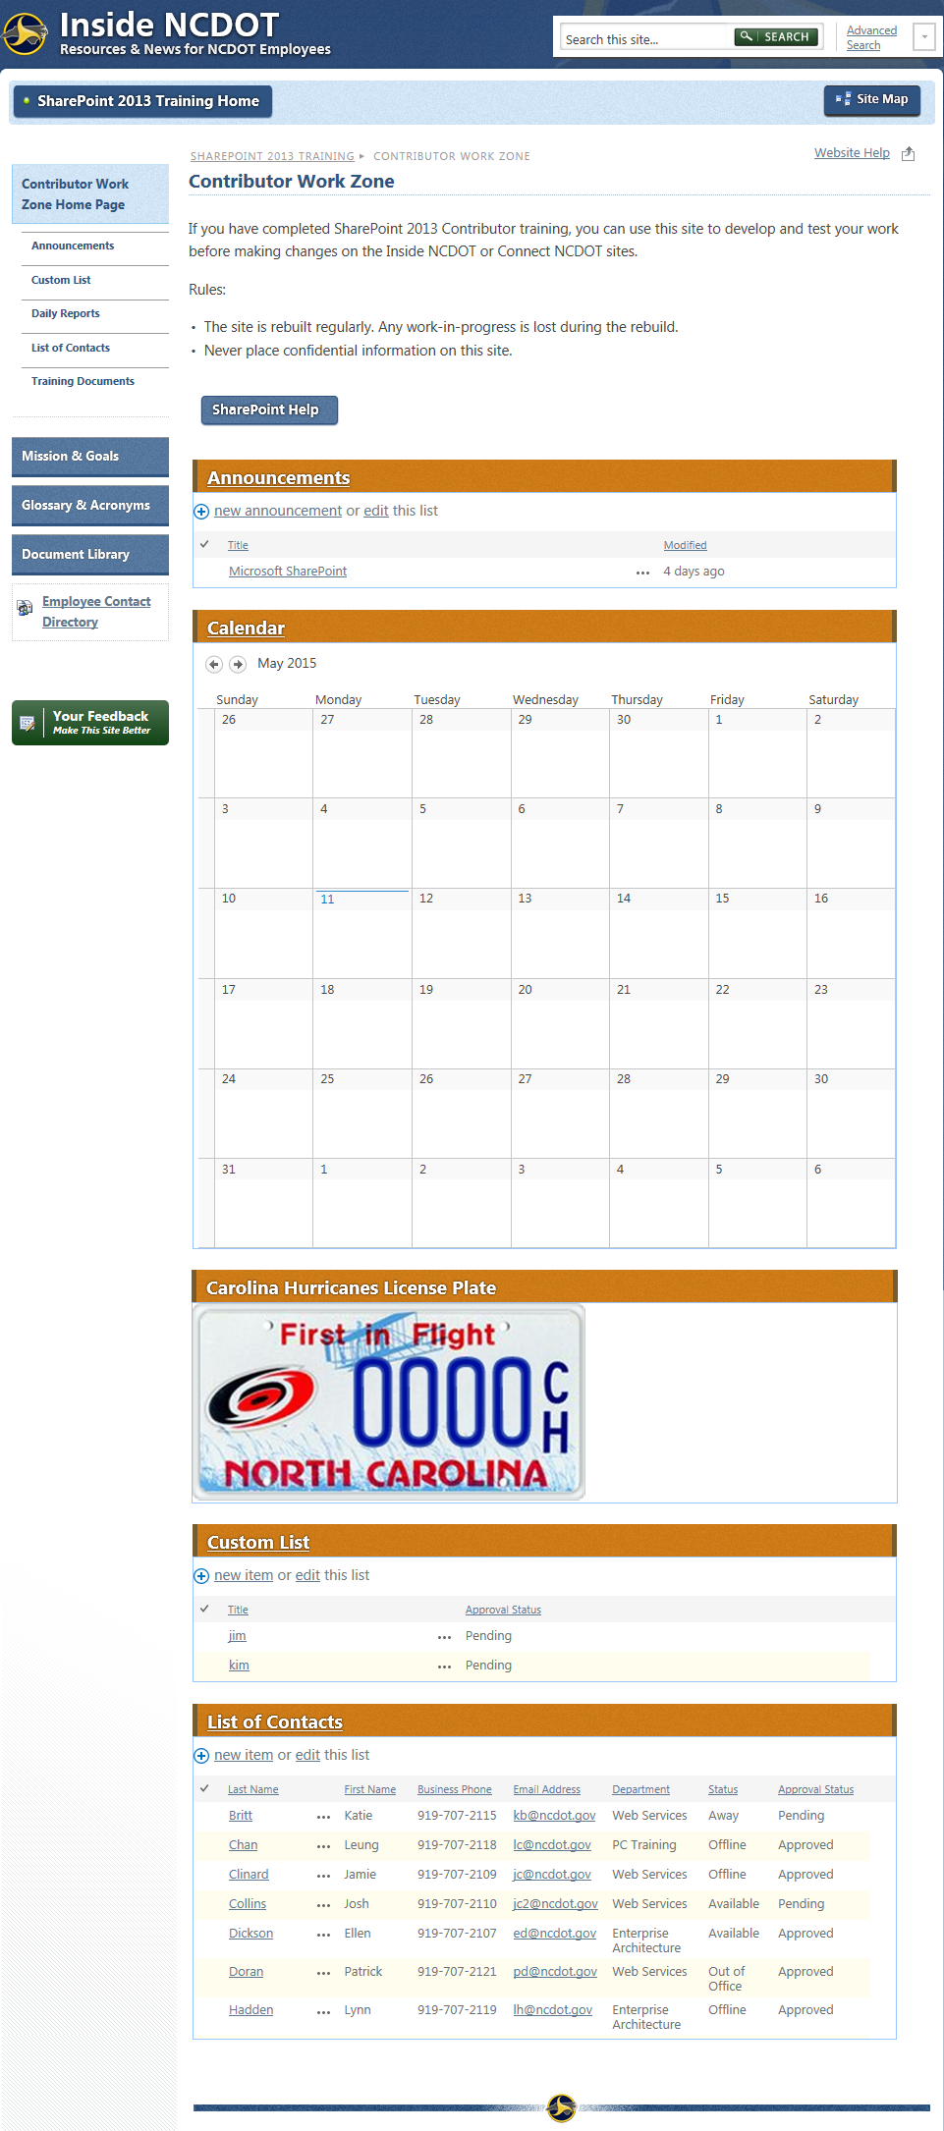 | 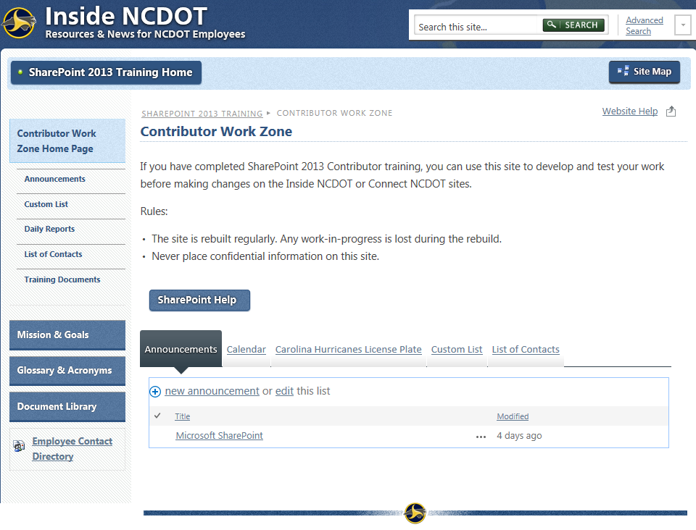
- Navigate to the page.
- Click the Settings gear, and click Edit page. If prompted, check out the page.

- Place all of the web parts that need tabs in the same web part zone and in the top-to-bottom order that you want the tabs to appear left to right. This example uses the Center zone.
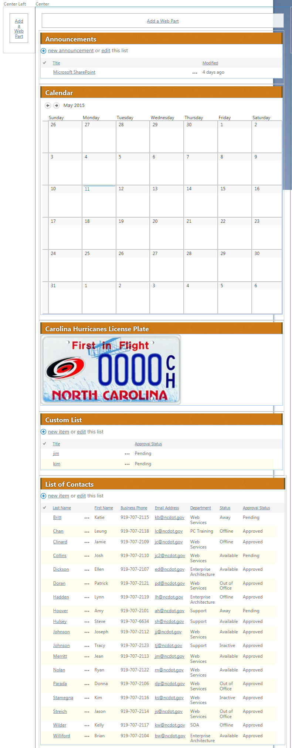
- Add the Simple Tabs web part to the same zone that contains the web parts. Click Add a Web Part in that zone. Under Categories, click Miscellaneous and, under Parts, click Simple-Tabs-Web-Part. Click Add.
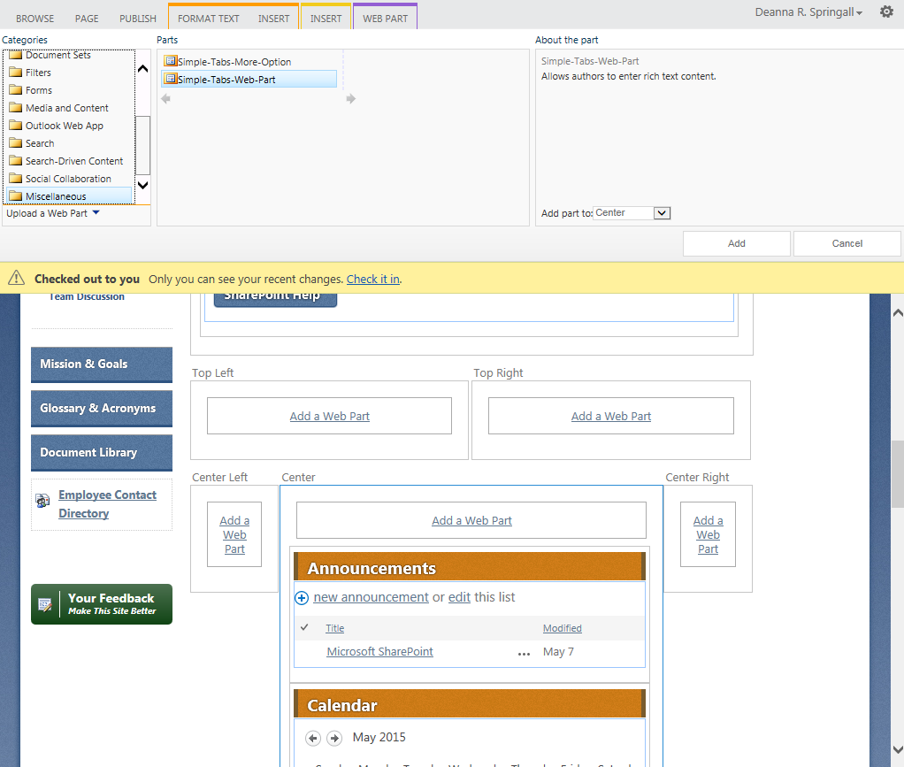
- The Simple Tabs web part is added, likely at the top of the web part zone. To work correctly, the Simple Tabs web part must be below the last web part you want as a tab. Try to drag and drop Simple Tabs to the correct location. If that doesn’t work, change its Zone Index.
  - Hover over the title of the last web part you want as a tab, click the down arrow, and click Edit Web Part to open the tool pane.
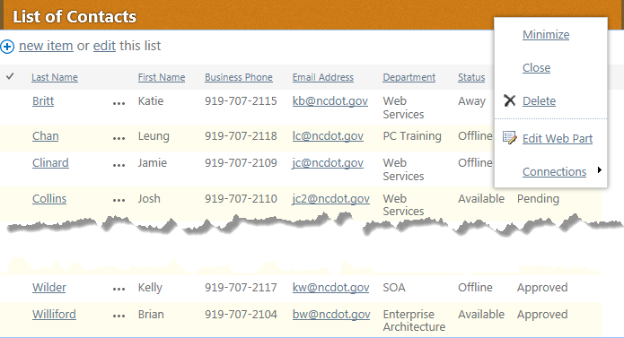
  - Expand the Layout section and note the Zone Index. Cancel out of the tool pane.
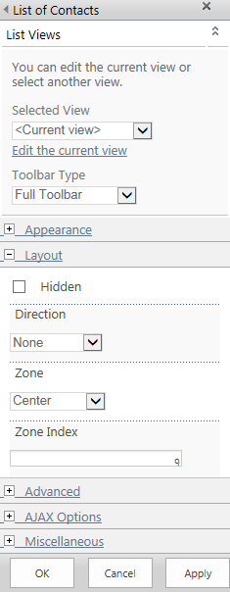
  - Edit the Simple Tabs web part and assign it a Zone Index that is larger than the Zone Index for the previous web part. In this example, assign a value greater than 9. Click OK to save the settings.
- In the ribbon, click the PAGE tab. In the Edit group, click Save to save the page.
- Remember to check the page in and publish it so users can see your changes.

Simple Tabs – More Option Web Part
If there are too many tabs to fit across the page and the display is corrupted, use the Simple Tabs – More Option web part.
This is an example of Simple Tabs with eight tabs that do not fit well on one line. The Team Discussion tab has wrapped to a second line and is overlaid by the Announcements tab.
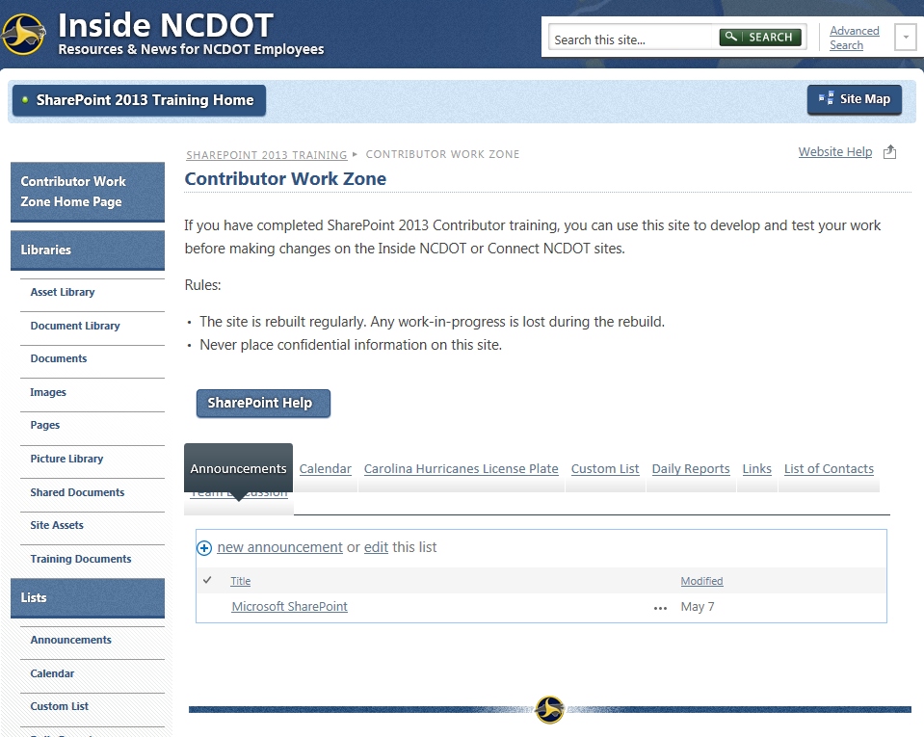

The Simple Tabs – More Option web part lists the first three tabs and then places a More tab that lists the remaining tabs. This is an example of Simple Tabs – More Option with the same eight web parts.
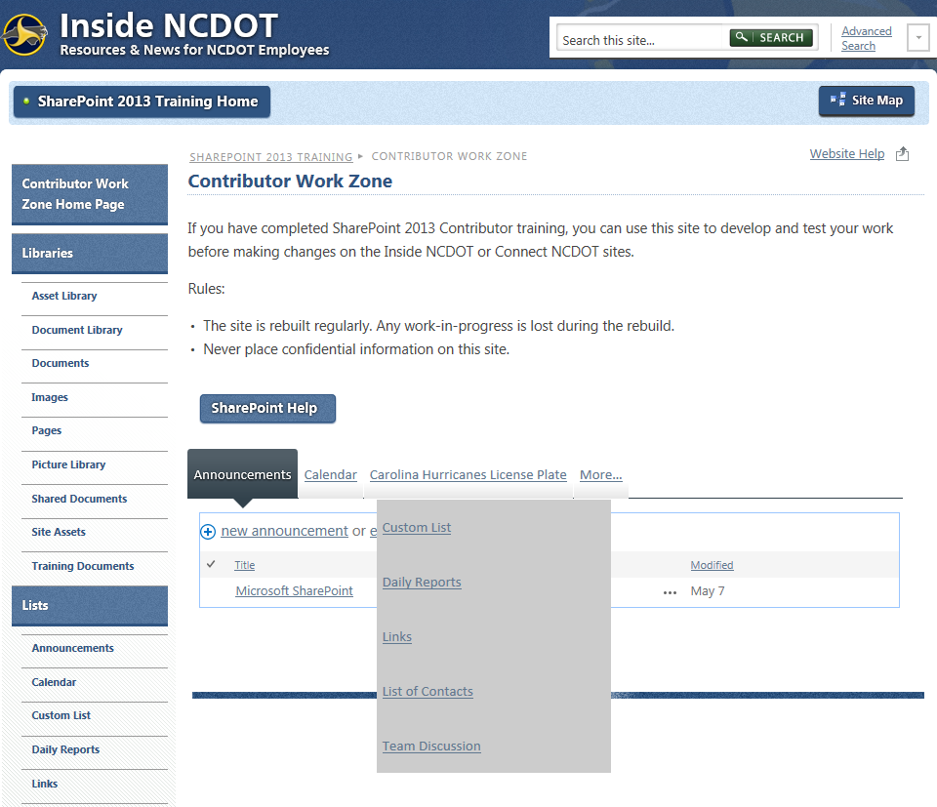
The Simple Tabs – More Option web part works exactly like the Simple Tabs web part. Remember to:
- Place all of the web parts that need tabs in the same web part zone and in the top-to-bottom order that you want the tabs to appear left to right.
- Add the Simple Tabs – More Option web part to the same zone that contains the web parts.
- Place the web part below the last web part you want as a tab. Try to drag and drop the web part to the correct location. If that doesn’t work, change the Zone Index of the Simple Tabs – More Option web part to a value greater than that of the last web part you want as a tab.

