Site Contents
The site contents display includes an icon, summary and link for all lists, libraries, and other apps in the site. Subsites, if any, are also displayed.
- Navigate to the site.
- Click the Settings gear, and click Site contents.
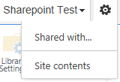
Site contents are displayed.
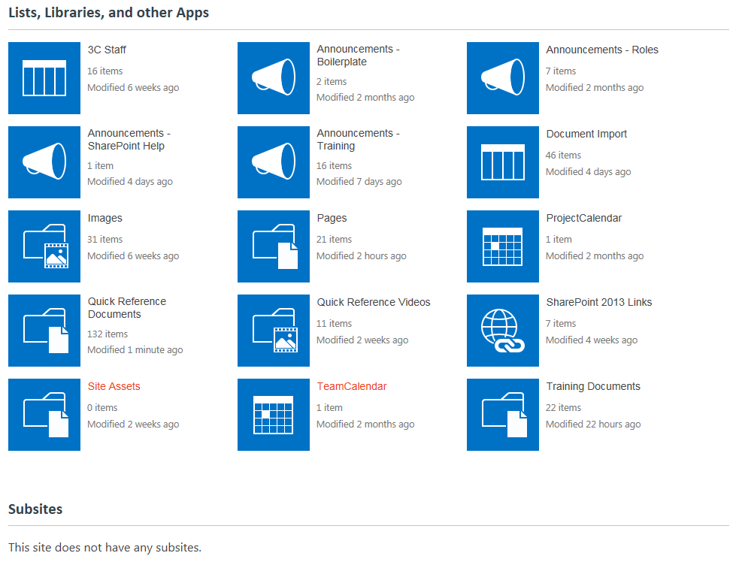Note: Depending upon your permissions, you may see additional options.
- Hover over the icon to see an ellipsis (…). Click the ellipsis for a description of the list or library, if available, as well as additional options that vary with your permissions.
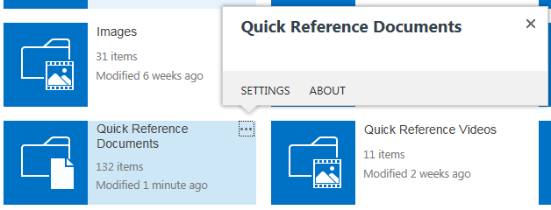
- To open the list, library or other app, click its icon.

