Sort or Filter
If a list or library contains many entries, it can be tedious to scroll or page to view all of them. Like Excel, SharePoint lets you temporarily sort and filter to limit the content you see and to improve usability.
Sorting is arranging items or files in a specific order, such as ascending by name or descending by date, while filtering retrieves and displays only the items or files that match specific information, such as an author’s name.
Note: To use a particular view repeatedly, Contributors can create personal views that only they can see, or Designers can create permanent views.
Note: Not all columns can be sorted or filtered; you may see a message to that effect.
- Navigate to the list or library.
- Hover over the header of the column to sort, and click the down arrow that appears next to the header. From the drop-down, click Ascending or Descending to sort the column in that order.
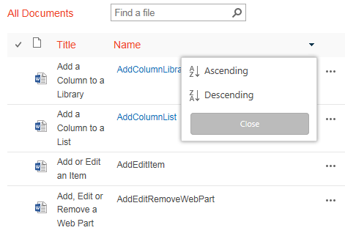
The library is now organized in descending order based upon those column values. The down arrow by the column header indicates the column is in descending order.
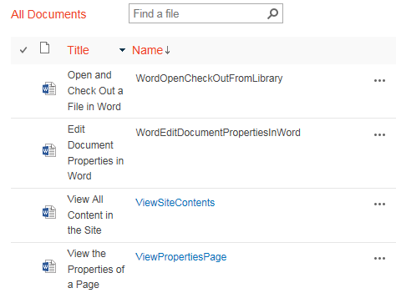
You can also click the column header to toggle between ascending and descending order.

- Hover over the header of the column to filter, and click the down arrow that appears next to the header. From the drop-down, click the checkbox for the filter option. You can select more than one filter.
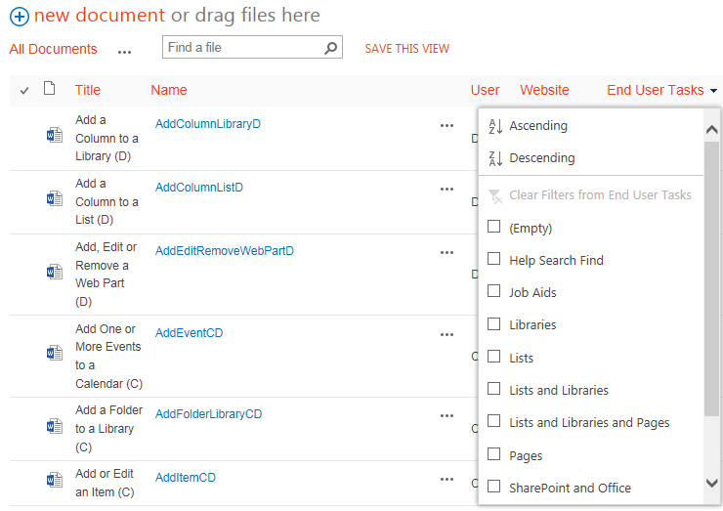The library now displays all documents that are tagged with that filter value. The funnel by the column header indicates a filter has been applied.
