The FORMAT TEXT Tab
The FORMAT TEXT tab in the SharePoint ribbon offers options to format text in areas that allow text entry.
Note: The options available to you vary with your permissions.
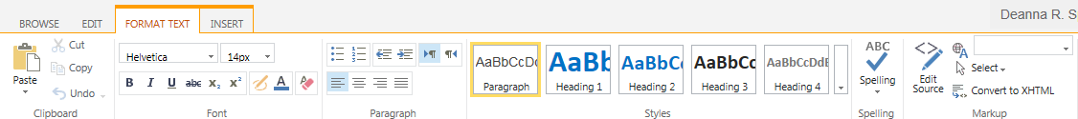

Clipboard, Font, Paragraph, Styles and Spelling Groups
These options should be familiar to anyone who has used Microsoft Word or another Office application.

Markup Group
Do not use the HTML options unless you are fluent with HTML coding.
- Edit Source: You can directly edit the HTML code for the page or web part.
- Language: You can highlight text and identify it as a particular language.
- Select: You can select text based upon its HTML tag.
- Convert to XHTML: You can convert the HTML so it complies with the latest XHTML standards.

