The INSERT Tab
The INSERT tab in the SharePoint ribbon offers options to add certain types of content once you are in a web part or a page.
Note: The options available to you vary with your permissions.
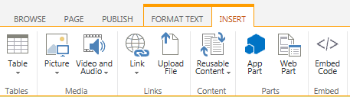

Tables Group
- Table: Add a table to the editable area. This option should be familiar to anyone who has used Microsoft Word or another Office product.

Media Group
- Picture: Select an image to add to the editable area. Browse to the image on your computer, enter a URL (address) for the image, or browse to an image that has already been uploaded to SharePoint.
- Video and Audio: Select a video or sound file to add. Browse to the file on your computer, enter a URL (address) for the file, or browse to the file that has already been uploaded to SharePoint. You can also embed a video from another source (such as YouTube) if you have the embed code.

Links Group
- Link: You can turn selected text into a link. Enter a URL (address) to link to, or browse to the destination if it is within SharePoint.
- Upload File: You can browse to and attach a file to a list item.

Content Group
- Reusable Content: Insert standardized text (such as a contact number for the Help Desk) in many different places while maintaining it in one centralized location.

Parts Group
- App Part: Insert an app (usually a list or library) into a page.
- Web Part: Insert a web part (including apps) into a page.

Embed Group
- Embed Code: Call or email the Help Desk to request assistance from Web Services.

