The ITEMS Tab
The ITEMS tab in the SharePoint ribbon offers options to work with the items in a SharePoint list.
- Navigate to the list.
- On the ribbon, click the ITEMS tab.
- To work with an existing item, select it by clicking the checkbox next to the title of the item.
Note: The options available to you vary with your permissions.
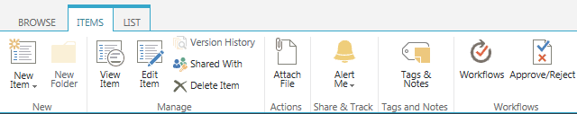

New Group
- New Item: This option lets you add a new item to the list. There may be several types of items to choose from.
- New Folder: If folder creation is enabled, you can add a folder to the list.

Manage Group
- View Item: See the item’s name, title and other metadata.
- Edit Item: This option lets you update an item and its properties.
- Version History: If versioning is turned on, you can review who has modified the item and read any comments about the change.
- Shared With: Not supported.
- X Delete Item: When you delete an item, it is sent to the Recycle Bin.

Actions Group
- Attach File: Items can have one or more files as attachments.

Share & Track Group
- Alert Me: You can create an alert if you want to be emailed when changes are made to the item or you can manage all of your alerts.
- Popularity Trends: SharePoint tracks usage statistics and creates an Excel spreadsheet that reports and graphs the number of hits and unique users by day and by month.

Tags and Notes Group
- Tags & Notes: Not supported.

Workflows Group
- Workflows: If workflows have been created, start a new workflow or view the status of a workflow that is running or has completed. Workflows are set at the list level, but executed on individual items.
- Approve/Reject: If content approval has been enabled, this is the option that lets you approve or reject an item.
Detailed help files are available for many of these commands and tools.

