The LIBRARY Tab
The LIBRARY tab in the SharePoint ribbon offers options to work with a SharePoint library.
- Navigate to the library.
- On the ribbon, click the LIBRARY tab.
Note: The options available to you vary with your permissions.
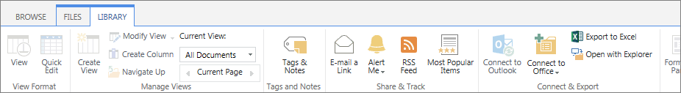

View Format Group
- View: If you are in Quick Edit, this option returns you to the standard list format.
- Quick Edit: With this feature, you can quickly edit many file properties at one time in a datasheet view.

Manage Views Group
- Create View: The default view is generally all files in the library, but you can create other views to sort, filter and display the files for a particular purpose. You can also create a personal view that only you can see.
- Modify View: Change the display settings of the current view. Use only the Modify option; do not use the Modify in SharePoint Designer (Advanced) option.
- Create Column: Add a column to the library so you can add additional properties for the files.
- Navigate Up: If you are in a folder in a library, use this feature to navigate up to the parent folder.
- Current View: Select another view from the drop-down menu.
- Current Page: If the library contains a lot of documents, use this control to page through the library. You can also use the arrows at the bottom of the page to move among the pages.

Tags and Notes Group
- Tags & Notes: Not supported.

Share & Track Group
- E-mail a Link: This option opens Outlook so you can send co-workers a link to the library.
- Alert Me: You can create an alert if you want to be emailed when changes are made to the library or you can manage all of your alerts.
- RSS Feed: If you are familiar with RSS and have an RSS reader, you can subscribe to this feed and be notified of changes.
- Most Popular Items: SharePoint tracks and reports library usage. Review which files have the most views and the most unique views, and which files are most recommended.

Connect & Export Group
- Connect to Outlook: You can connect a library to Outlook if you wish to use Outlook to view files in the library. This lets you avoid opening a browser to go to the SharePoint site.
- Connect to Office: In Microsoft Office applications, you can add a shortcut to a SharePoint library so you can easily create, open and save documents in the library from within Office. Options to Add to SharePoint Sites, Remove from SharePoint Sites, Manage SharePoint Sites.
- Export to Excel: This option lets you save file information in an Excel spreadsheet. The file names are a link to the library.
- Open with Explorer: You can display the contents of the library in the traditional Windows Explorer view.

Customize Library Group
This group contains commands for creating forms, doing advanced editing, and creating custom actions. Call or email the Help Desk to request assistance from Web Services.

Settings Group
- Library Settings: Manage settings (such as versioning and validation) that apply to the entire library.
- Shared With: Not supported.
- Workflow Settings: Manage the settings for workflows associated with this library or add a new workflow. Call or email the Help Desk to request assistance from Web Services.
Detailed help files are available for many of these commands and tools.

