The LIST Tab
The LIST tab in the SharePoint ribbon offers options to work with a SharePoint list.
- Navigate to the list.
- On the ribbon, click the LIST tab.
Note: The options available to you vary with your permissions.
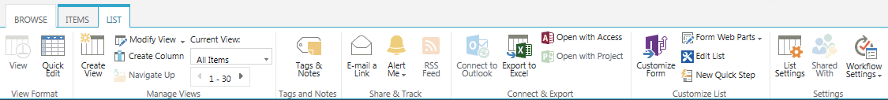

View Format Group
- View: If you are in Quick Edit, this option returns you to the standard list format.
- Quick Edit: With this feature, you can quickly edit many items at one time in a datasheet view.

Manage Views Group
- Create View: The default view is generally all items in the list, but you can create other views to sort, filter and display the items for a particular purpose. You can also create a personal view that only you can see.
- Modify View: Change the display settings of the current view. Use only the Modify option; do not use the Modify in SharePoint Designer (Advanced) option.
- Create Column: Add a column to the list so you can add additional properties for the items.
- Navigate Up: If you are in a folder in a list, use this feature to navigate up to the parent folder. NCDOT does not recommend using folders in lists.
- Current View: Select another view from the drop-down menu.
- Current Page: If the list contains a lot of items, use this control to page through the list. You can also use the arrows at the bottom of the page to move among the pages.

Tags and Notes Group
- Tags & Notes: Not supported.

Share & Track Group
- E-mail a Link: This option opens Outlook so you can send your co-workers a link to the list.
- Alert Me: You can create an alert if you want to be emailed when changes are made to the list or you can manage all of your alerts.
- RSS Feed: If you are familiar with RSS and have an RSS reader, you can subscribe to this feed and be notified of changes.
- Most Popular Items: SharePoint tracks and reports list usage. Review which items have the most views and the most unique views, and which items are most recommended.

Connect & Export Group
- Connect to Outlook: You can connect a list to Outlook if you wish to use Outlook to view list items. This lets you avoid opening a browser to go to the SharePoint site.
- Export to Excel: This option lets you save items in an Excel spreadsheet.
- Open with Access: This option lets you work with list items in an Access database.
- Open with Project: This option lets you open the task list in Microsoft Project as well as keep the list synced with Project.

Customize List Group
This group contains commands for creating forms, doing advanced editing, and creating custom actions. Call or email the Help Desk to request assistance from Web Services.

Settings Group
- List Settings: Manage settings (such as versioning and validation) that apply to the entire list.
- Shared With: Not supported.
- Workflow Settings: Manage the settings for workflows associated with this list or add a new workflow. Call or email the Help Desk to request assistance from Web Services.
Detailed help files are available for many of these commands and tools.

