The PAGE Tab
The PAGE tab in the SharePoint ribbon offers options to work with a publishing page.
- Navigate to a page.
- On the ribbon, click the PAGE tab.
Note: The options available to you vary with your permissions.
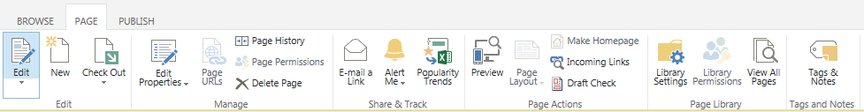

Edit Group
- Edit: This command opens a publishing page for editing. Once a page is open, Edit becomes Save, with options to Save, Save and Keep Editing, Stop Editing, or edit in SharePoint Designer (SPD is not supported).
- New: This command creates a new page using the default template.
- Check Out: If a page is checked out to you, no one but you can work on that page. Once a page is checked out, there are options to Check In, Discard Check Out, and Override Check Out. Check in the page when your work is complete, or discard the check out if you do not want to keep your changes. Depending upon how you open and close the page, you may be automatically prompted to check out or check in the page.

Manage Group
- Edit Properties: In the drop-down menu, you have the ability to view and edit page properties:
  - Edit Properties: Update the page’s properties.
  - Edit SEO Properties: Update the properties of the page to optimize search engine results. This is known as search engine optimization (SEO).
  - View Properties: See the page’s name, title and other metadata.
- Page History: You can review who has modified the page and read any comments about the changes.
- Page Permissions: This option lists individual and group permissions for the page.
- X Delete Page: When you delete a page, it is sent to the Recycle Bin.

Share & Track Group
- E-mail a Link: This option opens Outlook so you can send co-workers a link to the page.
- Alert Me: You can create an alert if you want to be emailed when changes are made to the page or you can manage all of your alerts.
- Popularity Trends: SharePoint tracks usage statistics and creates an Excel spreadsheet that reports and graphs the number of hits and unique users by day and by month.

Page Actions Group
- Preview: This feature opens the page in another window so you can see how your edits appear before saving, checking in, and/or publishing the page. Ensure pop-ups are enabled to use this feature.
- Page Layout: This option lets you change the layout of the page.
- Make Homepage: This command resets the home page of the site to the current page.
- Incoming Links: This is a list of pages that link to the current page.
- Draft Check: This option checks to determine if there are any unpublished components (such as an image) on the page. This may occur if the components have never been approved or the most recent version of the component has not been approved.

Page Library Group
- Library Settings: All pages reside in a library. Settings for the library are available through this option.
- Library Permissions: This option lists individual and group permissions for the page library.
- View All Pages: This is a list of all pages in the site. You can see the same information by clicking the Settings gear, clicking Site contents, and clicking the Pages library.

Tags and Notes Group
- Tags & Notes: Not supported.
Detailed help files are available for many of these commands and tools.

