Configure Validation for a List or Library
Validation lets you compare one column to another in the same list or library. Or, you can check a column’s value against a static value. For example, you can compare an expiration date and a creation date to check that the creation date occurs before the expiration date. Or, you could check that a due date does not extend past a project close date such as 6/15/2015. If validation fails, you can create a message that explains the problem.
Validation is only available for these types of columns.
- Single line of text
- Choice
- Number
- Currency
- Date and Time
Note: Validation can also be set at the column level. When setting validation at the column level, you can only compare the value in a column with a static value – you cannot compare two columns as you can here. See the help file for Create a Column.
- Navigate to the list or library.
- On the ribbon, click the LIST or LIBRARY tab. In the Settings group, click List Settings or Library Settings. This example uses a list.
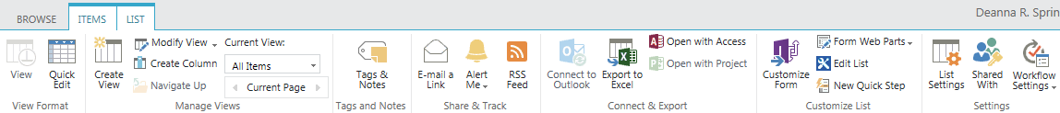
- On the Settings page under General Settings, click Validation Settings.
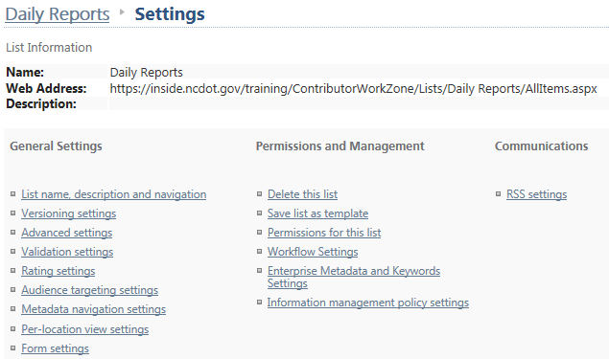
- Enter a formula in the Formula box to validate your data. For example, this list requests the day’s high and low temperatures, and the high temperature should be equal to or greater than the low temperature. Double-click High Temp F in the Insert Column to move that column into the Formula field.
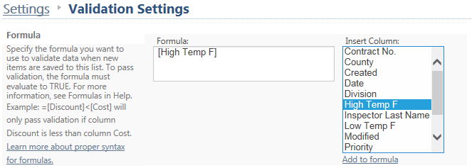
- Enter >= for greater than or equal, then double-click Low Temp F to move that column into the formula.
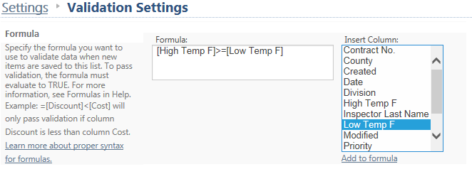
- Enter a User Message to explain what the user should correct if validation fails. Click Save.

- Return to the list and add an item with an invalid value. Click Save to test the validation. The item cannot be saved because of the invalid value. The user message appears to describe the problem.
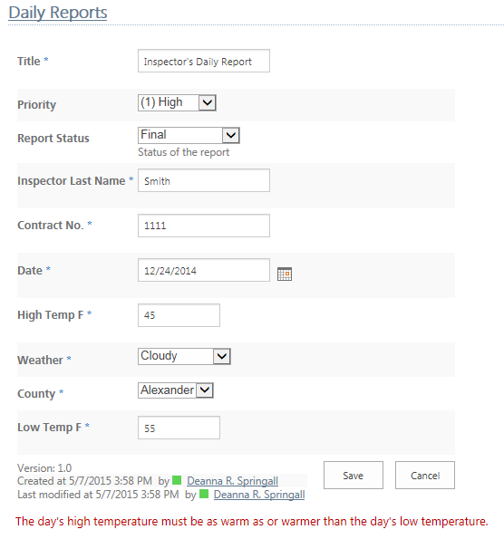
- Enter a valid value and click Save again.
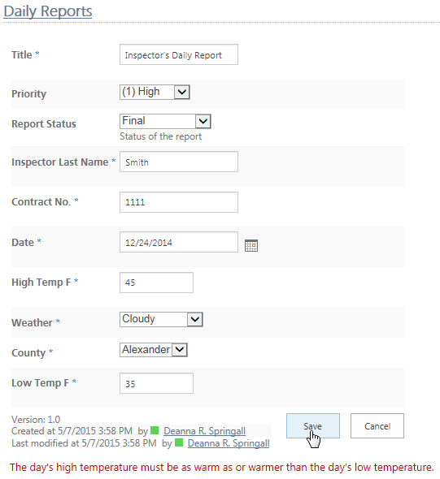
The item will be saved correctly and stored in the list.

